**Creating Record Entries in LL HMS**

**Part 1: Initial Creation**

I. Log in to HMS

II. Select the Accessions tab

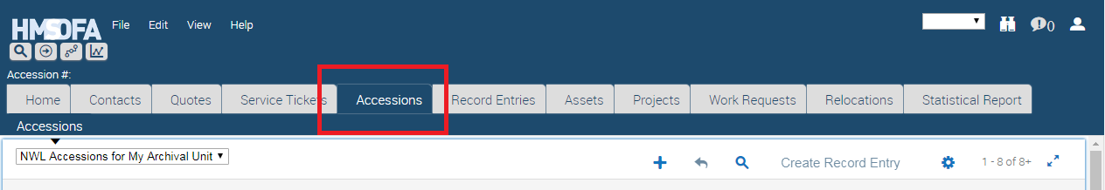

III. Go to the bottom half of the view, on the right, and select the New button.

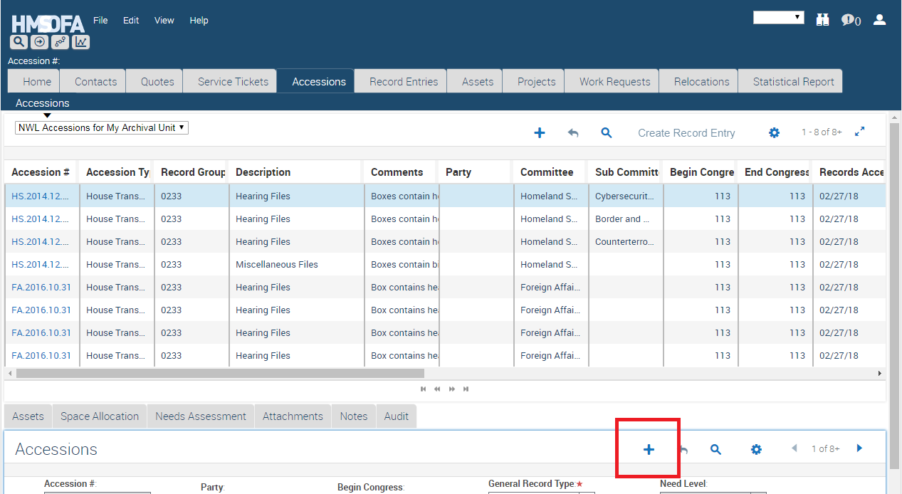

IV. Accession #: Enter the accession # in the Accession # field. Note you cannot edit the accession # once you have created the record entry, so do not make a mistake here.

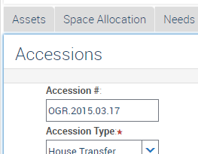

V. Accession Type: Select the appropriate accession type from the drop down. Most of your selections will either be House or Senate accession types. Please note the default setting is for Senate Transfer.

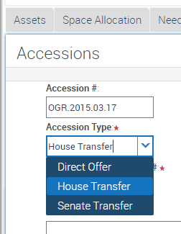

VI. Record Group/Collection #: Enter the appropriate record group # in the Record Group/Collection # field. This is also a field you cannot edit once the record entry is created, so make sure this is correct. Remember, the record group #’s are always 4 digit numbers (i.e. 0233 for House records and 0046 for Senate records).

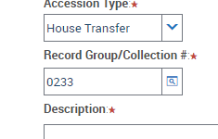

VIII. Description: Enter the appropriate information in the Description field. This field is used to describe, in broad terms, the theme of the records in the record entry you are creating. Put one (or two) of the following in the field: Investigative Files (includes subpoenas), Oversight Files, Subject Files, Hearing Files, Legislative Files, Official Communications (covers ECs, all agency reports-required-by-law, presidential messages, and state petitions or memorials), Staff Working Files, Administrative Files, Correspondence Files. If you find yourself using more than 2 of the terms, just insert Miscellaneous Files instead. This is probably the most difficult of the fields to fill out, so please review previously created entries, or talk to those who have created record entries for advice.

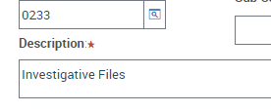

IX. Comments: Enter the appropriate information in the Comments Field. This field is used to describe the specific of the records in the record entry you are creating. In this field you need to describe what is contained in the records. In addition, you will want to describe other pertinent information. For example, you will want to list the box #’s if the sequence is unusual. This is vital for finding records during loan requests. As with the Description field, view other record entries to see sample of what will go into this field.

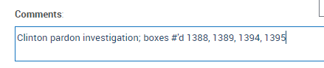

X. Party: If the records are party specific, select either Republican or Democratic in the Party field. This is most often applied to new Senate record entries, and only rarely with House record entries.

XI. Committee: Insert the appropriate committee name in the Committee field. Note, you can use the icon at the right of the field to search for the correct committee name. Also, you must have the committee spelled correctly, or HMS will not accept the information.

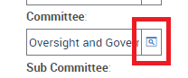

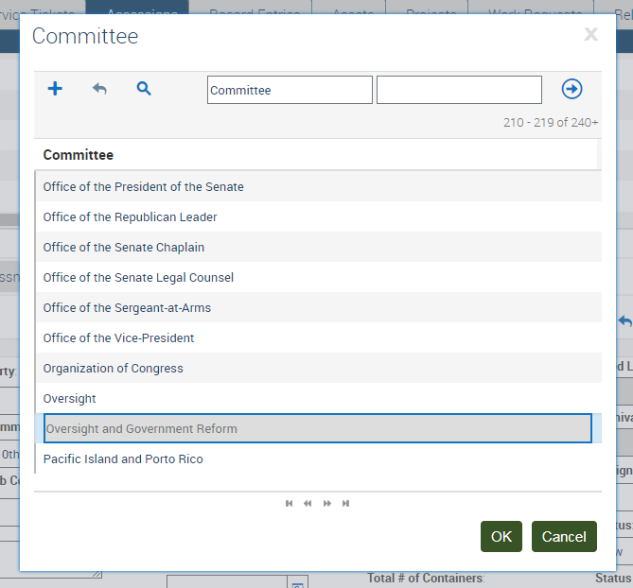

XII. Subcommittee: The information in XI applies to the Subcommittee field as well.

XIII. Begin Congress and End Congress: The Begin Congress, and End Congress fields are simple the date range of the records contained in the record entry being created.

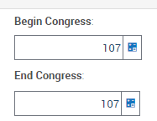

XIV. Records Accepted/Received Date: Use the date you process the entry into HMS.

XV. Contact Name: Do not fill out the Contact Name field.

XVI. General Record Type: There are actually two fields to fill out in the General Record Type field. These are General Record Type, and General Media Type. Click on the icon at the right side of the field, and click on the New button. Select the drop down menu under General Record Type. Then click on the right side (in the light blue), and select the drop down menu under General Media Type. In most cases, the General Record Type will be “Textual Records,” which is the selection for all textual records. If you select “Textual Records” as the General Record Type, then the General Media Type selection will be “Loose Sheets.

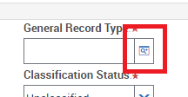

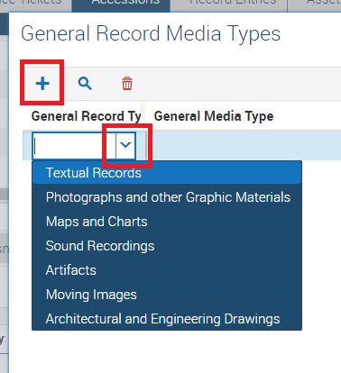

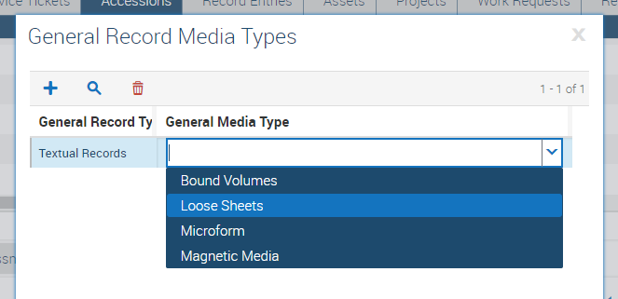

XVII. Classification Status: This field auto fills to Unclassified for all accessions. If the records are not Unclassified, select the appropriate option in the drop down menu.

XVIII. Access Restriction: Most new accessions are “Restricted-Fully.” However, just select the appropriate option from the drop down menu.

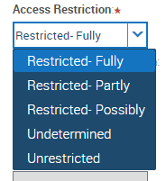

XIX: Specific Access Restriction: Click on the icon on the right side of this field, and a window will appear. Select the appropriate option on the left side, click Add, and when done select OK. Normally for House accessions, the option is House Rule. For Senate accessions, the option is Senate. If you have classified records, you must select both the House or Senate option, and “FOIA(b)(1) National Security.” If the records are restricted in any way in the Access Restriction field, you must select a specific access restriction.

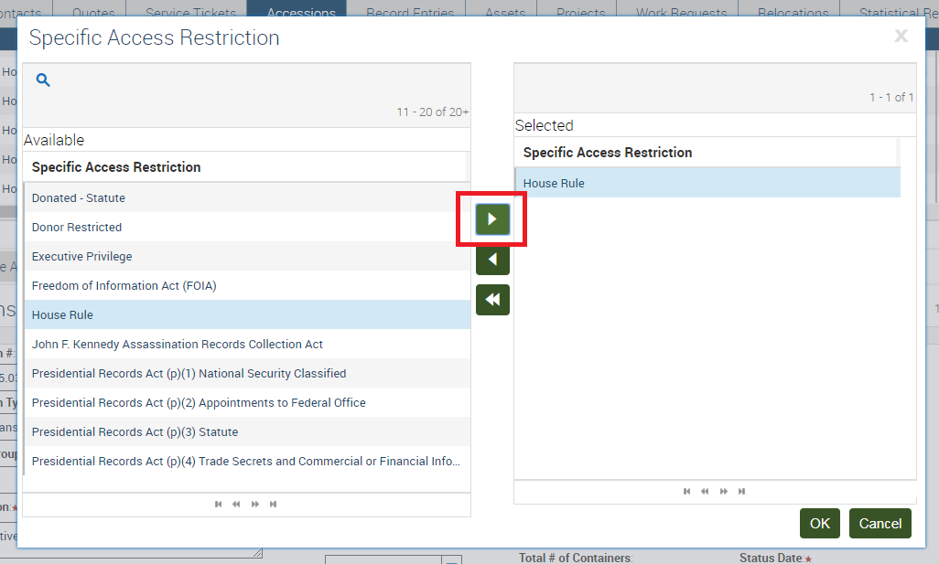

**Part II: Asset Creation**

I. At this point you need to create the assets for the record entry, so click on the Assets tab on the left side of the screen.

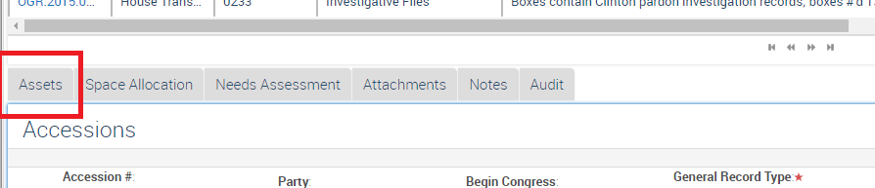

II. Container Type: Click on the icon on the right side of the Container Type field, and select the proper container type. To make things simple, 99% of the time the container type will be LGA-S, which is the container type for a legal-sized Hollinger box.

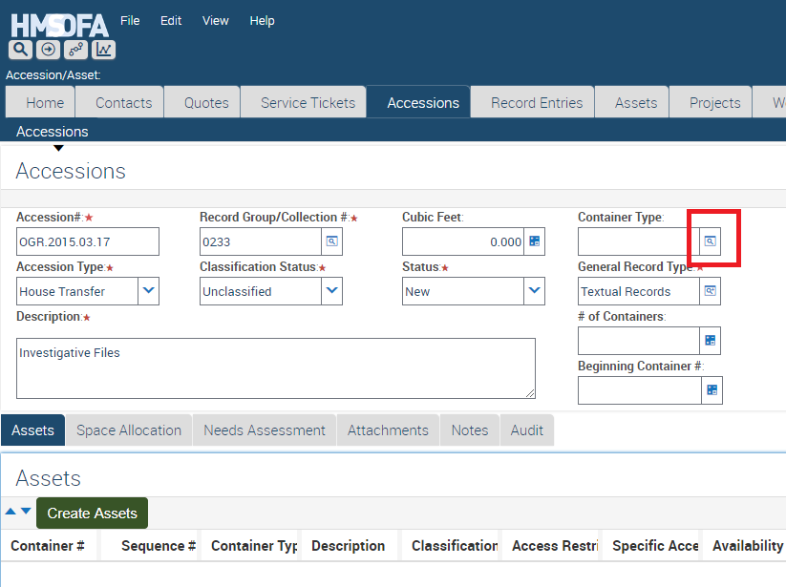

III. # of Containers: Enter the total # of boxes in this field.

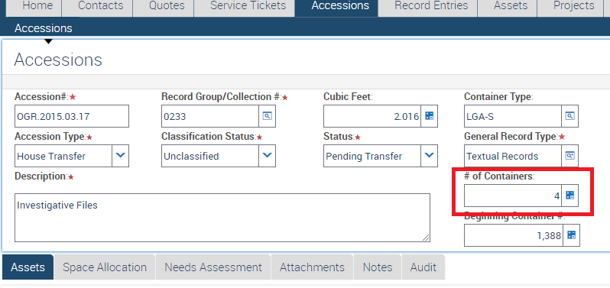

IV. Beginning Container #: Enter the beginning container # in this field. Most of the time, it will be 1.

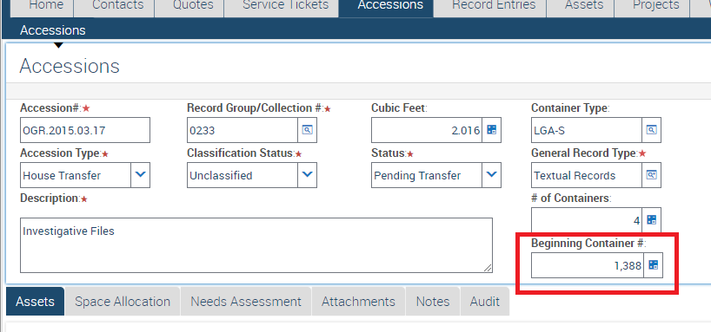

V. In the middle part of the screen, click on the Create Assets tab. At this point, HMS will create the assets for the record entry, which includes assigning an asset id for each box. If you have a large # of boxes, be patient while HMS creates them.

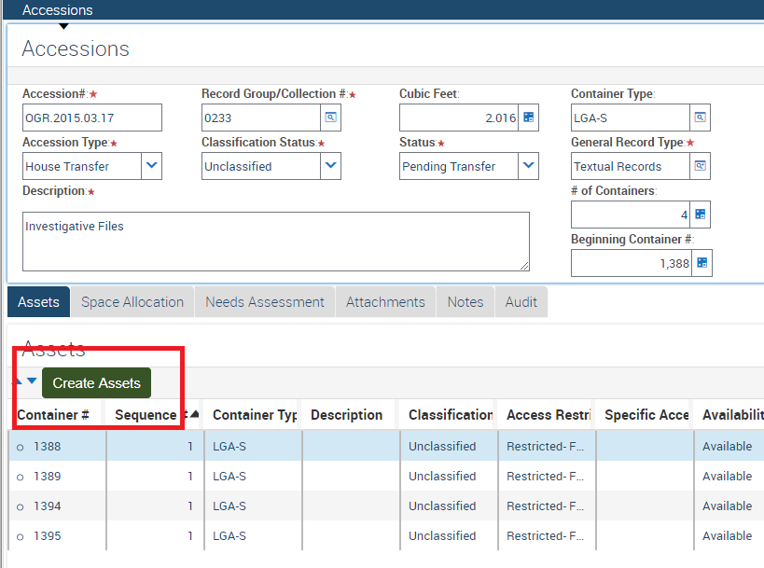

If you need to change the container number in case of a non-standard number’d run of boxes, just click in the container number field and make the change – it will save automatically.

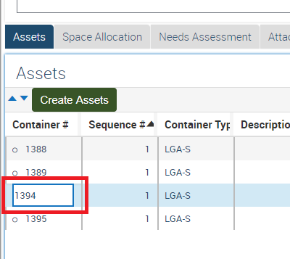

VI. The last step in the Asset tab is to put the correct location in the Asset Location field for each asset you just created. This will appear at the bottom of your screen. There are two ways to do this. One is to simply enter the location for each box, one at a time. The other is to first highlight the run of boxes you wish to edit (left click and shift) the location for. Then click on the Edit button in the top left of the screen (dark blue field), and select Change Records. In the first field, select Asset Location, insert the proper location (note: this can be copy and pasted in), and click OK. At that point, HMS will fill in the location for all of the selected assets. Note that a proper location will look something like LR-01-0012E2C-008-1-004-01. Also, if the location is incorrect in any way, HMS will not accept the change.

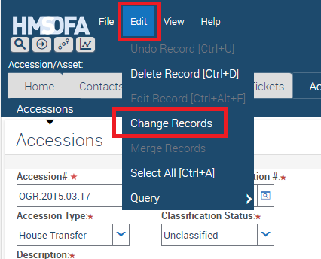

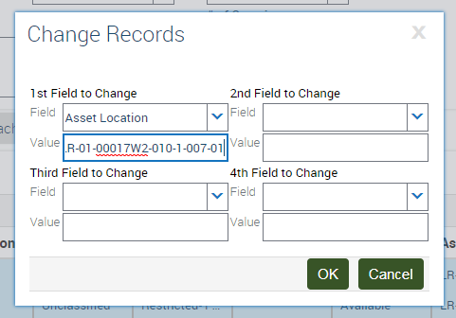

**PART III: Needs Assessment**

I. The last major step is the completion of the Needs Assessment. So, once the asset locations are all entered, click on the Needs Assessment tab in the middle of the screen.

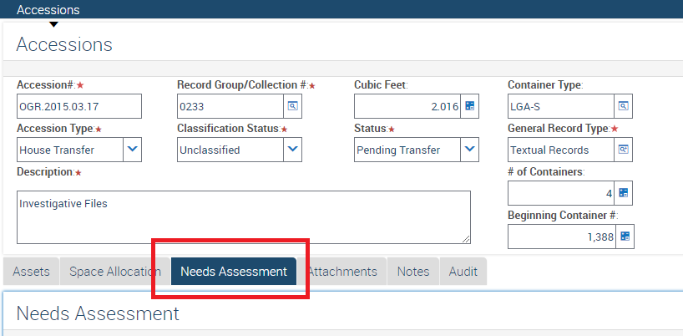

II. In the bottom part of the screen, click on New.

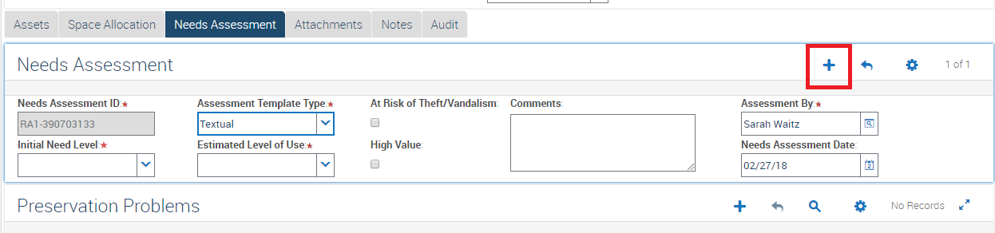

III. Initial Need Level: Select “No Preservation Action Now” from the drop down menu. On the rare occasions another option is needed, select that.

IV. Assessment Template Type: This auto defaults to Textual. Leave it that way, unless another option is required. i.e. For electronic records select Dynamic from the drop down menu.

V. Estimated Level of Use: Select Low from the drop down menu.

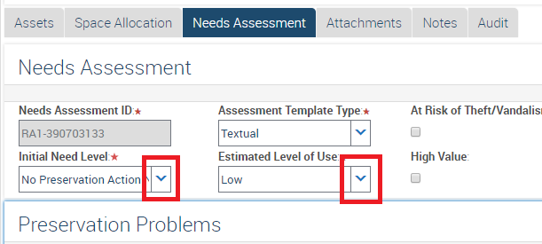

**Part IV: Final Creation**

I. Click on the blue Accessions tab at the top of your screen. This should take you back to the record entry you just finished mostly creating.

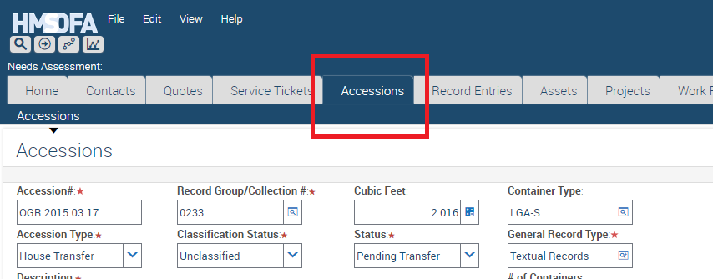

II. Review all of the information you entered. Remember, there are multiple fields (NWL Accession #, and Record Group) you cannot change once you create the record entry.

III. Status: If you are satisfied with your accuracy, go to the bottom part of the screen, on the right, and click on the drop down menu in the Status field. Select Verified, and click anywhere outside of the field.

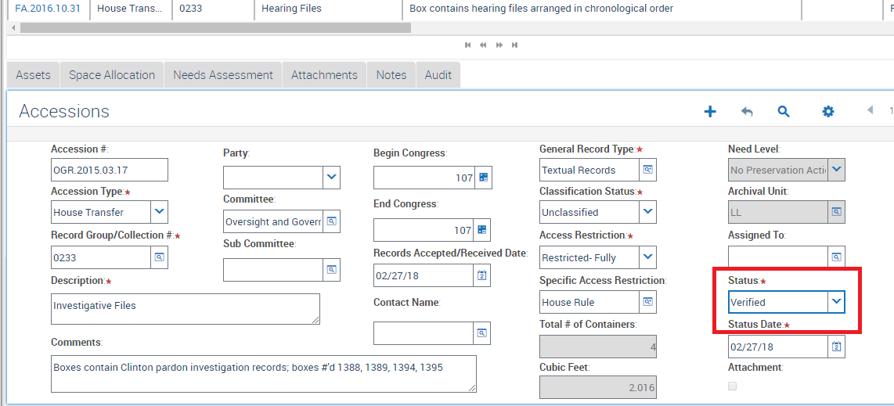

IV. At this point, the Create Record Entry button will become available at the top of the page. Click on that, and wait. Once the record entry is complete, HMS will take you to the new record entry in the Record Entry tab.

