**Processing Assessment (Record Entry) in HMS**

**Training Manual**

**Version 1.0**

**November 2017**



1. **Creating a New Processing Assessment Record from Record Entries**

To **create** a **new processing assessment record from Record Entries**, take the following steps:

1. Click the **Record Entries** screen tab and query for the desired record entries.
2. In the list applet, select the desired Record Entry or Entries that are in 'Active' status.
3. Click the 'Create Processing Assessment' button.  
     
   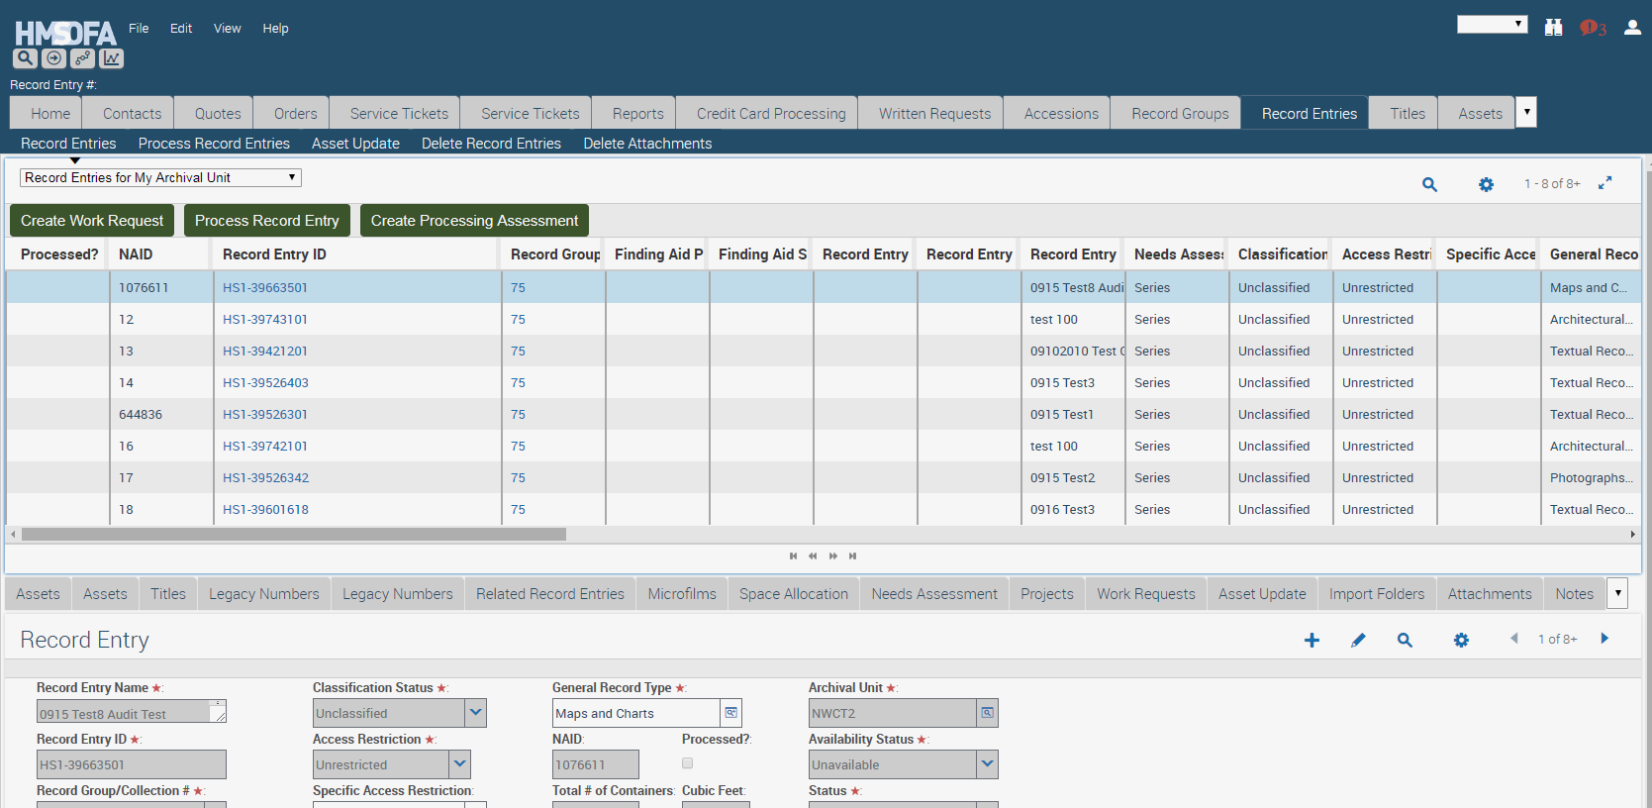
4. The system navigates to the Processing Assessment screen tab and creates a new Processing Assessment that is tied to the selected record entry or entries.
5. In the main view, update the Status to Active, so the Processing Assessment cannot be deleted.

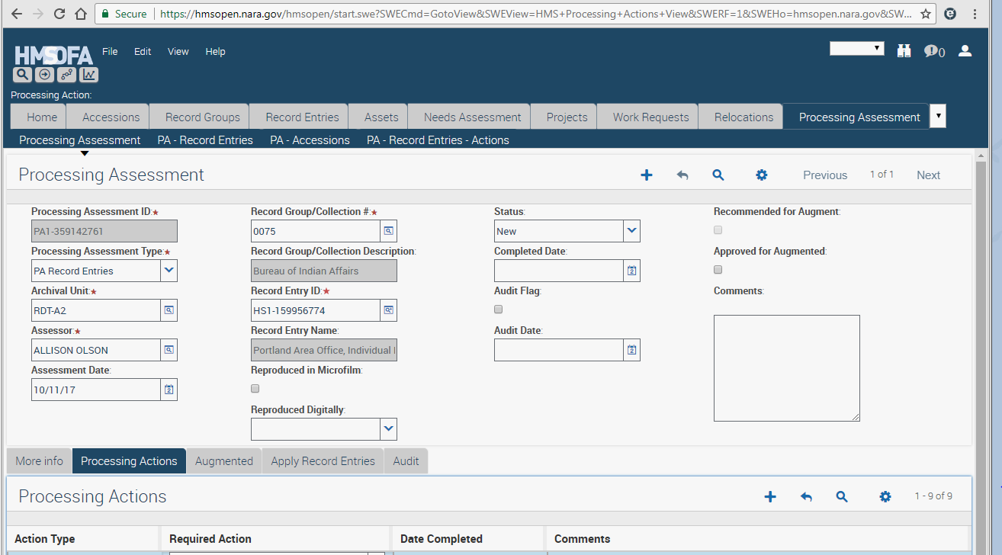

1. Under the Processing Actions view tab, the system generates nine processing actions based off the standards for Basic Processing from the Research Services Processing Manual. Fill out each row based on information gathered while assessing the record entry or entries.

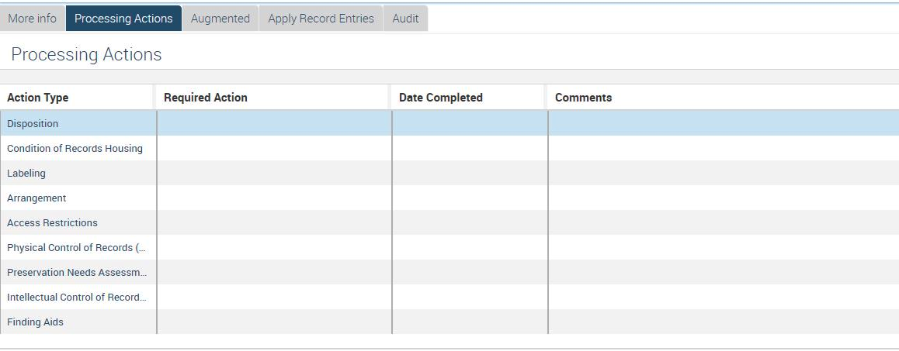

1. In the Processing Actions view, select a value from the 'Required Action' list of values for each Action Type.
   1. The list of values is unique to each Action Type, and match those found in the Processing Manual.
   2. If no action is required for that Action Type, select Requires No Further Action.
2. Click the calendar button in the Date Completed field to fill in the date when the action is completed.
   1. If Requires No Further Action is selected, the system automatically fills out the Date Completed field.
3. Enter text in the 'Comments' field if needed.
4. If needed, click the Create button to add additional Processing Action rows. Repeat steps 6-9.
5. If you are recommending augmented processing, click the **Augmented** view tab to populate Augmented Fields.
6. The fields listed on this tab include:  
   1) High intrinsic significance (Check Box)  
   2) High historic significance (Check Box)  
   3) % of significant records   
   4) Potential for significant space savings (Check Box)  
   5) Finding Aid (Check Box)  
   6) High anticipated or actual use (Check Box)  
   7) Augmented Justification (Long Text Field) include what needs to be done and why.
7. If any fields are populated, the system auto-populates the 'Recommended for Augment' field in the main Processing Assessment view. 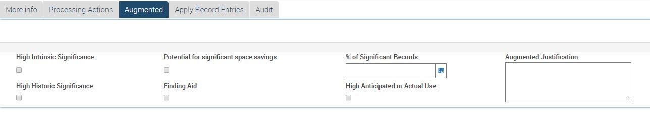
8. When all the required actions are completed,
   1. Click the Calendar button in the Completed Date field in the main Processing Assessment view to fill in the desired date. This will cause all blank Date Completed for associated actions to fill in.
   2. Update the Status to Completed.
9. **Add or remove additional record entries from an existing processing assessment.**
10. Click the  selection icon in the Record Entry ID field.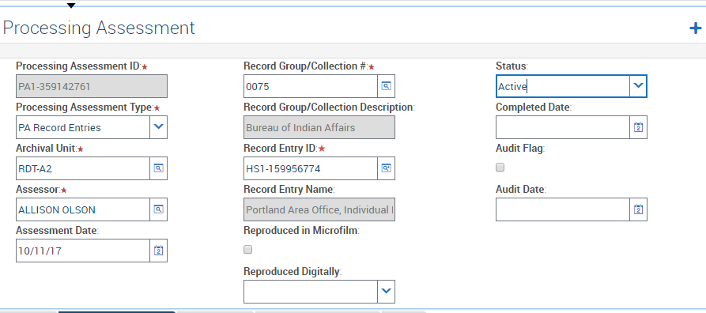



1. Query for or select the record entry or entries you want to add to the processing assessment.

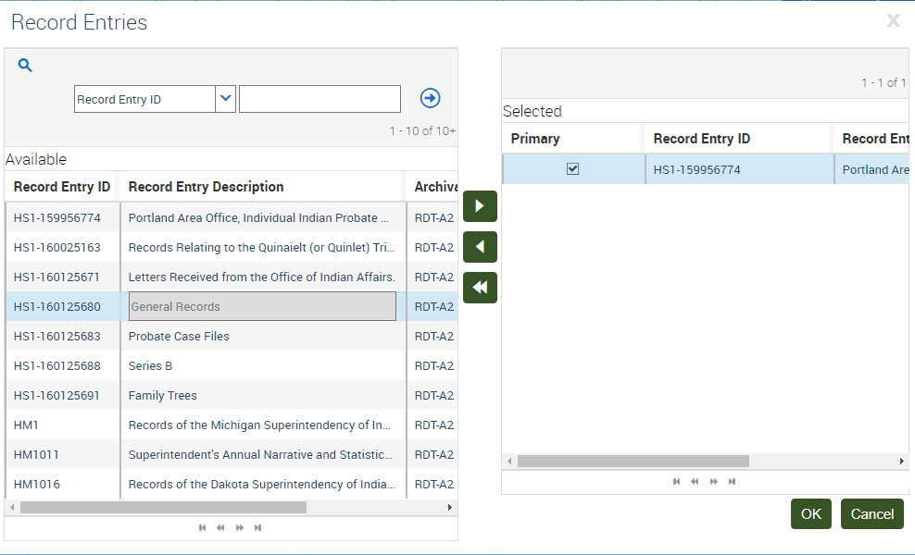

1. Click the  arrow to move the highlighted record entry from Available to Selected.
2. Click the  arrow to move the highlighted record entry from Selected to Available.
3. Check the Primary box to change which record entry shows on the main screen.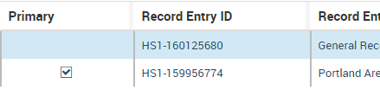
4. **Apply an existing processing assessment to different selected record entries**

This creates a new processing assessment with the same required actions and other information, and applies it to selected record entries.

1. Click the **Processing Assessment** screen tab.
2. Click the  Query button.
3. Query for the processing assessment record that you want to apply.
4. Click the Apply Record Entries view tab.
5. Select desired row/record entry records from the displayed list of record entries by populating/checking the checkbox field named 'Selected'
   1. You may also highlight the desired record entries and use the Change Records function to populate the Selected box.

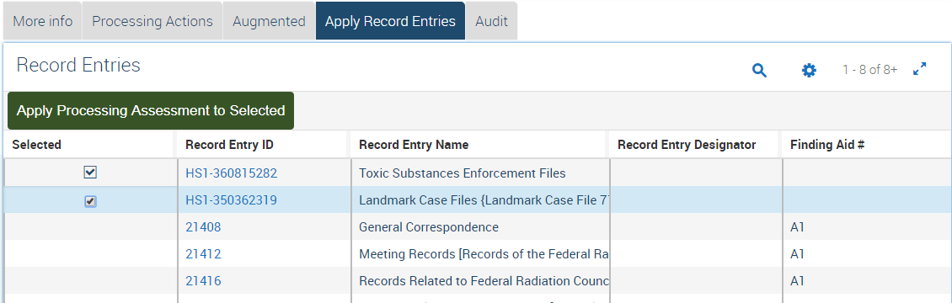

1. Click the 'Apply Processing Assessment to Selected' button
2. A new Processing Assessment will be created for each selected record entry. All processing action records are copied from the source processing assessment record.
3. **PA – Record Entries Link Bar View**
4. Click the 'PA - Record Entries' link bar view.

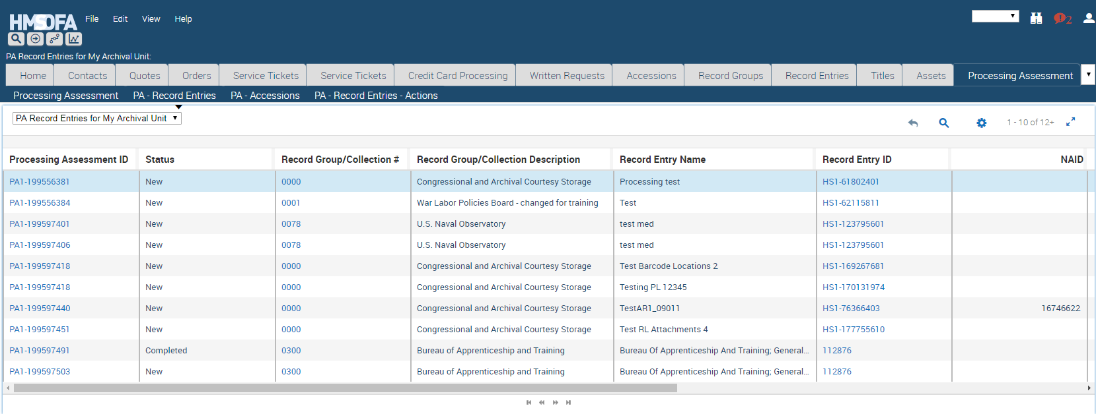

1. This view displays all the record entry processing assessments for your Archival Unit as an individual record. This view allows a user to search for all the processing assessments tied to a specific record entry. Processing assessments will appear multiple times if they are associated with more than one record entry.
2. **PA – Record Entries - Actions Link Bar View**
3. Click the 'PA - Record Entries - Actions' link bar view.
4. This view displays all processing actions for the record entry processing assessments in your archival unit. Each processing action is shown as an individual record/row This view allows querying for processing actions across processing assessments and record entries

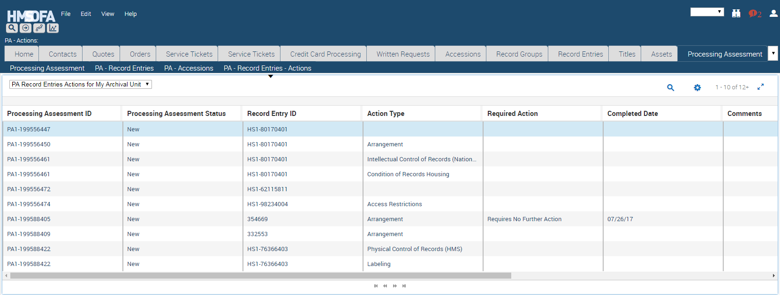

**Table 1 : HMS Processing Assessment Record Fields**

|  |  |
| --- | --- |
| **Data Element** | **Purpose** |
| Processing Assessment ID | System assigned unique identifier for a processing assessment. |
| Processing Assessment Type | System generated data element showing if the processing assessment was created for a record entry or an accession. |
| Archival Unit | Unit that has custody of the record entry or accession. |
| Assessor | Person who filled out the processing assessment. |
| Assessment Date | Date the processing assessment was filled out. |
| Reproduced in Microfilm | The record entry has been microfilmed. |
| Reproduced Digitally | The record entry has been digitized in part or in full. |
| Status | Status of the processing assessment. New- newly created and can be edited and deleted. Active- current valid assessment that can be edited. Obsolete- formerly valid assessment. Completed- all actions are completed. Reviewed Accession- the processing assessment was originally created for an accession and that accession has become a record entry. |
| Completed Date | Date the processing assessment was completed. |
| Audit Flag | The unit has audited the assessment. |
| Audit Date | Date the audit flag was checked. |
| Recommended for Augment | System adds check when information is entered in Augmented tab. Indicates the processing assessment needs to be reviewed for augmented processing approval. |
| Approved for Augment | The supervisor checks this box to indicate augmented processing is approved. The User ID is logged in the audit trail. |
| High intrinsic significance | A check indicates that the physical documents have attributes that are significant apart from the content. This might include symbolic significance (a treaty), an association with an important historical figure (a President), physical form (e.g., a diary or a work of art). |
| High historic significance | A check means the records are connected to a historical event or topic – i.e. Department of State records during WWII; Material relating to Brown vs. Board of Education. |
| Potential for significant space savings | A check means that completing holdings maintenance would result in significant space savings. For example: removing records from binders, reboxing partially-filled boxes, adjusting shelves to fit more boxes, flattening rolled records. |
| Finding aid | A check indicates improving or creating a finding aid would significantly reduce the burden on reference. |
| % of significant records | An estimated percentage of record entry or accretion that contains high intrinsic or historic significance. If there are only a few significant items, enter that information in the comments. |
| High anticipated or actual use | A check indicates a high usage based on researcher demand for similar records or parent series. |
| Augmented Justification | The needed actions for Augmented Processing and the reason to do them. |

**Processing Assessment (Accession) in HMS**

**Training Manual**

**Version 1.0**

**November 2017**



1. **Creating a New Processing Assessment Record from Accessions**

To **create** a **new processing assessment from Accessions**, take the following steps:

1. Click the **Accessions** screen tab and query for the desired accession.
2. In the list applet, select a desired Accession that is in 'Verified' status. There can only be one accession on a processing assessment.
3. Click the 'Create Processing Assessment' button

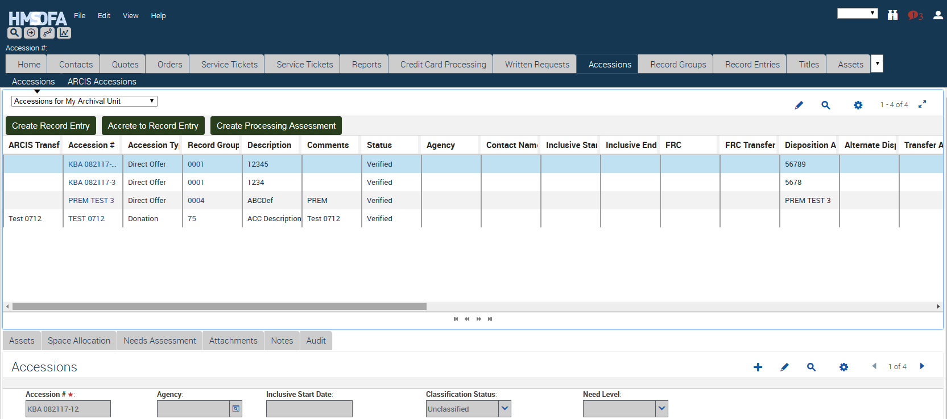

1. The system creates a New Processing Assessment record that is tied to the selected accession. The system navigates to the Processing Assessment screen tab.
2. In the main view, update the Status to Active, so the Processing Assessment cannot be deleted. 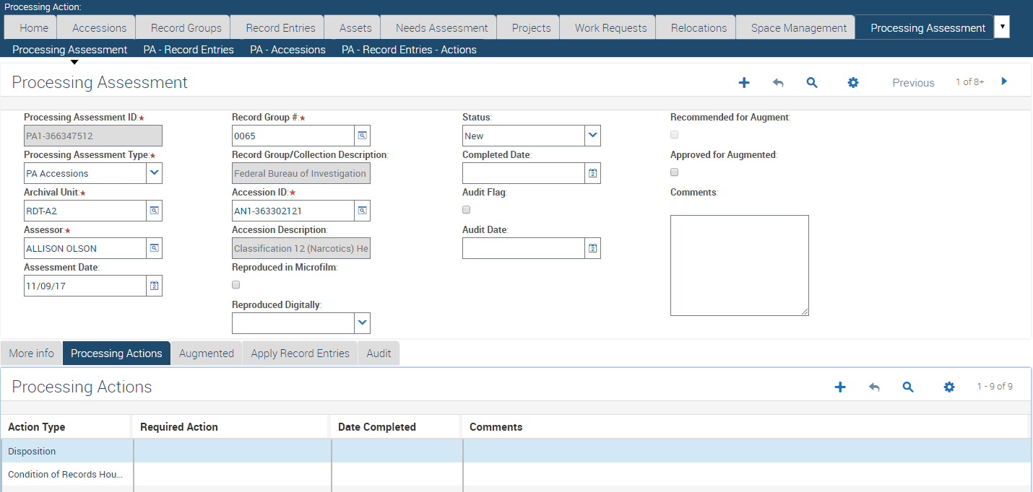
3. Under the Processing Actions view tab, the system generates nine processing actions based off the standards for Basic Processing from the Research Services Processing Manual. Fill out each row based on information gathered while assessing the accession.
4. In the Processing Actions view, select a value from the 'Required Action' list of value for each Action Type.
   1. The list of values is unique to each Action Type, and match those found in the Processing Manual.
   2. If no action is required for that Action Type, select Requires No Further Action.
5. Click the calendar button in the Date Completed field to fill in the date when the action is completed.
   1. If Requires No Further Action is selected, the system automatically fills out the Date Completed field.
6. Enter text in the 'Comments' field if needed.
7. If needed, click the Create button to add additional Processing Action rows. Repeat steps 6-9.
8. If you are recommending augmented processing, click the **Augmented** view tab to populate Augmented Fields.

A. The fields listed on this include:

1) High intrinsic significance (Check Box)

2) High historic significance (Check Box)

3) % of significant records

4) Potential for significant space savings (Check Box)

5) Finding Aid (Check Box)

6) High anticipated or actual use (Check Box)

7) Augmented Justification (Long Text Field) include what needs to be done and why.



B. If any fields are populated, the system auto-populates the 'Recommended for Augment' field in the main Processing Assessment view.

1. When all the required actions are completed,
   1. Click the Calendar button in the Completed Date field in the main Processing Assessment view to fill in the desired date. This will cause all blank Date Completed for associated actions to fill in.
   2. Update the Status to Completed.
2. **PA – Accessions Link Bar View**
3. Click the 'PA – Accessions’ link bar view right above the 'Processing Assessment for My Archival Unit' drop down.

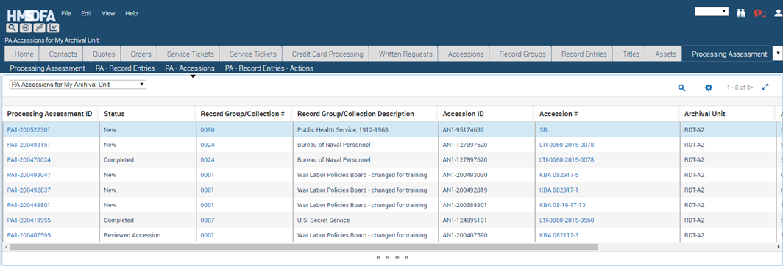

1. This view displays all accession processing assessments for your Archival Unit as an individual record. This view allows a user to search for all the processing assessments tied to a specific accession.

**Table 1: HMS Processing Assessment Record fields**

|  |  |
| --- | --- |
| **Data Element** | **Purpose** |
| Processing Assessment ID | System assigned unique identifier for a processing assessment. |
| Processing Assessment Type | System generate data element showing if the processing assessment was created for a record entry or an accession. |
| Archival Unit | Unit that has custody of the record entry or accession. |
| Assessor | Person who filled out the processing assessment. |
| Assessment Date | Date the processing assessment was filled out. |
| Reproduced in Microfilm | The record entry has been microfilmed. Not applicable for an accession. |
| Reproduced Digitally | The record entry has been digitized in part or in full. Not applicable for an accession. |
| Status | Status of the processing assessment. New- newly created and can be edited and deleted. Active- current valid assessment that can be edited. Obsolete- formerly valid assessment. Completed- all actions are completed. Reviewed Accession- the processing assessment was originally created for an accession and that accession has become a record entry. |
| Completed Date | Date the processing assessment was completed. |
| Audit Flag | The unit has audited the assessment. |
| Audit Date | Date the audit flag was checked. |
| Recommended for Augment | System adds checks when information is entered on Augmented tab. Indicates the processing assessment needs to be reviewed for allowing augmented processing. |
| Approved for Augment | The supervisor checks this box to indicate augment processing is approved. The User ID is logged in the audit trail. |
| High intrinsic significance | A check indicates that the physical documents have attributes that are significant apart from the content. This might include symbolic significance (a treaty), an association with an important historical figure (a President), physical form (e.g., a diary or a work of art). |
| High historic significance | A check means the records are connected to a historical event or topic – i.e. Department of State records during WWII; Material relating to Brown vs. Board of Education. |
| Potential for significant space savings | A check means that completing holdings maintenance would result in significant space savings. For example: removing records from binders, reboxing partially-filled boxes, adjusting shelves to fit more boxes, flattening rolled records. |
| Finding aid | A check indicates improving or creating a finding aid would significantly reduce the burden on reference. |
| % of significant records | An estimated percentage of record entry or accretion that contains high intrinsic or historic significance. If there are only a few significant items, enter that information in the comments. |
| High anticipated or actual use | A check indicates a high usage based on researcher demand for similar records or parent series. |
| Augmented Justification | The needed actions for Augmented Processing and the reason to do them. |