hms-need-assessment-instructions-for-rd-dc-1

**HMS NEEDS ASSESSMENT INSTRUCTIONS FOR WASHINGTON AREA ARCHIVES**

Updated Feb 2, 2015

Archival staff members will enter needs assessments in HMS during:

* Accessioning only if there is a preservation problem  
   and
* Processing of a record entry.

**Exceptions:** Archival staff members are NOT required to complete needs assessments when they are writing ARC entries only based on documentation without examining the records. This occurs during the processing initiative. Don’t enter a needs assessment for records that are stored offsite and you cannot assess the condition.

A needs assessment is filled out for one record entry in HMS. The needs assessment can then be applied to other record entries that have the same use level, preservation problems, and preservation actions.

**Creating or Updating a Needs Assessment**

1. Go to the Record Entry tab.
2. Query for the record entry you want to write a needs assessment for.

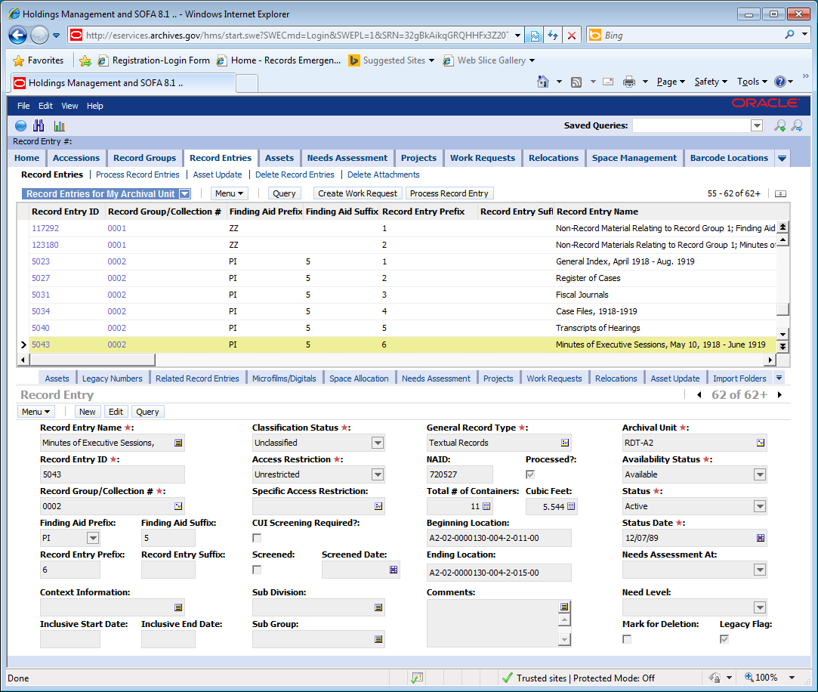

1. See if the Need Level is blank.

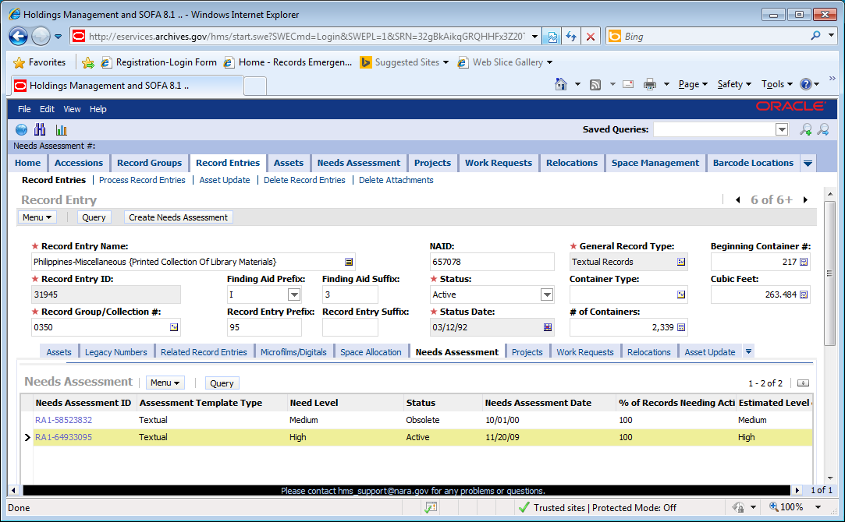

1. Click lower level Needs Assessment tab. If the record entry has no needs assessments that is the Need Level is blank, then click Create Needs Assessment button.



1. If the Need Level is not blank, look at the listed needs assessments.
   1. For the listed needs assessments, look at the Status

|  |  |
| --- | --- |
| New | Needs assessment is created, but not applied. |
| Active | Needs assessment is applied and valid. |
| Obsolete | Needs assessment in no longer valid. |
| Completed | All needed preservation actions are completed. |

* 1. Look at Needs Assessment At:

|  |  |
| --- | --- |
| Accession | Created on the Accession Tab. |
| Series | Created on the Record Entry Tab. |



* 1. Then click the hyperlink of the Needs Assessment ID with the status New or Active. This takes you to the current needs assessment that can be edited.

**OR**

1. If the needs assessment is status Completed or you want to replace the old needs assessment, click Create Needs Assessment button. This creates a new needs assessment for the record entry. The existing Active needs assessment’s status automatically becomes Obsolete.

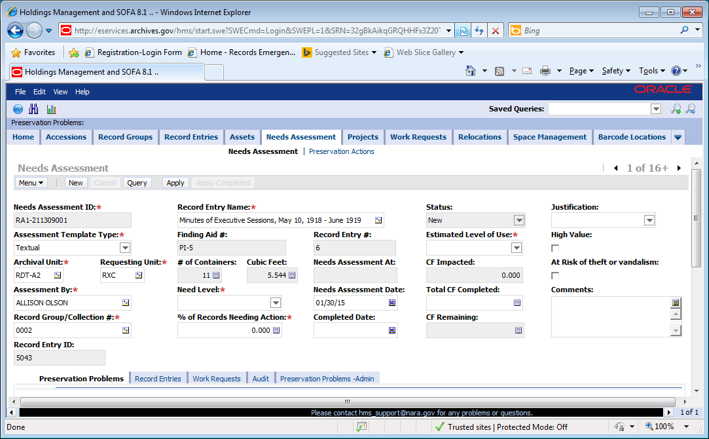

1. Change Assessment TemplateType, if necessary. The default is Textual.

The majority of the records with preservation problems determine the type. The types are:

* + Textual: records with content that is principally written words.
  + Cartographic: maps, charts, architectural and engineering plans.
  + Still Images: photographic images and graphic arts.
  + Dynamic Media: motion pictures, audio or video.

1. The Archival Unit is based on the custodial unit of the records. The Requesting Unit is the assessor’s unit.
2. Select **Estimated Level of Use**

Combined staff, researcher, and exhibit or other usefor the whole record entry or accession:

* **High Use** - records are generally used at least 3 times per year.
* **Medium Use** - records are generally used 1 or 2 times per year.
* **Low Use** -records are generally used less than once per year.

1. Select the appropriate **Needs Level For Textual/Cartographic/Still Image Records**

Urgent:

* + **Wet, actively moldy or currently pest infested records--call for conservation advice or intervention immediately.**
  + Machine readable records on obsolete formats, for which playback equipment is difficult to locate.
  + Unstable media which will not benefit greatly from cold storage and which must be copied before additional information loss occurs.
  + Records where the next use will likely result in loss of information.

High

* **High use** records with preservation problem(s)
* Records requiring cool or cold/below-freezing storage that are not in such storage.

Medium

* **Medium use** records with preservation problem(s)

Low

* **Low use** records with preservation problem(s)

No Preservation Needed At This Time

* Records with no preservation problems/needed actions

|  |  |  |  |  |  |
| --- | --- | --- | --- | --- | --- |
|  | | Need Level for Dynamic Media  Find the cell in the row of the preservation problem and in the column of the use level. This cell contains the  need level. When multiple problems are present determine the need level for each problem, then select the highest  need level as the record entries’ need level. | | | |
| Preservation Problem | | | High Use | Medium Use | Low Use |
| None Found | | | No Preservation Action Now | No Preservation Action Now | No Preservation Action Now |
| Audio/Video: digital original | | | Urgent | Urgent | Urgent |
| Magnetic media are blocked together | | | Urgent | Urgent | Urgent |
| Magnetic media have binder hydrolysis, sticky shed. | | | Urgent | Urgent | Urgent |
| Magnetic media shrunken acetate tape carriers. | | | Urgent | Urgent | Urgent |
| Mold or pests | | | Urgent | Urgent | Urgent |
| Require cool, cold storage or below-freezing storage | | | Urgent | Urgent | Urgent |
| * Spoking: Audio/Video | | | Urgent | Urgent | Urgent |
| * Spoking: Motion Picture Film | | | Medium | Medium | Low |
| Audio/Video: obsolete format/ obsolete playback equipment/unstable media | | | Urgent | Urgent | Urgent |
| *Brittle/ fragile: Audio/Video | | | Urgent | Urgent | Urgent |
| *Brittle/fragile: Motion Picture Film | | | Urgent | Urgent | High |
| * Damaged/ torn/obscured by tapes /heavily soiled: Audio Video | | | Urgent | Urgent | Urgent |
| *Damaged/torn/obscured by tape: Motion picture Film | | | Urgent | High | High |
| Audio is more than 8 years old? | | | High | High | High |
| Video is more than 5 years Old? | | | High | High | High |
| Require cool, cold storage or below-freezing storage. | | | High | High | High |
| Standard housings (ex. boxes, sleeves): poor condition/ not present/ damaging the records. | | | High | Medium | Medium |
| Custom housings (ex. boxes, sleeves) required due to non-standard sizes/formats. | | | High | Medium | Medium |
| Textual, Still Pictures and Cartographic records have preservation problems. | | | High | Medium | Low |
| Artifacts have preservation problems. | | | High | Medium | Low |
| Loose/poor wind. | | | Medium | Medium | Low |
| Other | | | High | Medium | Low |



1. Select High Value, if applicable

* “High value records are those that have historical, legal, and/or monetary value and are at the greatest risk of theft especially for resale; they are not security classified records.” (Definition from NARA Notice NR04-040)

1. Select At Risk of Theft or Vandalism, if applicable.

* Records are targets of theft or vandalism, because of high value or a connection to a controversial topic.

1. Specify the Percentage (%) of Records Needing Action.

* This data element is used to calculate total cubic feet needing preservation. In order to ensure that records are not double counted this example should be followed. If 30% of the records need conservation and 20% need reformatting, the % of Records Needing Action would be 30% if the same records need both actions, or 50% if different records need each action.



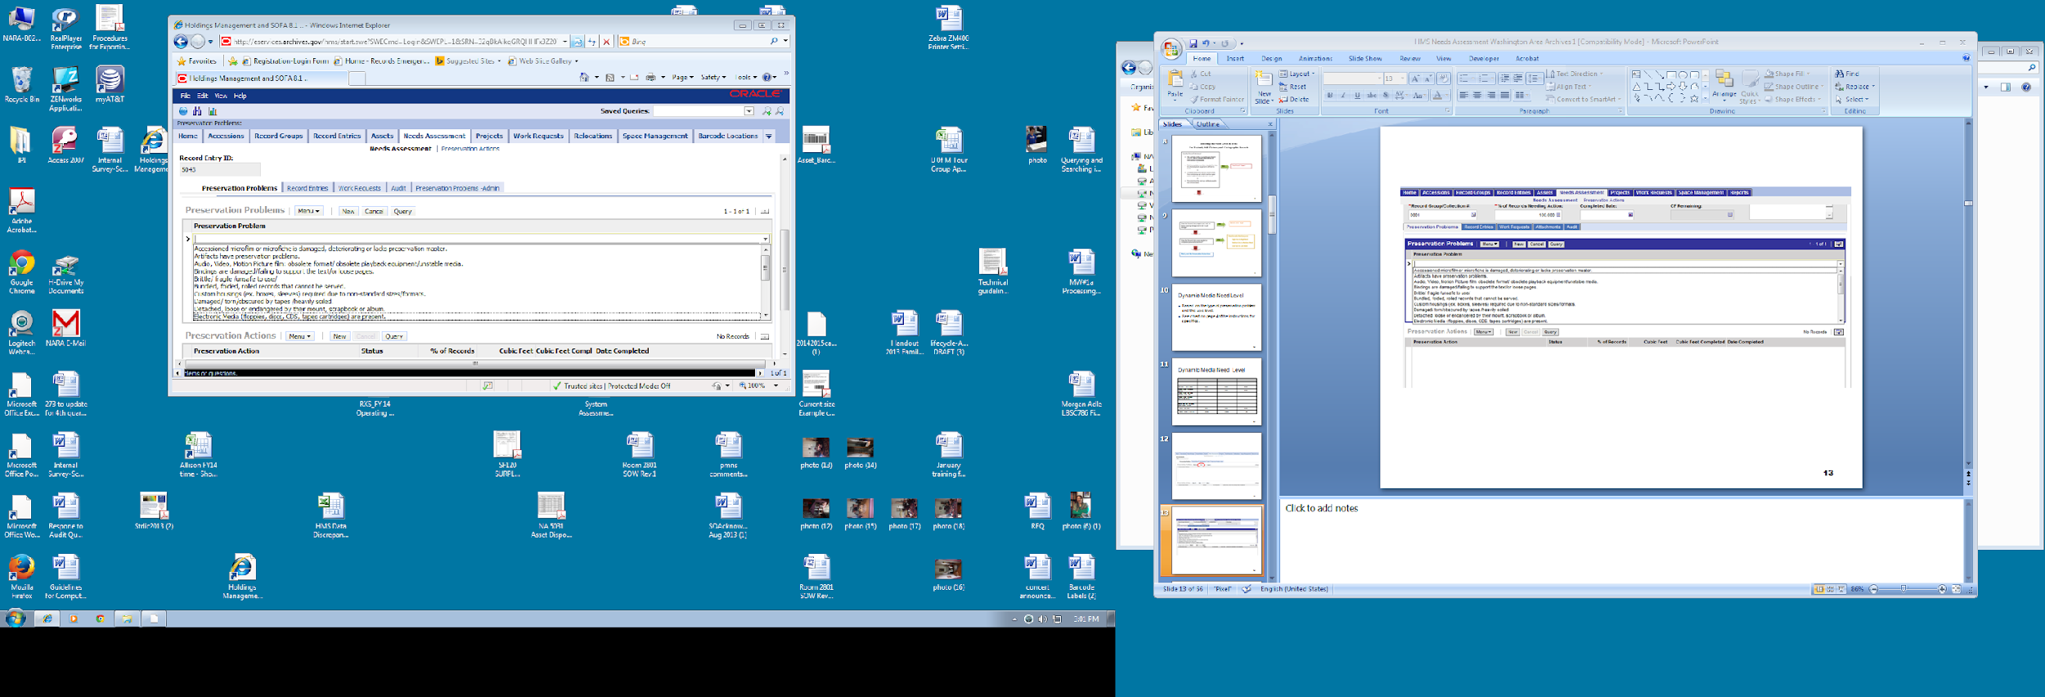

1. Select all Preservation Problems that apply. The list of problems is dependent on the assessment type: Textual, Cartographic, Still Images, or Dynamic.

a. Click New next to Preservation Problems

b. Click the arrow that appears on the blank line

c. Pick a problem from the drop down list

d. Click New again to add a blank line to add other preservation problems. Repeat as necessary.

**Textual/Cartographic/Still Image Preservation Problems**

**None Found**

* No preservation problems at this time.

**Standard housings (ex. boxes, sleeves): poor condition/ not present/ damaging the records.**

**(Suggested Preservation Actions: Holdings Maintenance-box, Holdings Maintenance- folder, Holdings Maintenance- sleeve/unfold/replace fasteners, Holdings Maintenance- other*)***

* No housing is present or the housing impedes safe handling and is damaging to the records.
* Records cannot be safely retrieved from or re-filed into their containers.
* Acidic paperboard boxes and folders are weak, damaged, falling apart, staining the records and/or not capable of fully supporting and protecting the records.
* Housings are not the correct size or format, and as a result, records are exposed, distorted, crushed or crumpled.
* Records are not foldered at all, nor individually housed where appropriate.
* Records need polyester sleeves, such as bare photos, or fragile or torn paper.
* DO NOT SELECT if boxes are physically intact and supporting the records, but do not meet current standards.

**Custom housings (ex. boxes, sleeves) required due to non-standard sizes/formats.**

**(Suggested Preservation Actions: Custom Housing)**

* Records need custom housings if they are:
  + too large or heavy for standard purchased boxes
  + artifacts that require support, padding, and segregation from textual files
* Custom housings will either be made by the Conservation Lab, or specifications will be developed so that custom containers can be purchased from a vendor

**Bindings are damaged/failing to support the text/ or loose pages**

**(Suggested Preservation Actions: Custom Housing or Conservation*)***

* Bound records have detached pages, broken spines, loose or detached covers, and/or the textblock is no longer supported.

**Brittle/ fragile /unsafe to use/**

**(Suggested Preservation Actions: Holdings Maintenance-Sleeve/unfold/remove fasteners, Conservation, and/or Preservation Copying)**

* The records are inflexible and brittle.
* The records are in poor or unstable condition, and cannot be handled safely without causing further damage.
* The records are not sturdy and have many tears, crumpled edges, breaks, etc.
* Laminated documents that have a strong acetic acid odor (“vinegar syndrome”) AND noticeable shrinkage or distortions.

**Damaged/ torn/obscured by tapes /heavily soiled.**

**(Suggested Preservation Actions:Holdings Maintenance-Sleeve/unfold/remove fasteners, Holdings Maintenance-Humidify, Flatten, Surface Clean, and Conservation)**

* Records are torn, have losses or detached pieces.
* Tape is obscuring the text or causing damage.
* The soil obscures text or transfers onto the user’s hands during use.

**Detached, loose or endangered by their mount, scrapbook or album.**

**(Suggested Preservation Actions: Custom Housing and/or Conservation)**

* + Items, such as photos, clippings, or ephemera, have detached and/ or loosened from their album or scrapbook pages or mount. They may be lost or damaged.
  + The condition of the mount or binding may damage the items.

**Bundled/folded/rolled records that cannot be served.**

**(Suggested Preservation Actions: Conservation, Holdings Maintenance-Humidify, Flatten, Surface Clean, and Conservation, and/or Preservation copy)**

* The records are inflexible and brittle and cannot be handled or opened without causing breaks, tears, and other damage.

**Accessioned microfilm or microfiche is damaged, deteriorating or lacks preservation master.**

**(Suggested Preservation Actions: Improve Storage Cold/Below Freezing or Textual/ Cartographic/Still Images Preservation Copy)**

* Positive or negative microfilm that has no preservation master
* Degrading acetate microfilm that has a strong odor of acetic acid and noticeable shrinkage, cockling, or delaminating of emulsion

**Unstable copies (i.e., Thermofax, mimeograph, etc.) or unstable ink.**

**(Suggested Preservation Actions: Preservation Photocopying or Textual/ Cartographic/Still Images Preservation Copy)**

* Unstable copy processes, such as Thermofax, Verifax, mimeograph, Ditto, etc, that are embrittled, darkened, and show loss of legibility.
* Some photographic reprographic processes used to create cartographic and architectural plans, such as diazotypes, that are embrittled, darkened, and show loss of legibility.

**Mold or pests.**

**(Suggested Preservation Actions: Major Mold Remediation, Minor Mold Remediation, Treatment for Pests)**

* Records are stained, weak, and/or stuck together as a result of water and resulting mold damage.
* Records are weakened, nibbled, and/or stuck together as a result of insect or rodent damage.
* Records contain insect or rodent droppings or carcasses.
* **Records that contain active mold or pests are at Risk for Immediate Loss and can contaminate other records. Contact your Conservation Liaison for assessment and treatment**.

**Plastic film support: acidic odor.**

**(Suggested Preservation Actions: Improve Storage Cold/Below-Freezing and/or Textual/ Cartographic/Still Images Preservation Copy)**

* strong acetic acid odor (“vinegar syndrome”)

**Plastic film support: shrinkage/ cockling/ bubbling/emulsion wrinkling/discoloring/disintegrating. (Suggested Preservation Actions: Cold/Below-Freezing Storage or Textual/ Cartographic/Still Images Preservation Copy)**

* Film appears distorted, has changed colored or has visible signs of deterioration.

**(Cartographic only) Aerial film: bad or failing splices/damaging or detached leaders/ torn film. (Suggested Preservation Actions Aerial Film Repair).**

**(Cartographic only) Aerial film: spindle/reel is damaged**

**(Suggested Preservation Actions: Aerial Film Repair).**

**(Cartographic only) Aerial film: acidic odor.**

**(Suggested Preservation Actions: Cold/Below-Freezing Storage or Textual/ Cartographic/Still Images Preservation Copy)**

* strong acetic acid odor (“vinegar syndrome”)

**(Cartographic only) Aerial film: shrinkage/ cockling/ bubbling/emulsion shrinkling/ discoloring/ disintegrating. (Suggested Preservation Actions: Cold/Below-Freezing Storage and/ or Textual/ Cartographic/Still Images Preservation Copy)**

* Film appears distorted, has changed colored or has visible signs of deterioration.

**(Cartographic only) Aerial film: blocked.**

**(Suggested Preservation Actions: Aerial Film Repair).**

* The film is stuck to itself forming a solid block.

**Image emulsion on photographic materials are flaking or rubbing off.**

**(Suggested Preservation Actions: Conservation, Custom Housing)**

* Photographs have flaking or lifting image layer.

**Photographic materials are/ blocked/ adhered together/ adhered to other materials.**

**(Suggested Preservation Actions: Conservation)**

* Photographs that are stuck together

**Require cool, cold storage or below-freezing storage**

**(Suggested Preservation Actions: Improve Storage Cool, Improve Storage-Cold/Below-Freezing)**

* Black and white acetate motion and still picture negatives/film, x-rays, and microforms: diazo and vesicular microfilm (not including reference copies.)
* Color still and motion picture negatives/film, slides and prints
* Modern digitally produced prints (Ink jet, dye sublimation, electrophotographic, thermal)

**Electronic Media (floppies, discs, CDS, tapes cartridges) are present.**

**(Suggested Preservation Actions: Electronic Records Preservation)**

* Contact Electronic Records Section RD-DC for advice.

**Audio, Video, Motion Picture film: obsolete format/ obsolete playback equipment/unstable media** **(Suggested Preservation Actions: Improve Storage Cool, Improve Storage-Cold/Below-Freezing, Audio Repair, Audio Preservation Copy, Video Repair, Video Preservation Copy, Motion Picture Repair, Motion Picture Preservation Copy)**

Any problems with audio, video or motion picture film that is mixed in with a Textual/ Cartographic/Still Image record entry such as:

* Motion picture films that have numerous broken sprockets, bad or failing splices, damaging or detached leaders
* Magnetic media that have shedding binder syndrome, shrunken acetate tape carriers, OR are blocked together
* Magnetic tape (audio, video, data) that has no preservation master
* Machine-readable records whose playback equipment is becoming obsolete or is already obsolete and unavailable

**Artifacts have preservation problems.**

**(Suggested Preservation Actions: Conservation)**

* Any problem with artifacts from broken pieces to rust to flaking paint.

**Other**

* Any problem not listed above. Note the problem in the Comment field.

**Preservation Problems for Dynamic Media**

**None found**

* No preservation problems at this time.

**Standard housings (ex. boxes, sleeves): poor condition/ not present/ damaging the records. (Suggested Preservation Actions: Holdings Maintenance-box, Holdings Maintenance- folder, Holdings Maintenance- sleeve/unfold/replace fasteners, Holdings Maintenance- other)**

* No housing is present or the housing impedes safe handling and is damaging to the records.
* Acidic paperboard boxes are weak, damaged, falling apart, staining the records and/or not capable of fully supporting and protecting the records.
* Housings are not the correct size or format, and as a result, records are exposed, distorted, crushed or crumpled.
* Records are not individually housed where appropriate.
* DO NOT SELECT if boxes are physically intact and supporting the records but do not meet current standards.

**Custom housings (ex. boxes, sleeves) required due to non-standard sizes/formats.**

**(Suggested Preservation Actions: Custom Housing)**

* Records need custom housings if they are:
  + too large or heavy for standard purchased boxes
  + require support, padding, or segregation
* Custom housings will either be made by the Conservation Lab, or specifications will be developed so that custom containers can be purchased from a vendor

**Brittle/ fragile**

**(Suggested Preservation Actions: Audio Preservation Copy, Video Preservation Copy, or Motion Picture Preservation Copy)**

* The records are inflexible and brittle.
* The records are in poor or unstable condition, and cannot be handled safely without causing further damage.

**Damaged/ torn/obscured by tapes /heavily soiled.**

**(Suggested Preservation Actions: Audio Repair, Audio Preservation Copy, Video Repair, Video Preservation Copy, Motion Picture Repair, or Motion Picture Preservation Copy)**

* Records are torn, have losses or detached pieces.
* Tapes are obscuring the images or causing damage.
* The soil obscures image or transfers onto the user’s hands during use.

**Mold or pests.**

* **(Suggested Preservation Actions: Audio Repair, Audio Preservation Copy, Video Repair, Video Preservation Copy, or Motion Picture Repair, Motion Picture Preservation Copy, Major Mold Remediation, Minor Mold Remediation, Treatment for Pests)**
* Records are stained, weak, and/or stuck together as a result of water and resulting mold damage
* Records are weakened, nibbled, and/or stuck together as a result of insect or rodent damage
* Records contain insect or rodent droppings or carcasses
* **Records that contain active mold or vermin are at Needs for immediate loss and can contaminate other records. Contact Special Media Labs in Digitization Services for assessment and treatment**.

**Require cool, cold storage or below-freezing storage.**

**(Suggested Preservation Actions: Improve Storage Cool, Improve Storage Cold/Below-Freezing)**

* Black and white acetate motion and still picture negatives/film, x-rays, and microforms: diazo and vesicular microfilm (not including reference copies.)
* Color still and motion picture negatives/film, slides and prints
* Modern digitally produced prints (Ink jet, dye sublimation, electrophotographic, thermal)

**Spoking**

**(Suggested Preservation Actions: Audio Repair, Audio Preservation Copy, Video Repair, Video Preservation Copy, Motion Picture Repair or Motion Picture Preservation Copy)**

* A distinctive pattern of lines radiating out from the hub, like the spokes on a bicycle wheel; this condition results from improper tension.

**Loose/poor wind**

**(Suggested Preservation Actions: Audio Repair, Audio Preservation Copy, Video Repair, Video Preservation Copy, Motion Picture Repair, or Motion Picture Preservation Copy)**

* Physical distortion caused by improper tension of the tape wind often appears as wavy or "scalloped" edges.

**Motion picture film has acidic odor.**

**(Suggested Preservation Actions: Improve Storage Cold/Below Freezing, Motion Picture Preservation Copy)**

* strong acetic acid odor (“vinegar syndrome”)

**Magnetic media have binder hydrolysis, sticky shed.**

**(Suggested Preservation Actions: Audio Preservation Copy, Video Preservation Copy)**

**Magnetic media shrunken acetate tape carriers.**

**(Suggested Preservation Actions: Audio Preservation Copy, Video Preservation Copy)**

**Magnetic media are blocked together**

**(Suggested Preservation Actions: Audio Repair, Audio Preservation Copy, Video Repair, Video Preservation Copy)**

* The film is stuck to itself forming a solid block.

**Audio/Video: digital original**

**(Suggested Preservation Actions: Audio Preservation Copy, Video Preservation Copy)**

**Audio/Video: obsolete format/ obsolete playback equipment/unstable media**

**(Suggested Preservation Actions: Audio Preservation Copy, Video Preservation Copy)**

* Machine-readable records whose playback equipment is becoming obsolete or is already obsolete and unavailable**.**

**Audio is more than 8 years old?**

**(Suggested Preservation Actions: Audio Preservation Copy)**

* After 8 years, audio formats are obsolete and become increasingly difficult to transfer to a new format.

**Video is more than 5 years Old?**

**(Suggested Preservation Actions: Video Preservation Copy)**

* After 5 years, video formats are obsolete and become increasingly difficult to transfer to a new format.

**Textual, Still Pictures and Cartographic records have preservation problems.**

**(Suggested Preservation Actions: Conservation, Textual/Cartographic/Still Images Preservation Copy, Microfilm or Microfiche Repair, Aerial film repair, Preservation photocopying)**

* This appears only on the dynamic media list. Mark if a dynamic media record entry contains any Textual, Still Pictures or Cartographic record that have preservation problem.

**Artifacts have preservation problems.**

**(Suggested Preservation Actions: Conservation)**

* Any problem with artifacts from broken pieces to rust to flaking paint.

**Other**

* Any problem not listed above. Note the problem in the Comment field.

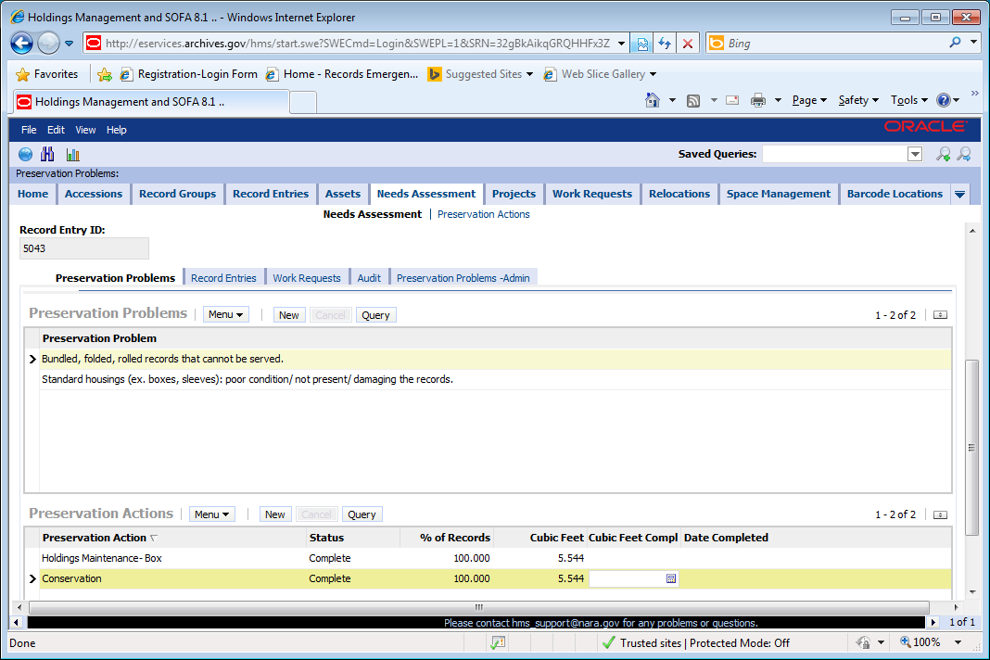

1. **Select all needed and completed preservation actions**
   1. Scroll down below Preservation Problems.
   2. Click New next to Preservation Actions.
   3. Click the arrow that appears on the blank line.
   4. Pick an action from the drop down list.
   5. Enter % of Records needing the action.
   6. Click New again to add a blank line to add other preservation actions. Repeat as necessary.

Refer to the suggested preservation action underneath each preservation problem for guidance on selecting the preservation actions. Contact your conservation liaison if you have any questions about the appropriate actions.

**Holdings maintenance- Box**

* Replace or add new boxes.

**Holdings maintenance- Folder**

* Replace or add new folders.

**Holdings maintenance- Sleeve, Replace fasteners, Unfold**

* Replace or add new sleeves.
* Remove paper clips, staples and other fasteners if they prevent access to information and replace with new fasteners to maintain order.
* Unfold document so they can be stored flat and accessed more easily. Unfolding is only done on records that are not brittle and will not be damaged by unfolding.

**Holdings maintenance-Humidify, Flatten, Surface Clean**

* Humidification and flattening or surface cleaning completed by archival unit.

**Holdings maintenance –Other**

* + Any holdings maintenance action not specified above. Includes tying volumes with cotton twill tape or covering fingerholes with boards.

**Custom housing**

* + Replace or add new custom-sized boxes, folder and sleeves.

**Major mold remediation**

* Treatment of active mold and/or removal of inactive mold that covers the majority of the surface of the holdings or has weakened the structure of the holdings.

**Minor mold remediation**

* Removal of inactive mold that covers a portion of the surface of the holdings and has not significantly weakened the structure of the holdings. This work may be performed by the archival unit.

**Treatment for pests**

* + Treatment of active pest infestation and removal of dead pests or frass.

**Conservation review**

* + Review by preservation/conservation staff to identify conservation and preservation needs. This should only be selected when there appear to be complex problems that require additional review to determine the required preservation action.

**Conservation**

* + Treatment by conservation staff such as mending, surface cleaning, dry cleaning or other intervention to preserve original records.

**Archival prep for reformatting/duplication**

* + Any action taken by archival staff to prepare records for preservation copying or duplication. This includes inventorying, tabbing, providing descriptions to be used to identify individual records or counting number of pages to identify number of needed scans.

**Textual/Cartographic/Still Images Preservation Copy**

* Reformatting or duplication of Textual, Cartographic or Still Image records that preserves the original records by limiting their use.
  + The entire record entry is copied and the copies are provided to researchers, **or**
  + The original record is withdrawn from its container and the copy is served to researchers.
* Creation of a copy to preservation standards that can be preserved in place of the original, when this appears to be necessary.

**Microfilm or microfiche repair**

* Repair of splices and other damage to microfilm/microfiche.

**Aerial film repair**

* Repair of splices and other damage to aerial film.

**Preservation photocopying**

* Photocopying of original records to preservation standards .
* The photocopy is served in place of the original, **or**
* The photocopy is maintained as the preservation copy, because of the instability of the original image.

**Mark high value records**

* NARA-approved stamping method to indicate that a high value record belongs to the National Archives; used as a theft deterrent.

**Improve storage cool\***

* Move records requiring cool storage into cool storage. Archival staff should mark this completed if records are already in cool storage.

**Improve storage cold/below freezing storage\***

* Move records requiring cold/below freezing storage to cold/below freezing storage. Archival Staff should mark this completed if records are already in cool storage.

**Vault or locked storage for high value records\***

* Move high value records into vault or locked storage. Archival staff should mark this completed if records are already in a vault or locked storage.

**Electronic Records Preservation**

* Preserve electronic records with appropriate methods.

**Audio preservation copy**

* Making an audio preservation copy to replace the original or as the copy to be preserved.

**Audio repair**

* Repair splices and other interventions to preserve the original audio records or make a copy of them.

.

**Video preservation copy**

* Making a video preservation copy to replace the original or as the copy to be preserved.

**Video repair**

* Repair splices, bake tapes and other interventions to preserve the original video records or make a copy of them.

**Motion picture preservation copy**

* Making a Motion Picture preservation copy to replace the original or as the copy to be preserved.

**Motion picture repair**

* Repair splices; replace leaders and other interventions to preserve the original motion picture film or to make a copy of them.

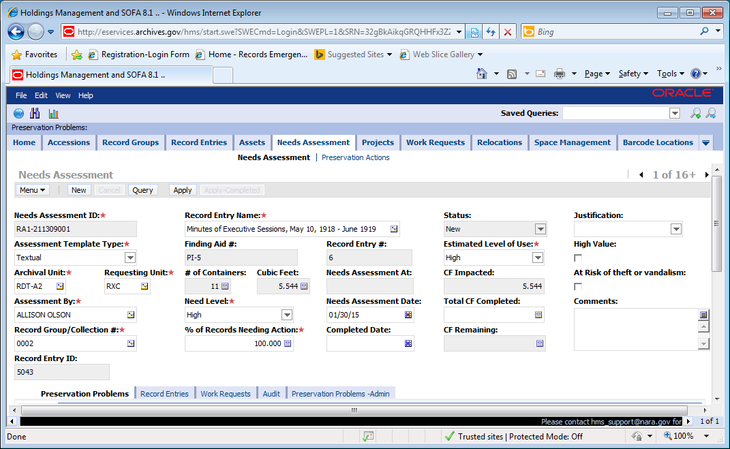

1. **Click the Apply button.** This changes the status of the needs assessment to Active. When a needs assessment is New, anyone can delete it.
2. **Marking Preservation Actions Completed**

Before updating the completed actions on the needs assessment, update the container type and number of containers on the Record Entry Tab if these numbers changed during the preservation action.

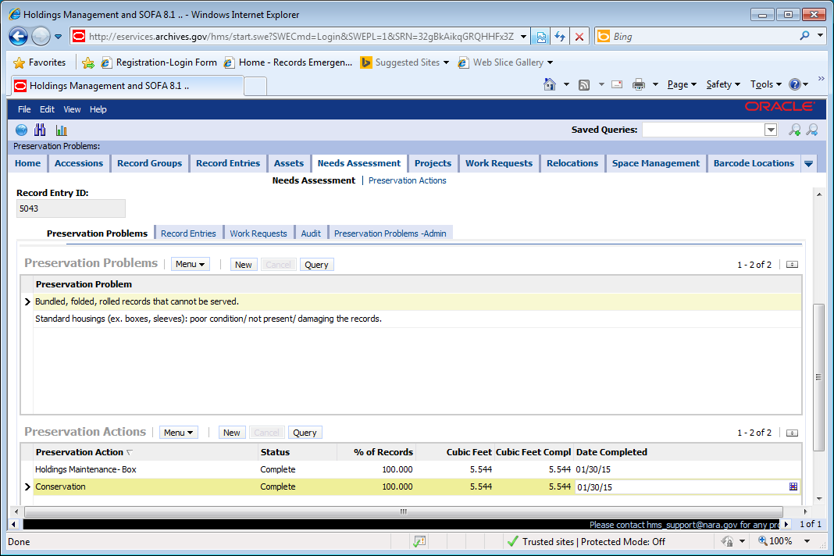

1. Enter the Cubic Feet Completed and the Date Completed on the specific preservation action line, such as Holdings Maintenance-box or Custom Housing.

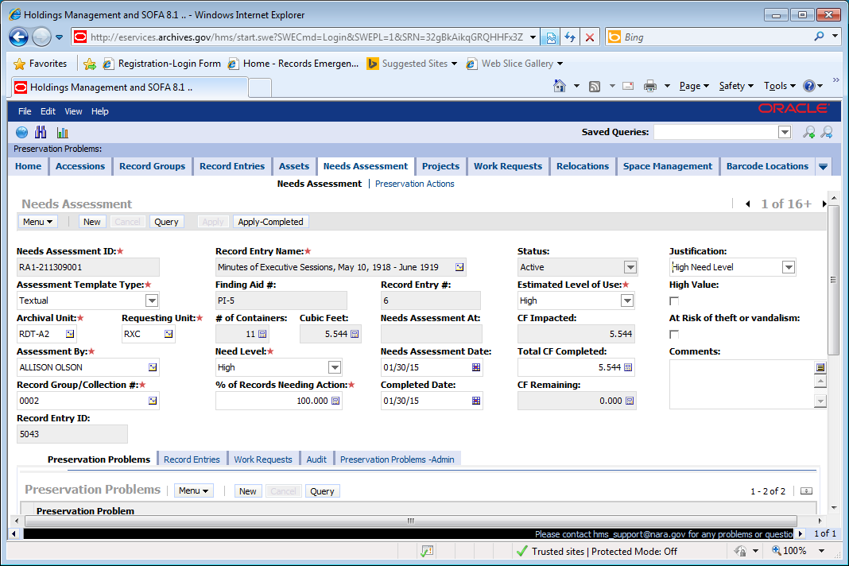

1. **When the All Preservation Actions are completed**
2. Enter the Completed Date, Total CF Completed, and Justification at the header level when all preservation actions are completed. This removes the records from the preservation backlog.



1. Click Apply-Completed. This changes the status to Completed and locks it from being edited.

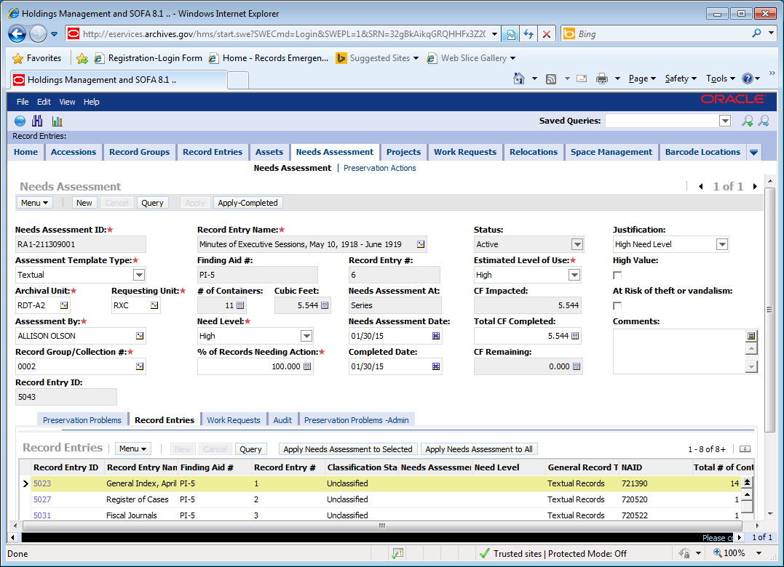

1. **Applying the needs assessment to multiple record entries in one record group.**
2. Click on lower level Record Entries tab.
3. Highlight the record entries that the needs assessment should be applied to.
4. Click Apply Needs Assessment to Selected. This applies the needs assessment to the highlighted record entries only.

**Or**



1. **If the needs assessment is for all record entries in the record group, click Apply Needs Assessment to All.**

**Printing Needs Assessment Report**

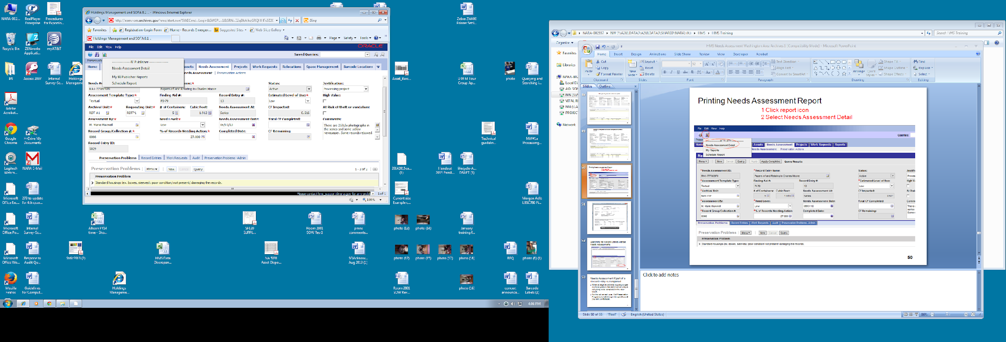

1. Click the Report Icon
2. Select Needs Assessment Detail Report

**Searching for Record Entries with No Needs Assessments**

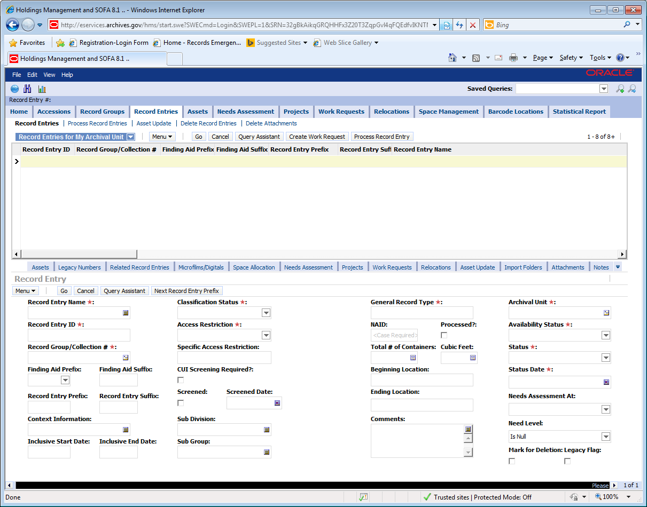

1. Go to the Record Entry tab.
2. Click Query button.
3. In data element Need Level, enter is null.
4. Enter any other criteria you want such as record group to limit the search.
5. Click Go.

**Reporting Part of a Record Entry Completed**

It is done when a portion of a record entry has all its needed preservation actions completed and another part still needs action. This is general done for large record entries that take multiple years to complete or if a record entry is partially completed and the rest is not going to be done in the near future.

1. Create or update the Active needs assessment for the record entry.
2. Enter the percentage of the record entry that was completed in the % Needing Action. Enter the Date Completed and the CF Completed at the Header level.
3. Add the preservation problems that it had.
4. Add the specific preservation actions that were completed. In the % Needing Action, enter the % that was completed. Then enter the CF Completed and the Date Completed for each action.
5. Go to the top of the needs assessment and click Apply-Completed. (If needs assessment is still Status New, then click Apply first and then Apply-Completed.)
6. Either from the Record Entry Tab or by click New on the Needs Assessment tab and entering the RG and record entry, create a needs assessment for the record entry with the Status New.
7. Enter the percentage of the record entry that remains to be done in the % of Records Needing Action.
8. Enter the Preservation Problems.
9. Enter the needed Preservation Actions and the % that needs to be done.
10. Click Apply to make the Status Active.

**Searching for Preservation Problems**

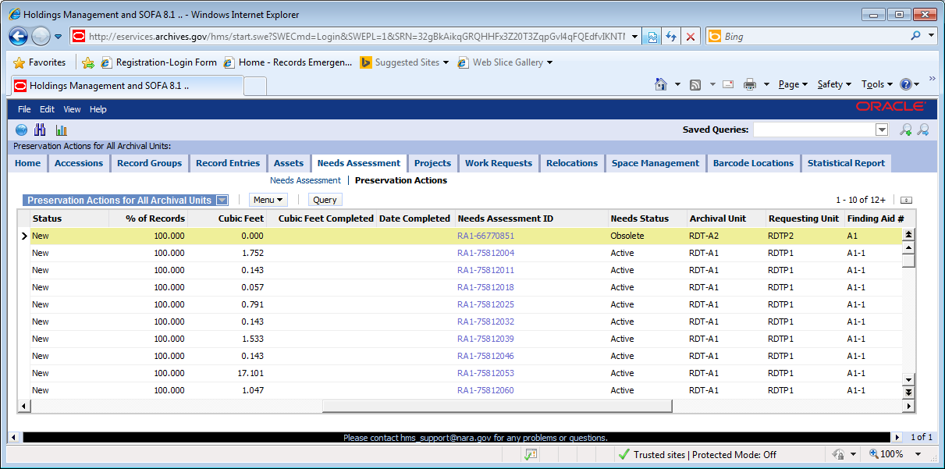 

1. Click on the Preservation Actions view. This is the list of all preservation actions for your unit.
2. Query as needed.

**Searching for a Needs Assessment**

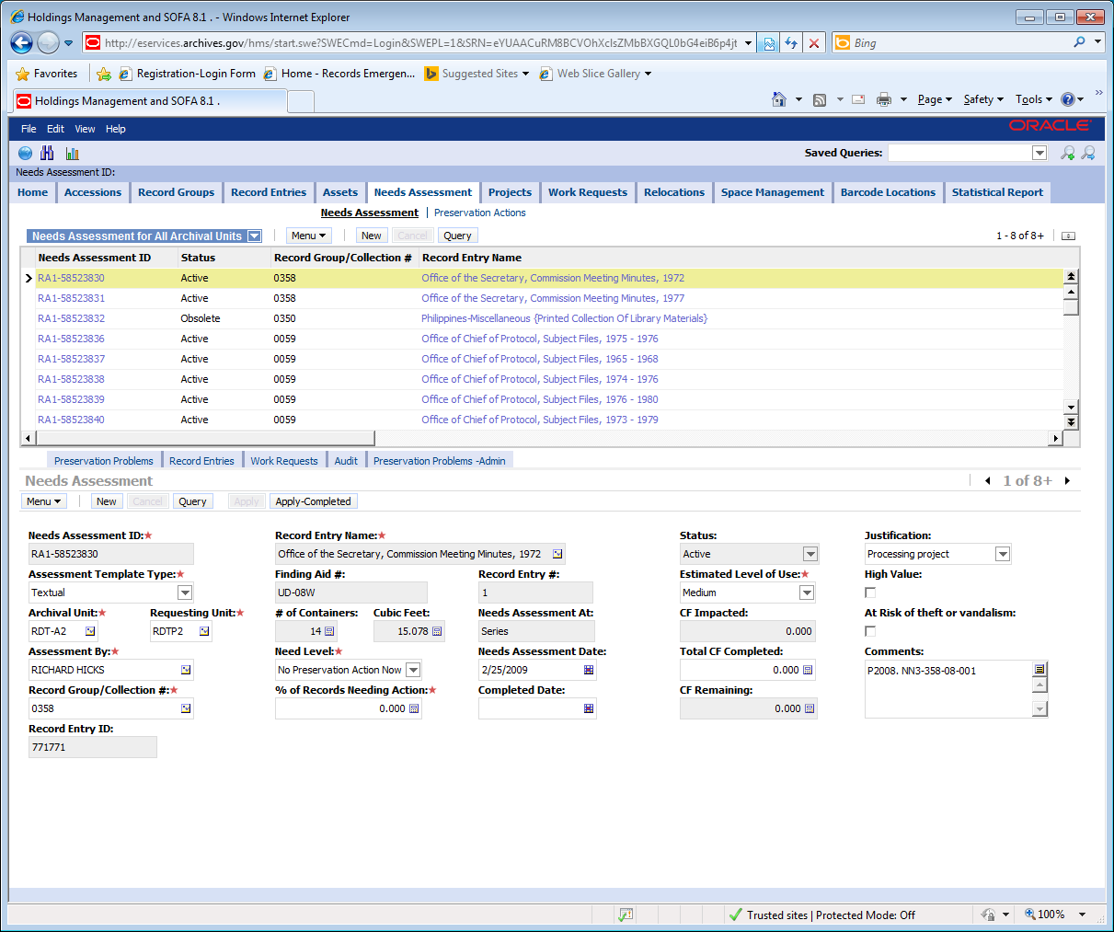

1. Go to the Needs Assessment tab.
2. Click Query
3. Enter the Needs Assessment ID or Record Group or other identifying information.
4. Click Go.

Hms-procedures-for-needs-assessment

**HMS**

**Needs Assessment Standard Operating Procedures**

_________________________________

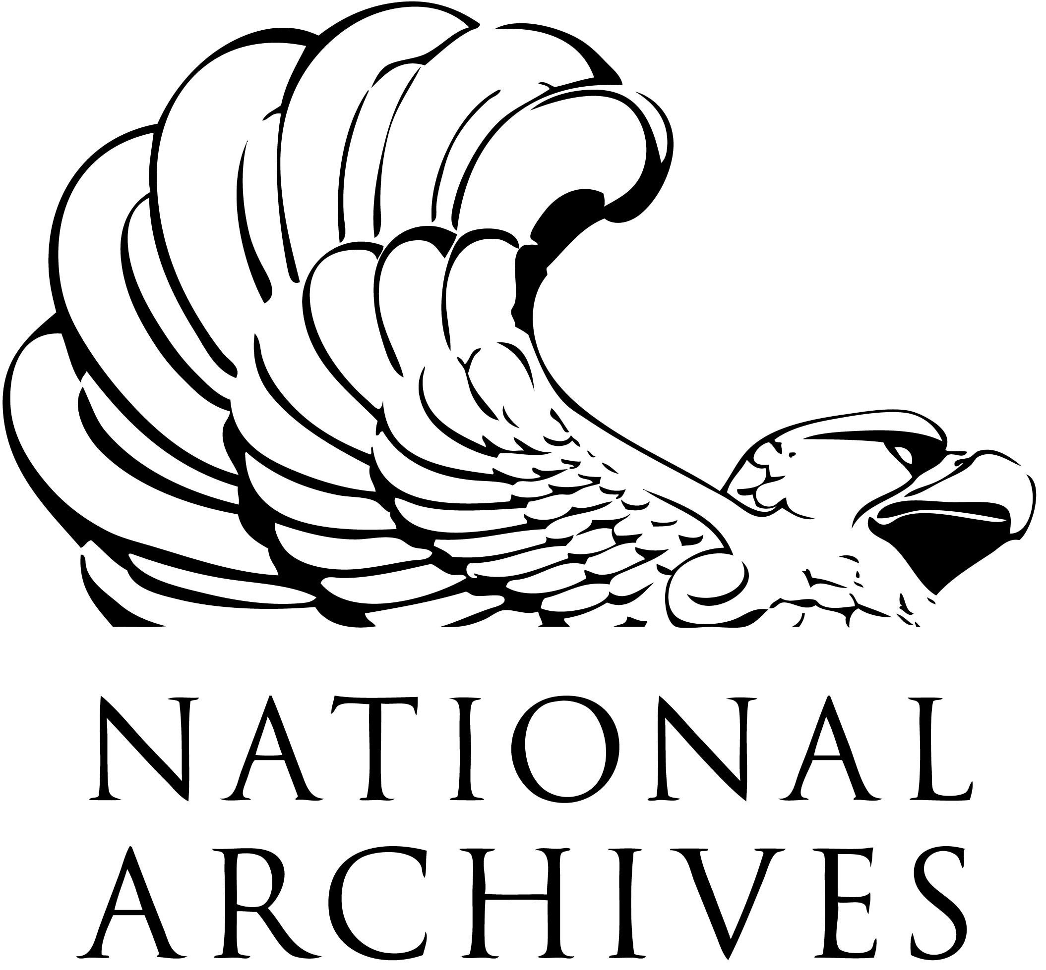

_________________________________

|  |  |
| --- | --- |
|  | Prepared by: |
|  | HMS Operating Procedures Working Group |

**National Archives and Records Administration**

**September 1, 2013**

*Version-1****.****1*

**Document Change Log**

|  |  |  |  |  |
| --- | --- | --- | --- | --- |
| ***HMS Processing Standard Operating Procedures Change Log*** | | | | |
| **Version** | **Date of Change** | **Sections Impacted** | **Summary of Changes** | **Changed by** |
|  |  |  | Change Risk Assessment to Needs Assessment. Change Risk Level to Need Level. | Allison Olson |

**HMS Standard Operating Procedures for Needs Assessment**

Archival staff members will enter needs assessments in HMS:

* During accessioning for Washington area and when an accession becomes a record entry for the regions.
* During processing of a record entry if a needs assessment doesn’t already exist.

**Exception:** Archival staff members are NOT required to enter the needs assessments when they are writing ARC entries only based on documentation without examining the records. This occurs during the processing initiative.

* When a preservation action is completed and no needs assessment exists.

A needs assessment can be created at anytime, such as when a needed preservation actions is discovered.

Needs assessments are filled out for one record entry or one accession in HMS. They can be applied to multiple record entries.

**During accessioning for the Washington Area only:**

1. Examine the records and their housings.
2. Enter the use level.
3. Enter the need level.
4. Enter the preservation problems.

**As soon as an accession becomes a record entry for the regions and during processing for everyone, the archival staff:**

1. Examine the records and their housings.
2. Create a needs assessment if no needs assessment exists or review existing needs assessments. Needs assessments have different status. Review new or active needs assessments to determine if they document all the needed actions. A completed needs assessment documents that all the needed preservation actions were completed for a record entry or for a part of that record entry. If a needs assessment has no needed or completed preservation action, the status is active, not completed. An obsolete needs assessment is a formerly valid needs assessment.
3. Select the assessment template type, estimated level of use, need level, and % requiring preservation action.
4. Select high value and/or at risk of theft or vandalism, if applicable.
5. Select all the applicable preservation problems.
6. Enter the needed and completed preservation actions and % of records for the specific action, which is the percent that needs or needed the specific action.
7. Click apply to make needs assessment Active. Active needs assessments cannot be deleted; they contain all the needed preservation actions for the record entry.

**When a preservation action is completed, archival staff updates the needs assessment:**

1. Enter the cubic feet completed and the date completed for each completed preservation action.
2. When all preservation actions are completed, enter the completed date, total CF completed, and justification.
3. Click apply-completed to make the needs assessment status completed. completed needs assessments cannot be altered or deleted.

**When a part of the record entry has all the preservation actions completed:**

1. Create a needs assessment with all the completed actions for a part of the record entry.
2. Click apply and then apply-Completed.
3. Create a second needs assessment with all the needed preservation actions for the rest of the record entry.
4. Click apply.

**Selecting the Need Level in HMS**

**For Textual, Still Picture, and Cartographic Records**



