Guide to Searching/Querying in HMS

A ***query*** allows you to complete a search against specific fields of a record (as part of a list on the screen/view you are on). You can use a variety of query operators to build a query. When you create a query, you can save and reuse the criteria.

The ***search*** feature allows you to search for records and view the results without leaving the screen you are currently working on (or losing the current data on your screen). The search feature will enable you to lookup records that cannot be located using a simple query.

**Queries**

A query in HMS helps you locate record entries meeting specific criteria. Any of the fields displayed on the front screen of the Record Entries tab can be searched. Some examples include:

* Record Group/Collection #
* Record Entry Name
* Finding Aid and Entry #
* Beginning or Ending Location
* NAID
* Comments
* Access Restrictions

**Query Operators**

Query operators are characters that assist in narrowing down results or making a search more specific. HMS users are strongly encouraged to use the “wildcard” or * operator when performing most searches. Using the wildcard instructs the system to search for anything that matches your criteria, regardless of its placement in the field.

| **Query Operator** | **Purpose** | **Example** |
| --- | --- | --- |
| * | Wildcard. Placed anywhere in a string, returns records containing the string or containing the string plus any additional characters at the position at which the asterisk appears, including a space. | Car* finds Car, Carson, and Carbon |
| ? | Wildcard. Placed anywhere in the string, returns records containing the characters specified in the string, such that any single character may appear at the location of the ?. | T?pe find type, tape, but not tripe |
| = | Placed before a value, returns records containing a value equal to the query value | = CA placed in the state field returns all records in CA |
| >, <, <> | Any of these, placed before a value, returns containing a value that is greater than (>), less than (<), or not equal to (<>) the query value | > 4/25/01 retrieves all records after April 25, 2001 |
| <= or >= | Placed before a value, returns records containing a value greater than or equal to (>=) or less than or equal to (<=) the query value | >= 500 returns records in which the value in the query field is greater than or equal to 500 |
| LIKE, like, NOT LIKE, not like | Placed before a value, returns records containing the value (LIKE or like) or not containing the value (NOT LIKE or not like) | LIKE Smi* returns all records that start with Smi |
| IS NULL, is null | Placed in the query field, returns records for which the query field is blank |  |
| IS NOT NULL, is not null | Placed in the query field, returns records for which the query field is not blank |  |
| AND, and | Placed between values, returns only records for which all the given conditions are true. | *Army and Navy* will return all records that have both the word army and the word navy in the query field |
| OR, or | Placed between values, returns records for which at least one condition is true. | *Army or Navy* will return all records that have either the word army or the word navy in the query field |
| NOT, not | Placed before a value, returns only records that do not contain the value. | *NOT Army* will return all records that do not have the word Army in the query field |

**Using the Query Assistant**

The query assistant allows you to search up to four different fields at once. You can either search for entries that match ALL or ANY of the designated criteria. The query assistant is also useful for those who want to avoid query operators.

To perform a query using the Query Assistant:

1. In the list or form, click the Wor50C button.
2. Click the Wor510 button. The Query Assistant dialog box appears.

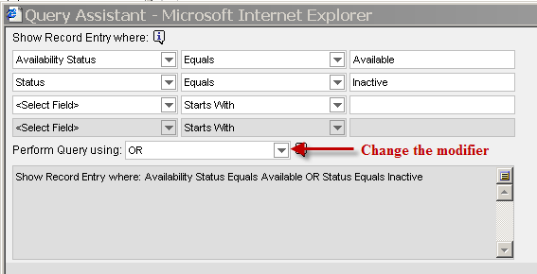

1. In the first column of the first row, select a field to query on from the drop-down list.
2. In the second column of the first row, select an operator for the query (e.g., equals, does not equal).
3. In the third column of the first row, enter the value you want to query for.
4. Fill in other rows as needed.
5. From the Perform Query Using drop-down list, select AND or OR to specify the type of operator you want to use between your criteria. AND will only show results that meet all the criteria. OR will show results that meet any of the criteria.
6. Click the Wor3A4 button. The query executes, the Query Assistant closes, and matching records appear.

Please note, when you use the Query Assistant, you do not need to enter operators to find the information you are looking for. You can also save your query by clicking Save Query before you execute the query.

**Save Query Criteria**

If you often query for similar criteria, or want to refer back to the results from a particular query, you can save the query.

1. 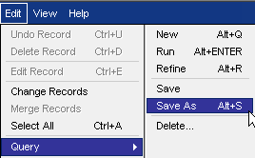Create and run the query.
2. From the application-level menu, select Edit.
3. Select the Query option.
4. Select the Save As option.
5. In the Save As dialog box, type a name in the Query Name field.
6. Click the Wor97 button. The saved query now appears in the Queries drop-down list at the top right corner of the Record Entries tab.

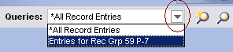

Searches

In general, Search helps you locate record entries using criteria that are not part of its details, but associated to it. You would use search to find a record entry by:

* Legacy Numbers (Accession #, Lot File #, FRC Transfer #, etc.)
* Microfilm publication #
* Record Group/Collection # and Entry #
* Record Entry Name
* Finding Aid and Entry #
* Record Group/Collection # and Title

****The Search function is the only way you can search for Legacy Numbers and Microfilm Publications. When searching these fields, it is highly recommended that you use the wildcard operator. The system does not require legacy numbers to fit a particular format, so try to search for a number in different ways if you don’t get an immediate hit. This is especially true for older legacy numbers.

**Search Operators**

You can use two wildcard operators to refine your searches.

| **Search Operator** | **Purpose** | **Example** |
| --- | --- | --- |
| * | Placed anywhere in a string, returns records containing the string or containing the string plus any additional characters at the position at which the asterisk appears, including a space. | Car* finds Car, Carson, and Carbon |
| ? | Placed anywhere in the string, returns records containing the characters specified in the string, such that any single character may appear at the location of the ?. | T?pe find type, tape, but not tripe |

**Exporting Data from HMS**

To export query results in HMS to MS Excel:

1. Run the query for the required information.
2. Click the Wor3B8 button and select Export. The Export Dialog Box will display.

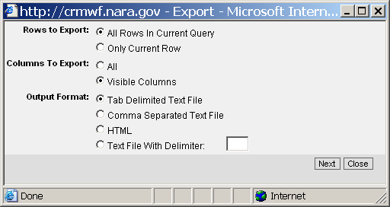

1. Click the Wor3B9 button to open the MS Excel file.

NOTE: You may be prompted to download the file. If so, download it and open it.

**Helpful Tips**

* You can query in either applet of the Record Entry front screen. Both will yield the same results.
* Use the Record Count to determine how many results you got from your query.
  + Click the Menu button.
  + From the drop down menu, choose Record Count.
* The only way you can change a field in the RE screen is by first hitting the Edit button. The ability to change information while querying has been eliminated.
* Customize the display in the upper applet in two ways
  + Click and drag the columns around to suit your needs. For instance, you can move the Total # of Containers column so it is beside the RE Name column. Your customization will remain each time you log in.
  + You can also choose the columns you want displayed.
    - Click the Menu button.
    - From the drop down menu, choose Columns Displayed
      * Move the columns you want displayed into the Selected Columns table.
* Refine your query using the Refine Query option.
  + Click the Menu button. Choose Refine Query.
  + Add or delete information from the desired fields.
* Clicking on the Record Entries tab will refresh the system and remove your results. If you navigate away from the front screen, such as going to the Assets tab, you can return to your results by clicking the Record Entries link below the tab.