Needs Assessment with No Needed or Completed Preservation Actions
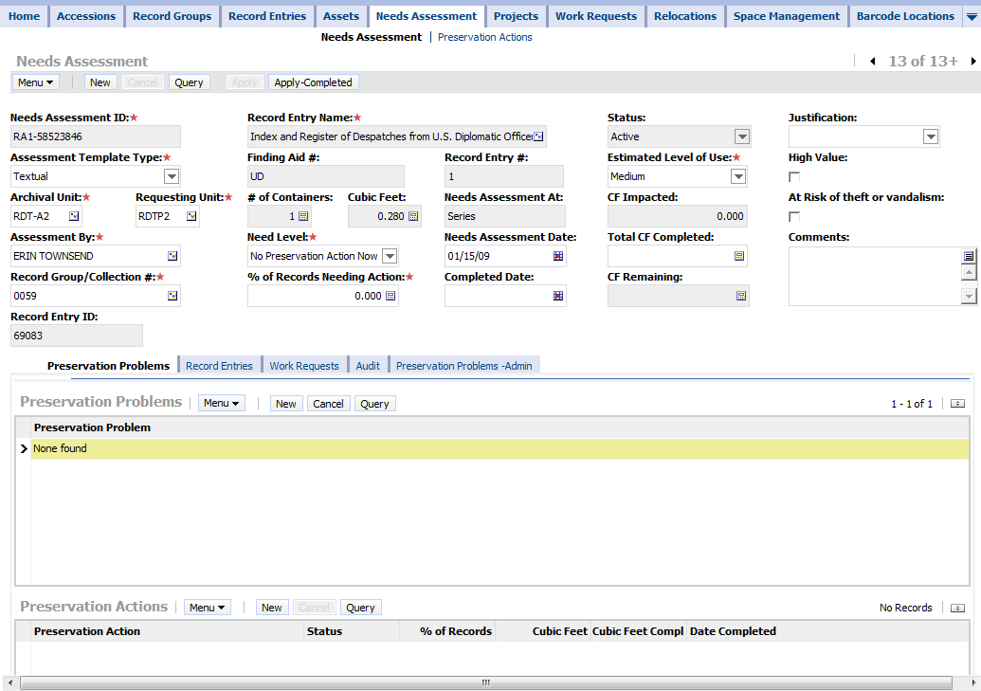
Needs Assessment with All Completed Preservation Actions

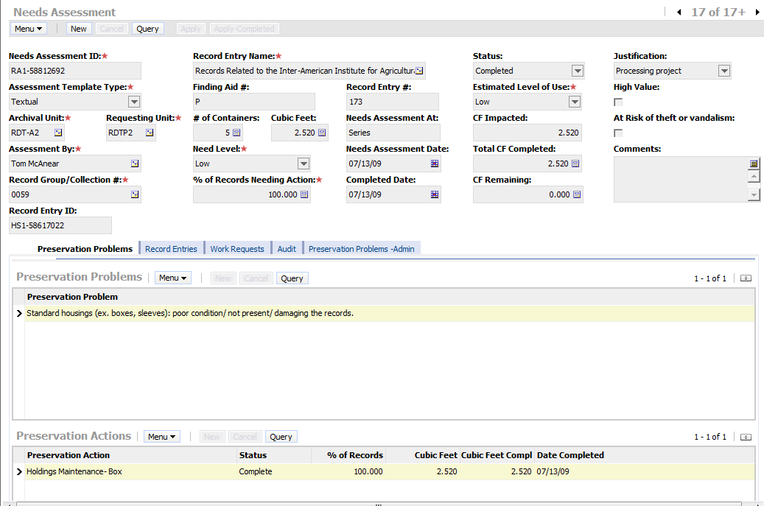
Needs Assessment with Some Still Needed and Some Completed Preservation Actions
