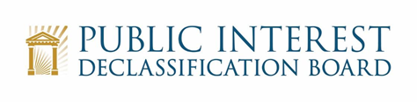

PIDB Virtual Public Meeting
August 19, 2022
10:00 – 11:05 a.m.

Agenda

- Welcome 10:00 – 10:05
Mark Bradley, Executive Secretary

- Opening Comments 10:05 – 10:15
- Ezra Cohen, Chair

- Perspectives on U.S. Nuclear Weapons Testing in the Marshall Islands
- Walter Pincus 10:15 – 10:40
  - Author of Blown to Hell: America’s Deadly Betrayal of the Marshall Islands (November 2021)
  - Researching Nuclear Weapons Testing in the Marshall Islands

- Previewing the PIDB’s Declassification Feasibility Study 10:40 – 11:00
- Ezra Cohen
  - Introductory Comments

- PIDB Members

- Concluding Comments 11:00 – 11:05
- Ezra Cohen and Alissa Starzak

