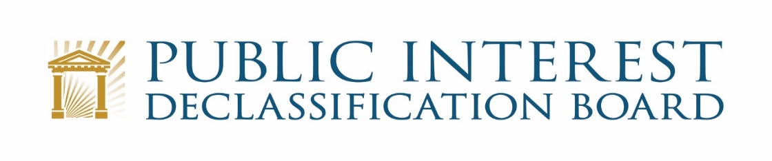
GOOGLE MEET VIDEO TELECONFERENCE
February 24, 2022
1:00 p.m. – 3:00 p.m.

- Welcome 1:00 – 1:05
Ezra Cohen, Chair

- ISOO and NARA Update 1:05 – 1:10
Mark Bradley, Executive Secretary

- PIDB Appointments

- Updates on other PIDB Activities 1:10 – 1:30
Ezra Cohen and PIDB Staff

- Sen. Murphy Record Review Request (John Powers and Beth Fidler)
- Congressional Engagements

- Marshall Islands Feasibility Study Briefing 1:30 – 1:45
Sharmila Bhatia and John Powers, PIDB Staff

- Update on Background Research and Information Gathering
- Proposed Schedule and Next Steps

- Sunshine Week Virtual Public Meeting (week of March 14-18) 1:45 – 1:55
The Members

- Discussion of Possible Speaker and Theme

- Possible In-Person Meeting 1:55 – 2:25
Ezra Cohen and PIDB Staff

- Discussion of Possible Dates
- Discussion of Possible Topics and Speakers

- Executive Order 13526 Briefing 2:25 – 2:55
John Powers

- NSC Request for Recommendations on E.O. 13526

- Recap and Conclusion 2:55 – 3:00
Ezra Cohen

