NATIONAL ARCHIVES AND RECORDS ADMINISTRATION

eady

to
Essential Evidence
R
Access

2005 Performance and Accountability Report

Table of Contents

Part 1 Management’s Discussion and Analysis
A Message from the Archivist of the United States 1
Introduction 4
How to Use This Report 4
About NARA 4
Our Vision 5
Our Mission 5
Our Strategic Goals 5
Our Organizational Structure 6
NARA’s Challenges and Management’s Actions to
Address These Challenges 8
Performance Highlights 14
Spotlight on Education 14
Spotlight on Partnerships 19
Performance Overview 25
Financial Highlights 33
Sources of Funds 33
Uses of Funds by Function 34
Audit Results 35
Financial Statement Highlights 35
Debt Management 38
Erroneous Payments Management 38
Systems, Controls, and Legal Compliance 39
Financial Managers’ Financial Integrity Act 39
Federal Information Security Management Act 40
Federal Financial Management Improvement Act 40
Prompt Payment Act 41
Inspector General Act 41
Facilities 42
Copies of This Report 44
Other Web Pages of Interest 44

Part 2 Performance Section
Measuring and Reporting Our Performance 45
FY 2005 Performance by Strategic Goal 46
Strategic Goal 1: Records Management 46
Strategic Goal 2: Electronic Records 53
Strategic Goal 3: Access 62
Strategic Goal 4: Space and Preservation 75
Strategic Goal 5: Infrastructure 80

FY 2005 Program Evaluations 87
Strategic Goal 1: Records Management 87
Strategic Goal 2: Electronic Records 87
Strategic Goal 3: Access 87
Strategic Goal 4: Space and Preservation 88
Strategic Goal 5: Infrastructure 89
Multi-Goal Evaluations 90
Status of NARA Records Management Initiatives 92
Federal Records Management Evaluations 96
Office of the Secretary of Defense 96
Department of Treasury, Office of the CIO 96
Internal Revenue Service 97
Department of Agriculture Forest Service, Department of the
Interior, Bureau of Indian Affairs / Bureau of Land Management /
U.S. Fish and Wildlife Service / National Park Service 97
Federal Bureau of Investigation 97
Performance Assessment Rating Tool (PART) Summary 98
Records Services Program 98
Electronic Records Services Program 99
Definitions 100

Part 3 Financial Section
A Message from the Chief Financial Officer 103
Auditor’s Reports 105
Inspector General’s Summary 105
Independent Auditor’s Report 106
Management Response to Auditor’s Reports 126
Financial Statements and Additional Information 129
Limitations of the Financial Statements 129
Principal Statements 130
Required Supplementary Stewardship Information 155
Required Supplementary Information 157

Appendixes
A Inspector General’s Assessment of Management Challenges
Facing NARA 165
B Federal Managers’ Financial Integrity Act Report 171
C Progress on 2004 Audit Recommendations 180
Part 1
MANAGEMENT’S DISCUSSION AND ANALYSIS
A Message from the Archivist of the United States
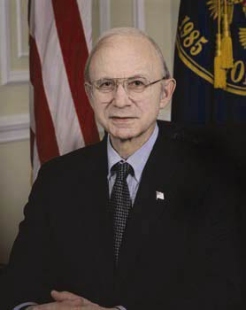
The National Archives and Records Administration (NARA) is our nation’s record keeper. Our daily work is that of preserving and providing access to the records of our Government, whether those records are the Declaration of Independence, service records of military veterans, or documentation on homeland security issues that will make our country safer.
Throughout the history of our democracy, these records have been first-hand witnesses to the events that have shaped our country. They have documented the rights and entitlements of our citizens, and they have held our Government officials accountable to the people.
NARA’s mission is vital to continuity of Government, homeland security, public trust, and national morale.
- We provide legal authority to many of the actions of the President and executive agencies through publication in the Federal Register, regardless of weather, terrorist attacks, or other emergency that may close other Federal operations.
- We are leading the Federal Government in developing the new technology that will enable the Government to share electronic information across space and time, reducing the risk that critical intelligence will be lost in obsolete hardware and software.
- We act as First Preservers in times of emergency, assisting Federal, state, and local governments in saving their critical records, especially those that document the rights and entitlements of citizens.
- We serve a broad base of customers through a series of education, outreach, and partnership initiatives, contributing to civic literacy in America.
- We protect the plans, drawings, maps, and photographs of Federal facilities worldwide.
- We preserve and provide access to the military service records of 56 million veterans of our armed forces, ensuring that they and their families receive the benefits they have earned by defending our country.
- We protect and display the founding documents of our country—the Declaration of Independence, the Constitution, and the Bill of Rights—which more than a million people a year come to see because these Charters of Freedom are the heart of the democracy we cherish.
Never before has NARA played a more essential role in our Government, and we recognize that the stakes are higher for our success.
That is why I am pleased to present the National Archives and Records Administration’s Performance and Accountability Report for FY 2005. Thanks to support from our stakeholders and partners and the efforts of our exceptional staff, we made significant progress on each of the goals of our Strategic Plan and our two preexisting material weaknesses. Our Strategic Plan focuses us on five goals—improving records management, meeting electronic records challenges, expanding opportunities for access, meeting storage and preservation needs of growing quantities of records, and strategically managing our resources. Our progress in these areas is detailed throughout this report, but I must highlight one special achievement here.
On September 8, 2005, NARA announced the award of the development contract for the revolutionary system that will preserve and provide access to electronic records across space and time, the Electronic Records Archives. The goal of this system is to make Federal Government electronic records available virtually anytime, anywhere, to anyone with Internet access.
Let me share an example of how critical this system will be. The personnel files for Americans serving in our armed forces in Iraq, Afghanistan, and around the world are in digital formats. Our service members depend on these records not only for their careers in the military, but subsequently to obtain veteran’s benefits, jobs, and insurance. But today no one can guarantee to Americans serving in our armed forces that these electronic records can be preserved for as long as needed. The Electronic Records Archives will enable the U.S. Government to honor its commitment to veterans; it will enable us to maintain their digital military personnel files intact and authentic.
I encourage you to read the rest of this report to discover other strides we have made in helping Federal agencies address records management problems, making it easier for our customers to find and order copies of records, preserving at-risk records for future generations, streamlining the Government’s rulemaking process, and much more.
We also have made strides in ensuring that our resources are well managed with the proper oversight. It is my informed judgment that there is reasonable assurance that NARA's management controls are achieving their intended objectives and that the program and financial data contained in this report are valid and reliable. This assessment is based on management control evaluations and other written evaluations conducted in NARA’s offices and staff organizations and senior management's knowledge gained from the daily operations of NARA programs and systems. I also have relied upon the advice of NARA’s Office of the Inspector General concerning this statement of assurance.
Pursuant to Section 4 of the Integrity Act, the financial subsystems of NARA generally conform to the objectives detailed in OMB Circular A-127, revised. Although three systems (Order Fulfillment Accounting System; Trust Fund–Gift Fund Financial Review, Analysis, and Reporting System; and Records Center Revolving Fund financial management systems) are not in complete conformance because they fail to meet the financial management system requirements, the nonconformances are not deemed material.
NARA, through its management control evaluation process, identified two material weaknesses in previous fiscal years—computer security in FY 2000 and collections security in FY 2001. We were able to eliminate the material weakness for computer security this year and make substantial progress on the collections security weakness, although work continues in that area. A new material weakness in preservation of records points to our recognition that we must continuously improve the processes we have in place to identify and preserve our at-risk records while at the same time look for new and creative solutions to address the chronic problem. The actions we will take to address this problem are outlined later in this report.
There is much more yet to be done, but I believe that our stakeholders and the public can be proud of their National Archives and Records Administration, which every day is protecting, preserving, and making available the essential documentation of our Government.

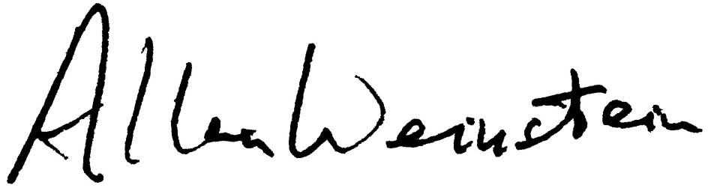

Allen Weinstein
Archivist of the United States

November 15, 2005
Introduction
This Performance and Accountability Report represents the culmination of the National Archives and Records Administration’s (NARA) program and financial management processes, which began with strategic and program planning, continued through the formulation and justification of NARA’s budget to the President and Congress and through budget execution, and ended with this report on our program performance and use of the resources entrusted to us. This report was prepared pursuant to the requirements of the Chief Financial Officers Act, as amended by the Reports Consolidation Act of 2000, and covers activities from October 1, 2004, through September 30, 2005.
How to Use This Report
This report describes NARA’s performance measures, results, and accountability processes for FY 2005. In assessing our progress, we are comparing actual results against targets and goals set in our annual performance plan, which we developed to help us carry out our Strategic Plan. Our complete set of strategic planning and performance reports is available on our web site at www.archives.gov/about/plans-reports/strategic-plan/.
This report has four major parts:
- Management’s Discussion and Analysis
Look here for our agency-wide performance and use of resources in FY 2005. You also will find information on the strategies we use to achieve our goals and the management challenges and external factors that affected our performance.
- Performance Section
Look here for details on our performance by strategic goal and long-range performance target in FY 2005. This section covers our targets, how and why we met or did not meet them, and explanations of how we assess our performance and ensure its reliability.
- Financial Section
Look here for details on our finances in FY 2005, our consolidated financial statements and notes, required supplementary information, and the reports from our external auditor and our Inspector General. Also included is information on our internal controls and an explanation of what kind of information each of our financial statements conveys.
- Appendixes
Look here for our Inspector General’s assessment of our agency’s management challenges, our FMFIA report, and an update on last year’s audit recommendations made by Clifton Gunderson, LLP.

About NARA
The National Archives and Records Administration is our national record keeper. An independent agency created by statute in 1934, NARA safeguards the records of all three branches of the Federal Government. Our job is to ensure ready access to essential evidence, and in doing so we serve a broad spectrum of American society. Genealogists and family historians; veterans and their authorized representatives; academics, scholars, historians, business and occupational researchers; publication and broadcast journalists; Congress, the Courts, the White House, and other public officials; Federal Government agencies and the individuals they serve; state and local government personnel; professional organizations and their members; students and teachers; and the general public—all seek answers from the records we preserve.
Our Vision
The National Archives is a public trust on which our democracy depends. It enables people to inspect for themselves the record of what Government has done. It enables officials and agencies to review their actions and help citizens holds them accountable. It ensures continuing access to essential evidence that documents

- the rights of American citizens,
Charlie Kee first visited France in World War II by bailing out of a B-26 bomber over Normandy after it was hit by German fire, only to be captured by the Germans. In 2005, a group in Normandy
invited him back to bestow honors on him for his service in the war. For this trip, he needed proof of his U.S. citizenship to get a passport.
So Kee, a resident of Granbury, TX, came to our Southwest regional archives in Fort Worth. Archivist Nigel Parker found a 1930 U.S. census page showing Kee as an eight-year-old. Kee stopped by to pick up the document. “As I watched him walk out,” Parker said, “I was reminded of why I like my job.” (Photo by
Nigel Parker)

- the actions of Federal officials, and
- the national experience.
To be effective, we at NARA must determine what evidence is essential for such documentation, ensure that Government creates such evidence, and make it easy for users to access that evidence regardless of where it is, or where they are, for as long as needed. We also must find technologies, techniques, and partners worldwide that can help improve service and hold down costs, and we must help staff members continuously expand their capability to make the changes necessary to realize the vision.
Our Mission
NARA ensures, for the Citizen and the Public Servant, for the President and the Congress and the Courts, ready access to essential evidence.
Our Strategic Goals
NARA’s strategic goals are set forth in our Strategic Plan, which we revised in 2003. This revision acknowledged recent achievements, especially in the e-Government arena; assessed new conditions facing us; and committed us to measure our value to the taxpayer by setting aggressive outcome-oriented performance targets.
Our five strategic goals are:
- Essential evidence is created, identified, appropriately scheduled, and managed for as long as needed.
- Electronic records are controlled, preserved, and made accessible for as long as needed.
- Essential evidence is easy to access regardless of where it is or where users are for as long as needed.
- All records are preserved in an appropriate environment for use as long as needed.
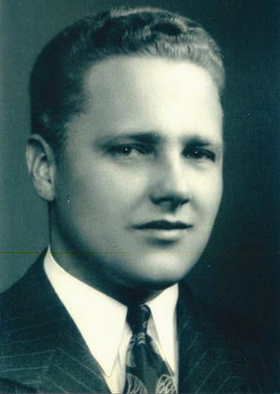
- NARA strategically manages and aligns staff, technology, and processes to achieve our mission.
The Gemeentemuseum in the Netherlands last year sent NARA’s Northeast regional archives in Waltham a World War II dog tag of a deceased American solider, Carl H. Johnson of Spencer, MA, that had recently been found by a young girl. The museum wanted to reunite the dog tag with Johnson’s descendants; they knew only that his sister was buried in Worcester, MA. Archives technician George Sermuksnis searched obituaries from the area and discovered that the soldier’s niece, Holly Moran, lived in Sturbridge, MA. The dog tag was sent to her. The Gemeentemuseum asked only for something to give the 10-year-old girl who had found the dog tag. Sermuksnis sent two pictorial books on Boston and New England. (Photo courtesy of Holly Moran)

Our Organizational Structure
We carry out our mission through a national network of archives and records services facilities stretching from Washington, DC, to the West Coast, and from Atlanta to Anchorage, including Presidential libraries documenting administrations back to Herbert Hoover. Additionally, we publish the Federal Register, administer the Information Security Oversight Office (ISOO), and make grants for historical documentation through the National Historical Publications and Records Commission (NHPRC). We preserve and make available, in response to hundreds of thousands of requests, the records on which the entitlements of citizens, the credibility of Government, and the accuracy of history depend. More and more people are using our services and gaining access to our records through the Internet, whether by requesting copies of records through our Inquire form at Archives.gov, commenting on regulations at the Government-wide site Regulations.gov, searching online databases of records and information, or engaging in a host of other activities through Archives.gov. We continue to encourage this trend, by adding online services and contributing to several of the President’s e-Government initiatives, so that citizens everywhere have access to our vast holdings. The organizational chart in figure 1 provides an overview of NARA’s structure.

Archivist of the
United States (N)

Allen Weinstein

Deputy Archivist of the United States /
Chief of Staff (ND)

Lewis J. Bellardo

Information Security Oversight Office (ISOO)

Director
J. William Leonard
National Historical Publications and Records Commission (NHPRC)

Executive Director
Max J. Evans

Office of the Inspector General (OIG)

Inspector General
I. Paul Brachfeld
Policy and Planning Staff (NPOL)

Director
Susan M. Ashtianie
Congressional Affairs and Communications Staff (NCON)

Director
John A. Constance
EEO and Diversity Programs (NEEO)

Director
Robert D. Jew
General Counsel (NGC)

General Counsel
Gary M. Stern
Office of Administration (NA)

Assistant Archivist
Adrienne C. Thomas
Office of the Federal Register (NF)

Director
Raymond A. Mosley
Office of Information Services (NH)

Assistant Archivist
L. Reynolds Cahoon
Office of Records Services—Washington, DC (NW)

Assistant Archivist
Michael J. Kurtz
Office of Regional Records Services (NR)

Assistant Archivist
Thomas E. Mills
Office of Presidential Libraries (NL)

Assistant Archivist
Sharon K. Fawcett
Figure 1. NARA’s Organizational Structure

NARA’s Challenges and Management’s Actions to
Address These Challenges
We at the National Archives and Records Administration (NARA) take our job of serving the public seriously. And never before have we played such an indispensable role in our Government. We are doing this work in the face of multiple challenges that affect the entire Government and beyond:
- The post–September 11 environment has forever changed our Government. We must deal with new and evolving concerns about security, continuity of operations, and emergency preparedness.
- The dramatic emergence of an electronic Government has brought to the fore new records management issues that have implications far beyond our Government. Inspired by the challenges of electronic records, NARA is transforming itself from an agency that manages predominantly paper to a leader in electronic records management.
- Deterioration of both the holdings that NARA must keep for posterity and the facilities in which they are housed is a fact of life. We must address with a steady hand the never-ending challenge of maintaining and preserving our holdings—both paper and electronic—and our infrastructure—both physical facilities and information technology.
Our mission is to ensure that Government officials and the American public have ready access to essential evidence, and this mission puts us at the very heart of intergovernmental electronic communication challenges. After providing the 9/11 Commission with thousands of documents crucial to their work, we now maintain the Commission’s web site and are processing all of the Commission’s records for use by Government officials and eventually the public. In response to requests for documents related to Supreme Court Justice nominee John Roberts, we provided both public and congressional access to tens of thousands of documents from our holdings. By digitizing these documents and making them available online, we ensured the broadest possible access to these materials.
Whether publishing the emergency Federal Register, protecting the vital records assets of Federal agencies nationwide, serving America’s veterans, meeting the challenges of electronic records, or displaying our nation’s Charters of Freedom—the Declaration of Independence, the Constitution, and the Bill of Rights—to inspire the American public, NARA plays a critical role in keeping America safe, secure, and focused on our democratic ideals.
Following are just a few examples of the ways in which the Government and the public are relying on NARA to meet vital needs.
- The Federal Register must be published each business day, regardless of weather, terrorist attacks, or other emergencies that may close other Federal operations. Publication, even during emergencies, is critical because many of the actions that Executive departments and the President need to take require the legal authority that comes from publication in the Federal Register.
- NARA responds to more than 1 million requests a year for information from or copies of Official Military Personnel Files (OMPFs). Many of these requests come from veterans, their families, or organizations working on behalf of veterans to verify their military service, apply for benefits, or research medical conditions. A veteran’s ability to obtain a job, housing, or medical care often depends on our ability to meet their information needs quickly.
- NARA protects the essential records of hundreds of Federal agencies and courts as well as the records of the Congress, the Supreme Court, and 13 Presidential administrations in 36 facilities nationwide. These records include everything from highly classified National Security Council policy memorandums to congressional committee records to architectural drawings of Federal facilities to satellite photographs of major cities to the tax returns of individual Americans. All of this information and more is saved for as long as needed because it is essential for the effective operations of our government, protecting the rights and entitlements of our citizens, understanding past decisions and informing future policy choices, holding appropriate officials accountable for their actions, and ensuring the safety and security of our country.
- Our greatest challenge is to ensure that valuable electronic records—from electronic OMPFs to geographic information systems to State Department cable files to transportation security databases—are managed and preserved over time so that key information is not lost in obsolescent hardware and software. To meet this challenge, NARA is developing the Electronic Records Archives (ERA), a revolutionary system that will capture electronic information, regardless of its format, save it permanently, and make it accessible on whatever hardware or software is currently in use.
Let us turn to the specific challenges NARA faces:
Security. We store more than 27 million cubic feet of Federal records in 36 facilities nationwide, and we have the vital responsibility to protect these records, the staff who care for them, and the public who visits our facilities to use them. To do this, we must be able to face multiple types of threats and have to plan for a variety of emergencies that may leave our facilities vulnerable or require us to provide shelter for staff and the public.
NARA Holdings Summary
FY 2005
 | Artifacts  (in items) | Traditional Holdings  (in cu. ft.) | Electronic Holdings  (in LDR*)
Washington, DC, Area Archives | 1,488 | 2,245,648 | 8,073,084,411
Regional Archives | 20 | 677,352 | 0
Records Centers | 0 | 24,646,060 | 0
Presidential Libraries | 542,056 | 231,571 | 35,308,040
Affiliated Archives | 0 | 12,425 | 0
TOTAL | 543,564 | 27,813,056 | 8,108,392,451
*LDR=Logical Data Records

Currently, NARA has a material weakness in collections security. We are responsible for the security of billions of records, and we do not have item-level control over our holdings—nor can we ever expect to. Because these records belong to the American people, however, they cannot simply be locked away in bombproof vaults. We have three primary challenges in this area:
- We must provide quality service to our customers while instituting reasonable internal controls to prevent theft. We must also maintain documentation to support the recovery of alienated holdings and subsequent prosecution of those who would steal records that belong to all Americans.
- We must take every reasonable measure possible to limit access to sensitive records and act expeditiously in coordinating efforts with appropriate law enforcement entities as warranted.
- We must protect and safeguard our facilities, the staff who work in our facilities, and the people who visit our facilities to mitigate the potential for damage and destruction through both natural and deliberately precipitated acts.
- Having an effective security posture requires that we take a big picture, holistic view of all our facilities and holdings. We are moving forward on the comprehensive plan to address our security weaknesses that we discussed in our Performance and Accountability Report last year.
Facilities. Our 36 facilities are our first line of defense for records preservation. Providing appropriate physical and environmental storage conditions is the most cost-effective means to ensure records preservation. We face an ongoing challenge, however, to ensure that all of our facilities meet necessary standards for the storage of Federal, and particularly archival, records. We also must ensure that other entities that store Federal records comply with existing facility standards. Our Strategic Plan includes several strategies for meeting our goal to preserve all records in an appropriate environment for use as long as needed. Our ability to meet our storage and preservation challenges will be a key factor in the future course of our agency.
Manuel Julio Leal, an American citizen, was stuck in the Dominican Republic in June 2005. He had traveled there without a U.S. passport or naturalization papers, so he was not allowed to return. Leal had been naturalized in 1969 in Illinois but could not remember where. So he called our Great Lakes regional archives in Chicago. NARA archivist Scott Forsythe tracked down Leal’s naturalization papers at the Federal court in Peoria and arranged to have them faxed to the U.S. Embassy in Santo Domingo. With copies of his naturalization papers, Leal was able to return to his home in the United States.

Information Technology. An important key to serving our Government and public customers is having a reliable, expandable, high-capacity, cost-efficient information technology and communications infrastructure. For us to be able to use automation to streamline operations and achieve cost-efficiencies, to develop Internet-based applications for agency and public access to information, and to provide direct online access to electronic records and digital images, we must have a sound technical infrastructure. In fact, if our applications perform poorly, we may impede the work of other Federal agencies or the efforts of the public to document their rights and entitlements.
The rapid pace of technological change and innovation in today’s environment does offer wide-ranging opportunities for improved information management. Information technology—particularly the World Wide Web—has become integral to providing government services and moving the Federal Government’s immense stores of information and services out of the “back office,” onto the Internet, and into the home and business sectors. As NARA moves to fully embrace e-Government and seize new technological opportunities, we must be able to quickly adapt to new technologies and leverage technical expertise to meet expectations for quality service.
Human Resources. The proliferation of technology has forever changed the nature of Federal recordkeeping. Most Federal records are now created electronically, and users increasingly expect immediate electronic access to them. Traditional paper documents are being overtaken by databases, digital images, digital sound, e-mail with attachments, geographic information systems, web sites, and other electronic record formats. The challenges associated with acquiring, preserving, and making available these myriad electronic records are immense and can only be met through creativity, leadership, entrepreneurship, and a willingness to think beyond the conventional. The Federal Government is looking to NARA, as the nation’s record keeper, to deliver these creative, entrepreneurial solutions.
We must respond to this call for leadership if we want to actively deliver value and innovation rather than simply react to the changes taking place around us. To do this, we must ensure that our staff has the skills and competencies needed to provide leadership in records services in the 21st century, and we must ensure that the systems and processes we use to acquire and manage our staff are efficient, streamlined, flexible, and appropriate for today’s modern workforce.
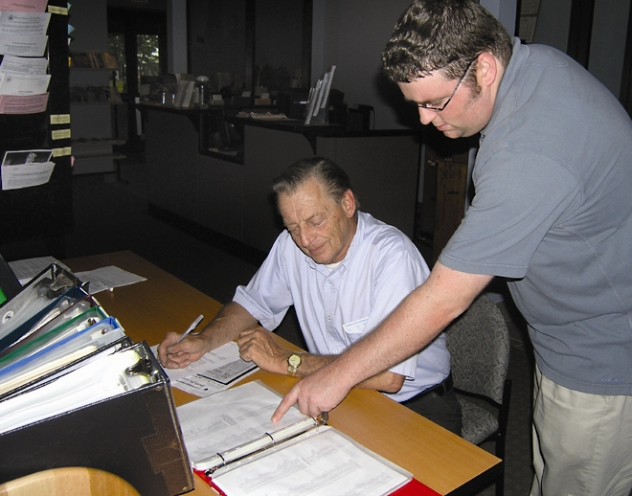
Our Strategic Plan commits us to hiring, developing, sustaining, and retaining staff according to the competencies needed to achieve our strategic goals. In addition, the President’s Management Agenda and Human Capital Assessment and Accountability Framework instruct agencies to engage in serious consideration of the skills and competencies needed to perform the work of the Government in the 21st century, to align human resources to support mission-critical activities, and to streamline and enhance delivery of essential human resources services by leveraging technology and other process flexibilities.
Thomas Hayes, archives aid in the Great Lakes regional archives in Chicago, instructs a researcher on the use of the 1900 census finding aid. (Photo by Mary Ann Zulevic)
Our future success as the Government’s leader for records services will depend in large part on the staff that we hire today. We must ensure that we have the right people in the right positions at the right time to move the agency forward at this extraordinary time in our history.
Personnel on Board
All funds as of September 30, 2005 | Washington, DC, Area |  |  | Field Locations |  |  | Nationwide Total
Programs | Full-Time Perm | Other | Total | Full-Time Perm | Other | Total | Full-Time Perm | Other | Total
Records Services | 867 | 126 | 993 | 0 | 0 | 0 | 867 | 126 | 993
Regional Records Services | 88 | 9 | 97 | 1,056 | 277 | 1,333 | 1,144 | 286 | 1,430
Presidential Libraries | 139 | 8 | 147 | 281 | 74 | 355 | 420 | 82 | 502
Information Security Oversight Office | 29 | 0 | 29 | 0 | 0 | 0 | 29 | 0 | 29
Federal Register | 73 | 1 | 74 | 0 | 0 | 0 | 73 | 1 | 74
National Historical Publications and Records Commission | 13 | 0 | 13 | 0 | 0 | 0 | 13 | 0 | 13
TOTAL | 1,209 | 144 | 1,353 | 1,337 | 351 | 1,688 | 2,546 | 495 | 3,041
Records Access. The Federal Government protects hundreds of millions of classified documents at great expense. In this year’s assessment of declassification in the Executive branch, the Information Security Oversight Office (ISOO) noted that the Federal Government’s classification system “cannot be depended upon to protect today's sensitive national security information unless there is an ongoing process to purge it of yesterday's secrets that no longer require protection.” This means undertaking automatic and systematic declassification, as well as mandatory declassification reviews, in accordance with Executive Order 12958, as amended. Nevertheless, declassification activity across the Government has been declining for the past several years.
In its most recent report to the President, ISOO noted an increase in both original classification and derivative classification decisions made by the Federal Government. The rise in classification can be attributed to a combination of factors, including a dramatic increase in the number of national security operations in recent years, the exponential increase in the Government’s ability to produce information (both classified and unclassified) through the use of information technology, and likely overclassification. Government faces the perpetual challenge of balancing security concerns with the need to share information. Too much classification unnecessarily impedes effective information sharing. Too little classification subjects our nation to potential harm. Proactive oversight by an agency of its security classification program is not a luxury. Allowing information that will not cause damage to national security to remain in the classification system, or to enter the system in the first instance, places all classified information at needless increased risk.
Federal agencies have a deadline of December 31, 2009, to review and resolve (by declassifying or exempting) their equities in security-classified documents more than 25 years old that have been referred to them by other agencies. We estimate that there are approximately 80 million pages in NARA’s holdings that must be acted on by the agencies before the 2009 deadline. Many of these documents must be reviewed by two or more agencies. We need to make these documents available to the agencies in a systematic fashion to enable them to accomplish their missions, protect permanently valuable Federal records, and prevent unauthorized releases of still sensitive information. Failure to establish a systematic process for handling referrals poses a significant risk for inadvertent release of still sensitive information. If agencies resolve referrals in an ad hoc manner, the Government loses control of the process. We will not be sure that all referred documents had been acted on because we will have no way of tracking agency actions. With no standard way of recording agency determinations, it is likely that we will make mistakes in interpreting agency decisions when records are processed for release. Without an organized referral process, it will be impossible to meet the deadline.
Therefore, in cooperation with other agencies, NARA has established an interagency referral center to provide a systematic approach to the referral process for Federal records. In our first year of operation we indexed approximately 1.5 million pages for referral, but the volume of work remaining is too great to be accomplished by the 2009 deadline without contract support.
Finally, classified records in our Presidential libraries pose a huge challenge for us because they are often extremely sensitive, filled with multiple equities, and highly sought after by Government officials and the public. The Reagan Library holds the next Presidential collection to which the Executive order must be applied and has classified holdings of approximately 8 million pages. This represents more classified pages than all of the previous libraries combined. Previously, we have implemented the Remote Archives Capture (RAC) Project, a collaborative program among NARA, CIA, and other classifying agencies through which classified Presidential materials at field locations are electronically scanned and sent to Washington for review by equity-holding agencies. So far this project has scanned more than 2 million pages from the Eisenhower, Kennedy, Johnson, Ford, and Carter Libraries, but the dramatic increase in volume of classified records from the Reagan administration presents significant challenges to our ability to comply with the Executive order.
Electronic Records Management. In this world of exponentially increasing volumes and formats of electronic records, having the ability to find, manage, use, share, and dispose of records—which is the essence of records management—is vital for the efficient and effective functioning of the Federal Government. Records management is an essential component of knowledge management, and yet records and information are rarely managed as agency business assets and records management remains marginalized in many agencies. This undermines the authenticity, reliability, integrity, and usability of Federal records and information essential for Government business, particularly electronic Government and public use.
This Government-wide challenge requires collaborative, creative solutions with benefits that are obvious to Federal agencies. That is why we are undertaking a multipronged approach to improving electronic records management that relies on a suite of strategies, policies, standards, and tools that facilitate the effective and efficient management of Federal records. Ultimately, records management should become so seamlessly integrated into agencies’ business processes thatit becomes “second nature”; what they would notice instead is that they can easily find the information they need, when they need it, in a form they can use to conduct their business. Getting to this outcome requires that we both transform our own records management program and transform records management across the Government. Given the urgent need to improve delivery of Government services, enable the sharing of information across agencies, and manage records and transactions more effectively, we could not wait to undertake these transformations sequentially. Therefore, we are leading collaborative projects in the following areas to address both of these transformations simultaneously.
- Records Management Initiatives—a series of coordinated NARA initiatives to transform NARA’s approach to Federal records management for all records.
- E-Government Initiatives—these include the ongoing Electronic Records Management E-Government Initiative and initiatives to implement the Interagency Committee on Government Information (ICGI) recommendations for section 207(e) of the E-Government Act of 2002.
- Electronic Records Archives—the key tool that will allow NARA and Federal agencies to manage, preserve, and have access to electronic records over space and time.
We are also committed to working with our Inspector General (IG) to identify and address significant challenges. The Inspector General’s Top Ten Management Challenges, which are highlighted in the IG’s semiannual reports to Congress and include the audits, investigations, and reviews they have undertaken to identify and address them, are included in appendix A.
Performance Highlights
Spotlight on Education
Hands-On History Lets Learners Touch the Past

Tell me, I forget.
Show me, I remember.
Involve me, I understand.

It is August 1948. President Harry S. Truman and the United States face a serious international crisis: In an act of high-stakes brinksmanship, the Soviet Union has sealed off the western sectors of Berlin. Winter is approaching, and more than 2 million Germans are cut off from the basic necessities of life. You are one of the President’s closest advisers. What advice do you offer him?
Fast forward to 2005. Midwestern students relive this and other historical crises in the White House Decision Center (WHDC) at the Truman Library and Museum in Independence, MO. Since the center’s opening in 2001, more than 18,000 youngsters from rural, suburban, and urban schools have participated in its unique program of experiential learning.
The center resembles the West Wing of the White House, complete with briefing rooms, a press room, Presidential portraits, and even wainscoting. In this realistic environment, participants assume the roles of President Truman and his advisers, including the Secretary of State, the Secretary of Defense, the Director of Central Intelligence, and the press secretary. They read copies of actual historical documents—many once marked “top secret.” They work together in advisory teams; analyze options; and supply the President with facts, recommendations, and assessments. Students also lead and participate in a press briefing, and one student, portraying the President, announces a course of action and fields penetrating questions from the media.
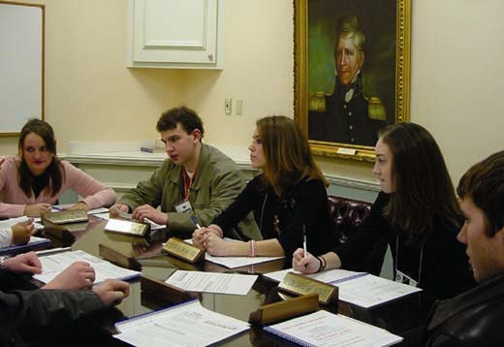
High school students take the roles of Presidential advisers in the Truman Library’s White House Decision Center. (Photo by Tom Heuertz)
Along the way, students learn about history, government, and the Presidency. They develop and apply skills in document analysis, problem solving, cooperation, communication, and leadership. And perhaps most important, they come to see history as vivid, compelling, and engaging—not just a matter of memorizing facts from a textbook.
“The WHDC provided my students with ‘hands-on’ history,” observed one Missouri teacher. “The past became the present—an interactive drama as my freshmen lived the push and pull of conflicting opinions within the halls of power, wrestled with the burden of the Presidency, and dealt with the power of the press.”
Students tend to put it more succinctly. As one high-school senior said, “It just takes learning out of the books and puts it in your face—and I love it.”
Historical documents and other primary sources have an uncanny power to capture the attention of even the most reluctant learner. Primary sources are materials that were created by those who participated in or witnessed the events of the past, and they bring the past to life with an immediacy that textbooks cannot match. Studies have shown that when students work with primary sources, they learn more and their critical thinking skills improve. It’s no wonder that primary sources are specifically identified in a number of places in the National Standards for History.
NARA’s enormous holdings of primary source materials constitute the greatest single resource for transforming the study of history and civics into a first-person experience. At its facilities across the country, through publications, workshops, and a variety of other programs, NARA puts primary sources into the hands of students and teachers, and it trains teachers in the skills they need to incorporate these materials into their lessons.
Early in his tenure as ninth Archivist of the United States, Allen Weinstein asked staff to prepare a report outlining the education and outreach efforts of the National Archives. The result was a 22-page, single-spaced document listing programs and activities in the Presidential libraries, regional archives, and Washington, DC–area facilities. “I was amazed at how much we were doing,” observed Weinstein. “And that report wasn’t even comprehensive.”
These efforts go back many years. In 1977 NARA began publishing its “Teaching With Documents” feature in Social Education, the journal of the National Council for the Social Studies, the nation’s largest professional association for social studies teachers. Each “Teaching With Documents” article examines a historical record from the National Archives and guides teachers in using the record in the classroom. More than 140 such articles have now been published, exploring the use of letters, reports, forms, photographs, patent drawings, and other records as teaching tools.
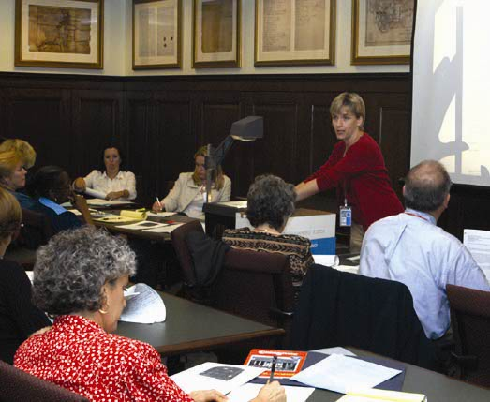
Education Specialist Lee Ann Potter leads a Primarily Teaching summer institute at the National Archives Building in Washington, DC. (Photo by Darryl Herring)
Also for many years, NARA has conducted the Primarily Teaching summer institute for educators. The workshop brings teachers from around the country and from many types of communities and schools to NARA’s Washington, DC, headquarters. Under the guidance of NARA education experts, each participant selects a specific topic, researches the topic in the records of the National Archives, and develops a teaching unit to take back to the classroom. The institute turns the teachers into learners, exposing them to the excitement of hands-on investigation, analysis, and discovery—an experience they will then be able to provide to their own students.
One teacher explained that the Primarily Teaching program had “opened up a new vista” for him. “I remember on the first day of the course being handed a copy of Richard Nixon's resignation letter,” he said. “History jumped out at me from that page, and I knew that if I had access to materials such as this, it would prove to be a gold mine in the classroom.”
This gold mine is about to go on the road. In response to the success of and enthusiasm for Primarily Teaching, NARA has started planning to make the institute available in other parts of the country. In 2006, pilot programs will take place at NARA’s regional archives in Laguna Niguel, CA, and at the Eisenhower Library and Museum, in Abilene, KS.
Each of NARA’s regional archives, Presidential libraries, and Washington-area facilities is its own gold mine of materials, and, from coast to coast, NARA units make these materials available to students and teachers. They develop printed and electronic publications that highlight the records held in their facilities, provide copies of the records, train teachers in methods for incorporating the records into their lessons, and demonstrate how the lessons relate to specific state and national standards.
Across the country, NARA units also collaborate with other educational institutions to make the excitement of primary sources available to teachers and students. NARA’s education office in Washington, its regional archives, and its Presidential libraries all work extensively with recipients of Teaching American History Grants. These grants, sponsored by the U.S. Department of Education and awarded to local educational agencies, are intended to raise student achievement by improving teachers’ knowledge, understanding, and appreciation of American history. Through on-site workshops and videoconferences, NARA staff provide professional development opportunities for teachers, training them in archival research techniques and in the use of primary sources in the classroom.
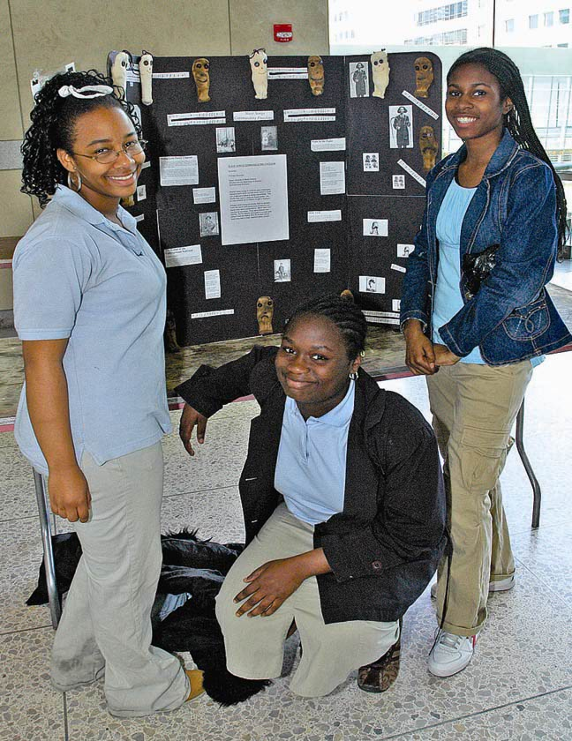
Three Philadelphia students proudly show off their National History Day entry at the National Constitution Center. (Photo courtesy of the City of Philadelphia Department of Records)
Staff across the country also are involved in National History Day, a year-long educational program that engages students in the discovery and interpretation of history. Through this program, students conduct research and create projects related to an annual theme; their projects are judged at the local, state, and national levels. NARA staff provide workshops for teachers, contribute lesson plans to an annual teachers’ guide, help students do archival research, serve as judges for local and state contests, and even host contests. The Eisenhower Library has been hosting the Kansas state finals for 23 years.
In 2005, thanks to the efforts of NARA’s Mid Atlantic Region, the National History Day program returned to Philadelphia after a lengthy absence. Regional staff organized and led a collaborative effort of local educational, cultural, and community organizations that re-established the program in the city and provided teachers, students, and parents with the resources and guidance necessary to participate. On April 21, in the National Constitution Center, National History Day competition took place in Philadelphia for the first time in almost two decades.
A Philadelphia-area middle school principal was stunned by the impact that the program had on his students—and in particular on one youngster who had previously been unmotivated by his studies. “With this young man,” said the principal, “the ‘light bulb’ clicked when he participated in National History Day. I never saw him so engaged and focused.” The young man won a first-place ribbon for his National History Day project—and has decided that he wants to go to college, a goal to which he had not previously aspired. The principal has decided to add more social studies teachers to his faculty. And NARA has started working with other organizations to revitalize the National History Day program in another major city: Washington, DC.
In a sense, education permeates everything that NARA does. NARA preserves the records of America, enabling all citizens to learn about their nation’s history, their families’ stories, and their own rights and entitlements. Every time a NARA unit helps a researcher, holds a genealogy workshop, offers a public lecture, or opens a new exhibit, learning takes place. One of the most exciting learning opportunities of the past year was provided by the opening of the Public Vaults, NARA’s new permanent interactive exhibit in the National Archives Building in Washington, DC. The exhibit gives people of all ages the feeling of going into the stacks and vaults of the National Archives to see the raw material from which history is made. Several of the displays in the Public Vaults are geared especially for young people. And virtually all of the materials in the Public Vaults can bring history alive in the classroom.

One of a series of posters designed to promote the value of teaching with primary sources.
That’s why, when NARA’s Learning Center opens next year in the same building, it will provide access to copies of each of the more than 1,000 records on display in the Public Vaults—and much more. The center’s ReSource Room will be the one-stop headquarters for teachers and parents seeking ways to bring history alive for their students and children. Everything NARA’s education specialists have written over the decades about teaching with primary sources—whether based in Washington, DC, or in the regional archives and Presidential libraries—will be gathered here. Included will be background materials, lesson plans, teachers guides, and, of course, copies of historical documents and other records. The Learning Center will also include the Learning Lab, which will provide a hands-on role-playing experience in which students will take on the roles of researchers and archivists.
Other experiential programs are in development across the agency. For example, the Eisenhower Library is about to formally launch its Five-Star Leaders program, in which students will take on the roles of top Allied political and military leaders, analyze documents relating to the Allied invasion of Hitler’s Europe, and provide formal briefings, with recommendations, to Supreme Headquarters, Allied Expeditionary Forces. All of these programs will invite students to make direct, immediate contact with events of the past.
Lee Ann Potter, head of NARA’s education programs in Washington, likes to tell of finding her own great-great grandfather’s homestead application among the billions of documents held by the National Archives—and of her husband’s response. She recalls, “His amazement at the tri-folded, 8-page, yellowing document from 1872 prompted him to say, ‘I can’t believe it was actually his. I can’t believe it is here. And I can’t believe they are letting you touch it.”
Those reactions encapsulate perhaps the three most important reasons for teaching history with primary sources: They are a part of the past. They are with us today. And touching them allows us, quite literally, to touch the past and connect with it.

To find out more . . .
- The Digital Classroom, the National Archives gateway for resources about primary sources as well as activities and training for educators and students, can be accessed at www.archives.gov/education/.
- Explore Our Documents, 100 milestone documents of American history, at www.ourdocuments.gov/.
- For links to education-related pages hosted by the Presidential libraries, visit www.archives.gov/education/presidential-libraries.html.
- For links to education resources available in the regional archives, go to www.archives.gov/education/regional-resources.html.
- For information on the Truman Library’s White House Decision Center, go to www.trumanlibrary.org/whdc/.
- For information on the National History Day event in Philadelphia coordinated by the Mid Atlantic Region, go to www.archives.gov/midatlantic/ education/nhd.html.

Spotlight on Partnerships
Although the National Archives and Records Administration stands as the sole Federal agency charged with preserving and making accessible the Government’s records, we are not alone in carrying out our mission.
In providing “ready access to essential evidence”—the records that document the rights of our citizens, the decisions of our Government officials, and our national experience—we draw assistance and support from a wide variety of private institutions, other Government agencies, and individuals:
- At the National Archives Building in Washington, D.C., visitors who come to see the parchment documents that created America find much more. A privately supported, state-of-the-art exhibition called the Public Vaults traces the story of our nation through a unique display of 1,100 records from deep within NARA’s stacks.
- At major universities, private research firms, and other Federal agencies, NARA has been working with experts in information technology and computer science. They’ve been developing ways to preserve for all time the digital records of our government in the Electronic Records Archives.
- In every section of the country, staff at our regional archives and Presidential libraries have nurtured strong and enduring relationships with local cultural, educational, and genealogical groups. Our partners enjoy access to the records of our rich history, and we find new audiences for discovering the nation’s story through primary sources.
These collaborations—and the benefits they bring to all Americans—are possible because of our strong and vibrant network of public-private partnerships, collaborations, and joint ventures.
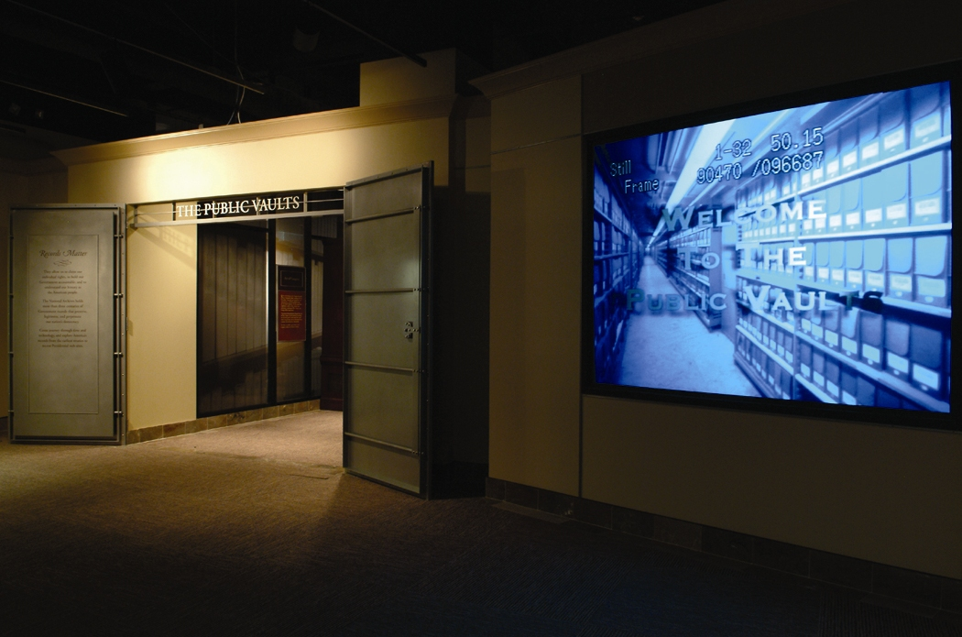
Over the years, these arrangements—some formal, some informal—have become part of the fabric of NARA at all levels. They have been developed by the agency as a whole, various units within NARA, and individual staff members who have introduced the National Archives to new audiences through professional and personal ties with community organizations, schools, and genealogy groups.
The Public Vaults exhibition opened at the National Archives Building in November 2004. (Photo by Earl McDonald)
By partnering with others, our reach and our impact are much greater. In Washington, we work closely with the Foundation for the National Archives, created in 1992 to support and develop interest in our programs and our vast resources.
As a result of the Foundation’s work over the past several years, the National Archives has received millions of dollars from private donors to help finance all or part of elements of the National Archives Experience, a set of seven interconnected components that offer a variety of ways to explore the nation’s records and uncover the stories they tell.
These components include the William G. McGowan Theater, the Lawrence F. O’Brien Gallery, the Public Vaults, the Learning Center, and the National Archives Experience portion of NARA’s public web site, Archives.gov. The Foundation also operates the popular Archives Shop in the National Archives Building, which features a wide variety of National Archives–branded merchandise.
The Foundation’s partners and supporters have included the William G. McGowan Charitable Fund, the family of Lawrence F. O’Brien, Dell Inc., Maryland philanthropists Willard Hackerman and Alan Voorhees, and the New York Life Foundation. The Foundation has also partnered on individual projects with U.S. News & World Report and Smith Barney.
At the McGowan Theater, we have, along with the family of the late Charles Guggenheim, established the Charles Guggenheim Center for the Documentary Film at the National Archives. An agreement with the Academy of Motion Picture Arts and Sciences makes us the Mid-Atlantic venue for the Academy’s documentary film Oscar nominees and other special events.

On September 8, 2005, Thomas Campbell, Contracting Officer for ERA (seated at left), and Don Antonucci, President of Lockheed Martin Transportation and Security Solutions (TSS), signed the contract under which Lockheed Martin will build the ERA system. Behind them are (from left) L. Reynolds Cahoon, Assistant Archivist for Information Services; Kenneth Thibodeau, Director of the ERA Program; Allen Weinstein, Archivist of the United States; Lewis Bellardo, Deputy Archivist; Judy Marks, who will succeed Antonucci as president of the TSS unit in October; and Andy Patrichuk, Lockheed Martin’s vice president responsible for the ERA program. (Photo by Earl McDonald)

One of the strategic challenges now facing the National Archives is how to preserve and make accessible for years, decades, even centuries, the electronic records of what we call e-Government.
The response to this challenge is the Electronic Records Archives (ERA). It is fundamental to e-Government in that it will allow these records to be managed and preserved over time and space. The stakes are high, and failure is not an option.
To help us create ERA, we formed working partnerships with those institutions on the frontier of research to learn how best to preserve information in electronic format long after the hardware and software that created it are out of use.
The collaborations on ERA have allowed us to tap the knowledge and abilities of world-class researchers in such prominent institutions as the Supercomputer Center at the University of California at San Diego, the Massachusetts Institute of Technology, the National Center for Supercomputing Applications at the University of Illinois, the Georgia Tech Research Institute, and the University of Maryland Institute for Advanced Computer Studies. We’re also working with other Federal agencies, such as the National Science Foundation, the Army Research Laboratory, and the National Institute for Standards and Technology. Other partners include industry groups and international organizations that face similar challenges. These partnerships have allowed us to gain far more technical insights and information than we could have on our own.
With the awarding of the contract for ERA to Lockheed Martin Corp. in September 2005, we also appointed an advisory committee on the Electronic Records Archives. It is made up of experts in computer science, information technology, archival science, records management, information science, law, history, genealogy, and education.
NARA has taken a leadership role in partnering with professional organizations dealing with records and archives on a program called “New Skills for Archivists,” which seeks to identify the skills needed in the new world of electronic records.
While the National Archives Experience and the Electronic Records Archives involve two of our best-known partnerships, they represent only a portion of our network of collaborations and partnerships. Throughout the agency, at all levels, other partnerships serve to advance NARA programs and services and to bring NARA to new audiences, new stakeholders, and new customers.
This is happening not only in Washington, DC, but in our regional archives and Presidential libraries. At each of the libraries, a nonprofit foundation supports a broad spectrum of innovative and insightful public, education, and information programs so that young and old alike can learn about history from the documents and the artifacts that were the backdrop of history as it was being made.

For five years, NARA has partnered with Howard University in Washington, DC, to significantly enhance access to one of the most valuable sources of African American genealogical information: the records of the Bureau of Refugees, Freedmen, and Abandoned Lands. While NARA microfilms the records, Howard, with a grant from the Peck Stacpoole Foundation, is preparing the indexes. The project is to be completed in fiscal year 2006. Earlier, the University of Florida assisted NARA in putting the Florida records on microfilm.
Freedmen's Bureau records in the stacks of the National Archives Building in Washington, DC. The microfilmed versions will allow researchers greater access to the records while protecting the fragile originals. (Photo by Roscoe George)
NARA and the Library of Congress collaborate on a number of projects aimed at improving the preservation and storage of documents and artifacts. In FY 2005, the two agencies began discussions on expanding their research relationship to create a Joint Preservation Research Agenda, which will broaden their knowledge of methods to conserve and preserve valuable records and artifacts.
In our role as “First Preserver,” NARA has joined with professional archival and records management organizations to provide assistance in preserving and conserving damaged records in hurricane-battered Gulf Coast states. On its own, NARA has partnered with the Federal Emergency Management Agency on records recovery activities in New Orleans. We have also partnered with the State of Mississippi to provide training for individuals working on records recovery and with the Federal Bureau of Investigation for training and technical guidance.
In late 2004, NARA partnered with U.S. News & World Report and Smith Barney to sponsor the inaugural exhibit in the Lawrence F. O’Brien Gallery. A collection of Presidential photographs, called “The American Presidency: Photographic Treasures of the National Archives” featured images of the private moments of America’s most public person.
Our Southeast regional archives in Atlanta, along with the Carter and Johnson Libraries and the Martin Luther King, Jr., National Historic Site and others, co-sponsored a special exhibition in 2005 to commemorate the 40th anniversary of the enactment of the Voting Rights Act of 1965.
NARA’s Pacific Region in San Francisco has partnered with the University of California at Berkeley to produce a web site called “Case Files for Early Immigrants to San Francisco and Hawaii,” a trove of information for Asian American genealogy. The web site is supported by the university.
Our Center for Legislative Archives is one of many partners involved in the new Capitol Visitor Center, a 580,000-square-foot addition beneath the Capitol’s east plaza. A 16,500-square-foot exhibit gallery will feature original House and Senate records preserved at the Center, other historical records from NARA, and documents from the Library of Congress. NARA will gain a new audience in the millions of visitors to the Capitol each year.
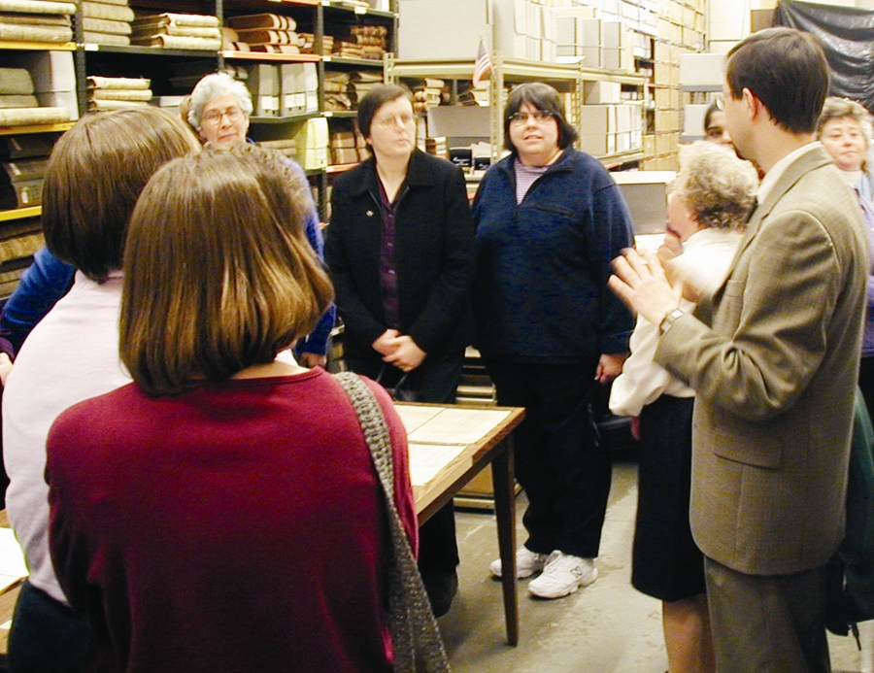
For five years, NARA worked with Middlemarch Films, NOVA/WGBH in Boston, and the Public Broadcasting Service to produce a film, Preserving the Charters of Freedom, that is now shown twice daily in the McGowan Theater. The film traces the story of how the Declaration of Independence, the Constitution, and the Bill of Rights were taken out of their old encasements, given conservation treatment, and placed in new state-of-the-art encasements during the renovation of the Rotunda.
Stuart Culy (right), archival director for NARA–Northeast Region (Boston), gives a tour to teachers in the "Using Historical Documents" program. (Photo by Michael Moore)
Throughout NARA—in Washington, the regional archives, and the Presidential libraries—staff members work with elementary and secondary schools and colleges and universities as well as individual teachers and students to bring our holdings into the nation’s classrooms. These efforts include work with Teaching American History grants and the National History Day competitions at local, state, and national levels.
Several of our Presidential libraries—Kennedy, Ford, Johnson, Clinton, and Bush—are located on, adjacent to, or near university campuses and are valuable resources for graduate and undergraduate students studying American history or public policy.
The Eisenhower Library in Abilene, KS, has a formal arrangement with Kansas State University’s Institute for Military History and 20th Century American Studies in Manhattan, KS, and the Army’s Command and General Staff College at Fort Leavenworth, KS. The library helps host major conferences and serves as a rich resource and a portal to NARA for the university’s online doctoral program in military history.
Many other partnerships take the form of loans of documents. For example, NARA has recently loaned Louisiana Purchase documents to various institutions to commemorate the 200th anniversary of the treaty. The National Museum of the American Indian has borrowed various Indian treaties and documents. NARA loaned the Library of Congress a variety of documents, including President Harry S. Truman’s recognition of the State of Israel, for its exhibit “From Haven to Home,” which commemorated 350 years of Jewish life in America.
Around the nation, our regional archives work with various groups, especially genealogy organizations, to familiarize them with the records NARA holds and how best to access and research them. Our Presidential libraries are often the site of symposia, celebrations, or special events co-sponsored with their affiliated institute or foundation or with other organizations or institutions.
Today, NARA is rich in partnerships, collaborations, joint projects, document loans, and other arrangements with other public and private institutions that allow us to do things that we simply could not do otherwise.
By bringing America’s records to new audiences, these partnerships help us broaden our reach and our ability to share the primary sources of America’s story with Americans.
To find out more. . .
- To learn more about the Foundation for the National Archives and the National Archives Experience, go to www.archives.gov/national-archives-experience/support/.
- For information on Presidential library support organizations, visit www.archives.gov/presidential-libraries/about/foundations.html.
- For links to partnerships related to the Electronic Records Archives, go to www.archives.gov/era/partnerships/.
- To learn more about the Freedmen’s Bureau project and African American genealogy, go to www.archives.gov/research/african-americans/.

Using the National Archives and Records Administration
FY 2005
 | Researchers  Microfilm | Researchers  Other  Records | Written Requests | Public  Program  Attendees | Museum  Visitors
Washington, DC, Area | 26,109 | 65,803 | 38,173 | 2,152 | 1,003,006
Office of Regional Records Services
Northeast Region (Boston) | 7,469 | 943 | 2,258 | 1,339 | —
Northeast Region (Pittsfield) | 2,853 | — | 933 | 655 | —
Northeast Region (New York) | 5,921 | 1,681 | 4,450 | 674 | —
Mid Atlantic Region (Philadelphia) | 6,648 | 342 | 1,266 | 513 | —
Southeast Region (Atlanta) | 4,253 | 523 | 2,167 | 137 | —
Great Lakes Region (Chicago) | 2,934 | 404 | 3,614 | 162 | —
Great Lakes Region (Dayton) | — | — | — | 82 | —
Central Plains Region (Kansas City) | 2,531 | 497 | 2,199 | 751 | —
Southwest Region (Fort Worth) | 4,333 | 1,087 | 3,419 | 402 | —
Rocky Mountain Region (Denver) | 3,312 | 925 | 437 | 609 | —
Pacific Region (Laguna Niguel) | 4,178 | 603 | 1,474 | 432 | —
Pacific Region (San Bruno) | 3,479 | 1,239 | 2,797 | 373 | —
Pacific Region (Anchorage) | 1,565 | 465 | 413 | — | —
Pacific Alaska Region (Seattle) | 4,883 | 940 | 1,503 | 1,038 | —
National Personnel Records Center | — | 74 | 1,024,569 | — | —
Regional Records Services Total | 54,359 | 9,723 | 1,051,499 | 7,167 | —
Presidential Libraries
Hoover | — | 324 | 1,351 | 33,163 | 55,564
Roosevelt | — | 1,439 | 2,949 | 14,961 | 106,194
Truman | — | 830 | 2,462 | 5,282 | 94,540
Eisenhower | 13 | 1,222 | 3,523 | 11,735 | 69,980
Kennedy | — | 1,314 | 3,037 | 45,732 | 187,354
Johnson | — | 1,515 | 2,871 | 6,263 | 224,078
Nixon | — | 1,600 | 2,005 | 600 | —
Ford | — | 1,033 | 2,028 | 19,458 | 48,336
Carter | — | 723 | 1,092 | 176 | 76,515
Reagan | — | 848 | 601 | 50,122 | 297,465
Bush | — | 279 | 1,295 | 20,975 | 132,327
Clinton | — | 33 | 2,733 | 27,508 | 447,788
Presidential Libraries Total | 13 | 11,160 | 25,947 | 235,975 | 1,740,141
TOTAL | 80,481 | 86,686 | 1,115,619 | 245,294 | 2,743,147


Shang She Jung, 67, of Port Chester, NY, was unable to obtain Social Security benefits because he couldn’t prove his citizenship. He had come to the United States in 1947 as a child from China, but in the 1950s he was separated from abusive parents, without a birth certificate, passport, or any other kind of documentation. Our Northeast regional archives in New York City referred him to our Pacific Region in San Francisco. There, Bill Greene, an archival immigration files expert, matched Jung with his family’s original immigration case file and a directive that he be admitted “as a U.S. citizen.” The New York Times told Jung’s story in a 2004 article called “A Man Without a Country Finds One After 57 Years.”

Jung and his mother. (Records of the Immigration and Naturalization Service, RG 85)
Performance Overview
We break down our five strategic goals into long-range performance targets and set annual targets in our Annual Performance Plan each year. The following chart provides a synopsis of our FY 2005 performance. Details of some of this year’s major accomplishments under each strategic goal follow the chart.
Snapshot of 2005 Performance
Strategic Goal 1: Essential Evidence Is Created, Identified, Appropriately Scheduled, and Managed for as Long as Needed.
1.1: By 2008, 95% of agencies view their records management program as a positive tool for asset and risk management.
1.2: By 2008, 95% of approved capital asset plans have approved records schedules by the time those systems begin creating records.
1.3: By 2008, 95% of customers are satisfied with NARA scheduling and appraisal services.
Performance Indicator | 2001 Actual | 2002 Actual | 2003 Actual | 2004 Actual | 2005 Target | 2005 Actual
Annual percent of targeted assistance partnership agreements delivering the results promised. | 100 | 100 | 100 | 100 | 95 | 100
Median time for records schedule items completed (in calendar days). | 237 | 470 | 155 | 253 | 200 | 372
Strategic Goal 2: Electronic Records Are Controlled, Preserved, and Made Accessible for as Long as Needed.
2.1: By 2008, NARA’s Records Center Program accepts and services electronic records.
2.2: By 2008, 80% of scheduled archival electronic records are accessioned by NARA at the scheduled time.
2.3: By 2008, 80% of archival electronic records are managed at the appropriate level of service.
2.4: By 2008, the median time from the transfer of archival electronic records to NARA until they are available for access is 35 days or less.
2.5: By 2008, the per-megabyte cost for managing archival electronic records through the Electronic Records Archives decreases each year.
Performance Indicator | 2001 Actual | 2002 Actual | 2003 Actual | 2004 Actual | 2005 Target |  | 2005 Actual
Percent increase in number of archival electronic holdings accessible online. | — | — | — | 51 | 20 |  | 20
Median time from the transfer of archival electronic records to NARA until they are available for access (in calendar days). | — | — | 450 | 736 | 250 |  | 413
Percent of NARA’s electronic holdings stabilized in preparation for their transfer to the Electronic Records Archives. | 97 | 98 | 97 | 93 | 80 |  | 99.7
Strategic Goal 3: Essential Evidence Is Easy to Access Regardless of Where It Is or Where Users Are for as Long as Needed.
3.1: By 2007, access to records and services and customer satisfaction levels meet or exceed NARA’s published standards.
3.2: By 2007, 70% of NARA services are available online.
3.3: By 2008, 80% of NARA archival holdings are described in an online catalog.
3.4: By 2007, Government-wide holdings of 25-year-old or order records are declassified, properly exempted, or appropriately referred under the provisions of Executive Order 12958, as amended, through a series of ISOO-led interagency efforts.
3.5: By 2007, NARA archival holdings of 25-year-old or older records are declassified, properly exempted, or appropriately referred under the provisions of Executive Order 12958, as amended.
3.6: By 2007, 10% of records of a two-term President or 15% of records for a one-term President are open and available for research at the end of the 5-year post-Presidential period specified in the Presidential Records Act.
3.7: By 2007, 90% of all NHPRC-assisted projects produce results promised in approved grant applications.
Performance Indicator | 2001 Actual | 2002 Actual | 2003 Actual | 2004 Actual | 2005 Target |  | 2005 Actual
Percent of written requests answered within 10 working days. | 93 | 93 | 94 | 95 | 95 |  | 96
Percent of Freedom of Information Act requests for Federal records completed within 20 working days. | 27 | 76 | 61 | 65 | 90 |  | 80
Performance Indicator | 2001 Actual | 2002 Actual | 2003 Actual | 2004 Actual | 2005 Target |  |  | 2005 Actual
Percent of requests for military service separation records at the National Personnel Records Center in St. Louis answered within 10 working days. | 7 | 40 | 37 | 75 | 95 |  |  | 88
Percent of items requested in our research rooms furnished within one hour of request or scheduled pull time. | 93 | 94 | 96 | 98 | 95 |  |  | 98
Percent of customers with appointments for whom records are waiting at the appointed time. | 99.7 | 99.8 | 99.9 | 99.3 | 99 |  |  | 99.4
Percent of Federal agency reference requests in Federal records centers that are ready when promised to the customer. | 93 | 92 | 94 | 96 | 95 |  |  | 97
Percent of records center shipments to Federal agencies that are the records they requested. | 99.99 | 99.99 | 99.99 | 99.99 | 99 |  |  | 99.99
Percent of archival fixed-fee reproduction orders that are completed in 35 working days or less. | — | 88 | 99 | 99.9 | 80 |  |  | 97.2
Percent of education programs, workshops, and training courses meeting attendees’ expectations. | 97 | 96 | 95 | 99 | 95 |  |  | 99
Percent of NARA services available online. | 24 | 25 | 30 | 40 | 50 |  |  | 50
Percent of traditional holdings in an online catalog. | — | 19 | 20 | 33 | 40 |  |  | 42
Percent of artifact holdings in an online catalog. | — | 19 | 17 | 40 | 40 |  |  | 43
Percent of electronic holdings in an online catalog. | — | 0.02 | 0.02 | 10 | 10 |  |  | 31
Annual number of Presidential pages scanned (in thousands). | 322 | 332 | 470 | 500 | 300 |  |  | 563
Cumulative percent of Clinton Presidential and Vice Presidential traditional holdings processed for opening January 20, 2006. | 1 | 1 | 1 | 2 | 5 |  |  | 3
Percent of NHPRC grant-funded projects that produced results promised in grant applications. | 91 | 79 | 86 | 88 | 87 |  |  | 85
Strategic Goal 4: All Records Are Preserved in an Appropriate Environment for Use as Long as Needed
4.1: By 2009, 100% of NARA’s archival holdings are in appropriate space.
4.2: By 2009, 100% of NARA records centers comply with the October 2009 regulatory storage standards.
4.3: By 2007, 50% of NARA’s at-risk archival holdings are appropriately treated or housed so as to retard further deterioration.
Performance Indicator | 2001 Actual | 2002 Actual | 2003 Actual | 2004 Actual | 2005 Target |  |  | 2005 Actual
Cost of archival storage space per cubic feet of traditional holdings stored. | — | — | — | $6.11 | — |  |  | $6.48
Percent of cumulative backlog of NARA’s at-risk archival holdings ever treated. | 28 | 32 | 35 | 41 | 43 |  |  | 47
Strategic Goal 5. NARA Strategically Manages and Aligns Staff, Technology, and Processes to Achieve Our Mission.
5.1: By 2008, the average time a leadership position remains unfilled is 30 days or less.
5.2: By 2007, the percentages of NARA employees in underrepresented groups match their respective availability levels in the Civilian Labor Force.
5.3: By 2007, NARA accepts 100% of the validated legal documents submitted electronically for publication in the Federal Register.
5.4: By 2008, all public network applications are available 99.9% of the time.
Performance Indicator | 2001 Actual | 2002 Actual | 2003 Actual | 2004 Actual | 2005 Target |  |  | 2005 Actual
Percent of staff having performance plans linked to strategic outcomes. | 48 | 80 | 93 | 91 | 95 |  |  | 92
Percent of staff having staff development plans linked to strategic outcomes. | — | 1 | 91 | 52 | 95 |  |  | 78
Percent of applicant pools for positions at grades GS-13 and above that contain people in underrepresented groups. | 74 | 78 | 89 | 92 | 93 |  |  | 95
Percent of public network applications availability. | — | — | — | 98.7 | 97.0 |  |  | 98.9
Goal 1: Improving Records Management
We completed the first full year of our redesigned records management training program. With a Records Management Training Officer now part of our NARA-wide records management team, we will continue to apply adult education concepts and explore alternative delivery approaches in our training efforts. Our program is designed to address new trends in records management and the ongoing revolution in information technology so that agency records professionals can play an important role in process design, IT capital planning, and information and knowledge management in their agencies. We completed our first year of our certification program for individuals who successfully complete training in Federal records management. The certification program is designed to raise awareness and improve effectiveness of Federal records management, increase the level of professionalism of those managing Federal records, give Federal records professionals a set of benchmarks to gauge their professional development, and give NARA the ability to better assess the effectiveness of its training program. Participants who successfully pass a series of examinations receive NARA's Certificate of Federal Records Management Training, signed by the Archivist of the United States. In our first year we certified 47 individuals.
We continue to support the President’s e-Government initiatives through the ERM Initiative, which is providing practical recordkeeping guidance and tools to Federal agencies for managing electronic records. We are the lead agency for the ERM Initiative project to develop records management service components. This year we collaborated with records management and enterprise information architecture stakeholders from eighteen Federal agencies, NARA subject matter experts, and industry and academic experts to develop a set of records management components, a finalized set of functional requirements, and a prioritized list of component activities. These requirements serve as a baseline and starting point for the procurement and development of records management service components.
NARA is an executive sponsor of the Interagency Committee on Government Information (ICGI) and was chair of the Electronic Records Policy Working Group (ERPWG). Before ending its work in FY 2005, the ERPWG produced a report offering recommendations for the effective management of Government information on the Internet and other electronic records. NARA created the Federal Records Council, a 27-member interagency committee to advise the Archivist and Federal agencies on all aspects of records management, with special emphasis on the management of electronic records. The Council, the successor to ERPWG, provides a formal mechanism for agencies and NARA to identify strategies, best practices, and solutions to electronic information and records issues.
This year, under the auspices of ICGI, we completed a draft of a Records Management (RM) Profile in the Federal Enterprise Architecture (FEA). We also continued work on an online Electronic Records Management (ERM) Toolkit. The Toolkit, scheduled for a test launch in early FY 2006, will be a NARA-managed Internet portal that will share ERM tools government-wide.
We continue to offer targeted assistance to Federal agencies nationwide with urgent records management problems. Through targeted assistance partnerships, our records management experts spend time on-site at the offices of other Federal agencies to train personnel, help plan records inventories, assist in scheduling records for disposal or transfer to NARA, and aid in writing records management plans. Since 1999, NARA has established 372 targeted assistance projects with 107 Federal agencies and field offices, of which 279 projects have been completed.
Goal 2: Meeting Electronic Records Challenges
In September 2005 we awarded to Lockheed Martin Corporation the contract for the Electronic Records Archives (ERA), the system that will capture electronic information, regardless of its format, save it permanently, and make it accessible on whatever hardware or software is currently in use. In our continuing effort to remain accountable for ERA we formed a high-level committee of recognized experts and leaders in their fields to advise and make recommendations to the Archivist on issues related to the development, implementation, and use of the ERA system. This Advisory Committee on the Electronic Records Archives will provide an ongoing structure for bringing together experts in computer science and information technology, archival science and records management, information science, law, history, genealogy, and education.
We now have more than 85 million logical data records accessible online through Access to Archival Databases (AAD), an early prototype of a portion of the ERA system.
Goal 3: Expanding Opportunities for Access
We have added more than 14,000 descriptions of our holdings to the Archival Research Catalog (ARC) this year. ARC is an online catalog of NARA’s nationwide holdings. We described 42 percent of our holdings in ARC this year, surpassing our target of 40 percent.
In response to the appraisal of Official Military Personnel Files (OMPFs) as permanent records, we established an Archival Programs Division in the National Personnel Records Center (NPRC) to manage the records and constructed an archival research room where members of the public can examine the records available for research. The new archival research room opened in May. The first batch of archival records made available included nearly 1.2 million OMPFs of former U.S. Navy and Marine Corps enlisted personnel who served in the military between 1885 and 1939. This first set of opened records also included the files of 150 “persons of exceptional prominence” who served in the military and who died at least ten years ago. Among these files were the OMPFs of John F. Kennedy, Elvis Presley, and Jackie Robinson.
We continued to expand our electronic services through our Enhancing NARA’s Online Services program, in which we look for opportunities to make more of our services available electronically for both Federal agencies and the public. We currently make 50 percent of our services available to the public online. We expanded the functional capability of Order Online! to allow customers to perform online searches to find microfilm available for purchase, viewing, or renting and to order microform products. Applicants may now submit grant applications to the National Historical Publications and Records Commission (NHPRC) online through Grants.gov.
We continue to collect public feedback about Archives.gov and our other web sites through the American Customer Satisfaction Index (ACSI) online surveys of our sites and major application interfaces such as ARC and AAD. The results of these surveys helped guide the redesign of our web site, Archives.gov, to make it more helpful to our customers through improved navigation of the site. In recognition of our efforts we won “Best Practices, Best Web Design in 2005,” a peer award voted by Federal web managers throughout Government service. We used the web site to facilitate access to such high-demand documents as the 9/11 Commission’s recently released “Staff Monograph on the Four Flights and Civil Aviation Security,” which is an adjunct to the frozen public access version of the Commission’s web site that is now a Federal record managed by NARA. We also provided online digital copies of documents from our holdings relating to Supreme Court nominee John Roberts. The timely publication of these documents online ensured the widest possible access to these materials by the public.
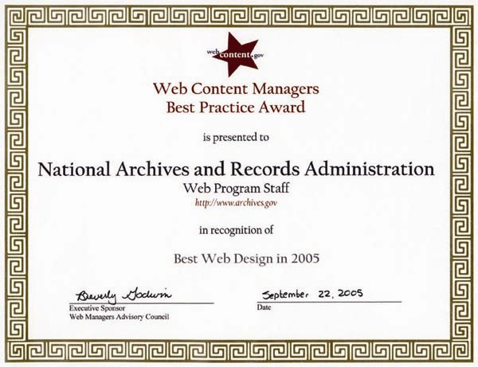
We continued to exceed our customer service targets in FY 2005 in nearly every area. More than 96 percent of the written requests we received from customers were answered within 10 working days. Eighty-eight percent of the requests for military service separation records we received were answered in 10 working days or less. Ninety-eight percent of the items our customers requested in our research rooms were furnished within one hour of request or the scheduled pull time. And 99 percent of our customers rated our educational programs, workshops, and training programs as meeting their expectations.
Goal 4: Meeting Storage and Preservation Needs of Growing Quantities of Records
Our major initiative in this area is the renovation of the National Archives Building. In FY 2005 we finished all work in the base renovation contract, with only work to replace electrical systems in the archival storage areas and some refinishing of the Rotunda display cases left to complete next year.
Four Presidents (President George W. Bush and former Presidents Jimmy Carter, George H.W. Bush, and Bill Clinton), family members of other Presidents, and approximately 30,000 people attended the dedication of the Clinton Presidential Library and Museum on November 18, 2004. All archival and artifact holdings from the Clinton administration are now housed in this state-of-the-art facility that meets our storage standards. The library’s exhibit is now open to visitors, and the library has its research room open with a small amount of material available for research.
We also opened a new archival facility for the Southeast Region in Morrow, GA. This facility consolidates operations previously housed in three separate facilities in Georgia and Alabama and features ample storage space that meets our environmental storage standards and excellent facilities for our researchers and attendees of public programs.
In his last mission as a helicopter gunship pilot in the Vietnam War, Stephen E. Lawrence had tried once to rescue the crew of another downed gunship under enemy fire, then went back again to finally fly them to safety. Lawrence and his three crewmates received the Distinguished Flying Cross. The crewmates’ awards were upgraded later to the Silver Star, the Army’s third highest medal. Lawrence was recommended for the Distinguished Service Cross, the Army’s second highest medal, but he left the Army soon thereafter with only his Distinguished Flying Cross. Earlier this year, some friends of Lawrence decided to correct what they considered an injustice. When their search for documents about the mission reached NARA, however, archivist Richard Boylan found a surprise—paperwork showed that Lawrence had indeed been awarded the prestigious Distinguished Service Cross in 1972 but never received notification. The award presentation finally was made in a special Pentagon ceremony in March 2005.

In response to the risk assessment of the Official Military Personnel Files (OMPFs) we completed at the NPRC, we began preservation work on the oldest, most fragile records. These records, representing slightly more than one percent of the files in the collection, date back to 1885 and contain data about Navy and Marine Corps enlisted personnel who served prior to World War II. NARA’s archival holdings at St. Louis will gradually expand to include significant volumes of OMPFs and related records.
Goal 5: Strategically Managing Our Resources
In FY 2005 our security program was enhanced by the update of NARA 804, Information Technology (IT) Systems Security, and the inclusion of the Security Architecture component in the Enterprise Architecture. We further strengthened our program through the creation of IT governance boards which provide strong support for configuration management of IT systems that are in production and under development. We adopted standardized configurations for a number of key operating systems, and network monitoring was enhanced through the deployment of an Intrusion Detection System. Classified IT systems were brought under centralized management control, and NARA produced and tested a Disaster Recovery Plan. These activities allowed us to close a longstanding material weakness; however, we expect IT security to continue as a priority as we rely more and more on our IT infrastructure to provide services to the public.
We expanded the availability of electronic submission of Federal Register documents using the Electronic Editing and Publishing System (eDOCS). To date we have registered a total of 15 agencies to submit documents electronically to the Federal Register. This year we used eDOCS to manage more than 7,000 documents, approximately 22 percent of our total workload this year. More than 142 million Federal Register documents were retrieved online by our customers. We are proud of our efforts to make the workings of government more readily accessible to citizens.
A more detailed examination of our FY 2005 performance can be found in the Performance Section of this report.
Linking Our Budget to Our Objectives
Our long-term objectives are tied directly to our budget. The chart below illustrates, by strategic goal and long-term objective, the resources allocated to each of these goals. (The resources obligated to each of these goals are shown in figure 3 on p. 35.) The chart also links the major budget functions to each of our long-term objectives.

NARA Goals & Long-Term Objectives | Records Services | Archives-Related Services | Electronic Records Archives | Revolving Fund | Trust Fund | NHPRC | Repairs & Restoration

Goal 1: $17,029,000 and 148 FTE
1.1 By 2008, 95% of agencies view their records management program as a positive tool for asset and risk management. | 
1.2. By 2008, 95% of approved capital asset plans have approved records schedules by the time those systems begin creating records. | 
1.3. By 2008, 95% of customers are satisfied with NARA scheduling and appraisal services. | 
Goal 2: $53,196,000 and 86 FTE
2.1. By 2008, NARA’s Records Center Program accepts and services electronic records. |  |  |  | 
2.2. By 2008, 80% of scheduled archival electronic records are accessioned by NARA at the scheduled time. |  |  | 
2.3. By 2008, 80% of archival electronic records are managed at the appropriate level of service. |  |  | 
2.4. By 2008, the median time from the transfer or archival electronic records to NARA until they are available for access is 35 days or less. |  |  | 
2.5. By 2008, the per megabyte cost of managing archival electronic records through the Electronic Records Archives decreases each year. |  |  | 
Goal 3: $146,139,000 and 2,344 FTE
3.1. By 2007, access to records and services and customer satisfaction levels meet or exceed NARA’s published standards. |  |  |  |  | 
3.2. By 2007, 70% of NARA services are available online. |  |  |  | 
3.3. By 2008, 80% of NARA archival holdings are described in an online catalog. | 
3.4. By 2007, government-wide holdings of 25-year-old or older records are declassified, properly exempted, appropriately referred, or appropriately delayed under the provisions of Executive Order 12958, as amended, through a series of ISOO-led interagency efforts. | 
3.5. By 2007, NARA archival holdings of 25-year-old or older records are declassified, properly exempted, appropriately referred, or appropriately delayed under the provisions of Executive Order 12958, as amended. | 
3.6. By 2007, 10% of records of a two-term President or 15% of records for a one-term President are open and available for research at the end of the 5-year post-Presidential period specified in the Presidential Records Act. | 
3.7. By 2007, 90% of all NHPRC-assisted projects produce results promised in grant applications approved by the Commission. |  |  |  |  |  | 
Goal 4: $63,981,000 and 151 FTE
4.1. By 2009, 100% of NARA’s archival holdings are in appropriate space. |  |  |  |  |  |  | 
4.2. By 2009, 100% of NARA records centers comply with the October 2009 regulatory storage standards. |  |  |  | 
4.3. By 2007, 50% of NARA’s at-risk archival holdings are appropriately treated or housed so as to retard further deterioration. | 
Goal 5: $34,274,000 and 123 FTE
5.1. By 2008, the average time a leadership position remains unfilled is 30 days or less. |  |  |  | 
5.2. By 2007, the percentages of NARA employees in underrepresented groups match their respective availability levels in the Civilian Labor Force. |  |  |  | 
5.3. By 2007, NARA will accept 100% of the validated legal documents submitted electronically for publication in the Federal Register. |  | 
5.4. By 2008, all public network applications are available 99.9% of the time. |  |  |  | 

Financial Highlights
Fiscal year 2005 was the second year that NARA prepared consolidated financial statements in accordance with the Chief Financial Officers (CFO) Act, as mandated by the Accountability of Tax Dollars Act of 2002. The financial statements presented in this report have been prepared from NARA’s accounting records in accordance with the generally accepted accounting standards prescribed for Federal entities by the Federal Accounting Standards Advisory Board (FASAB) and presentation standards prescribed by OMB Circular A-136, “Financial Reporting Requirements.”
Sources of Funds
NARA is funded through appropriated budget authority that includes annual, multiyear and no-year appropriations which are available for use within certain specified statutory limits. Other financing sources include the National Archives Trust Fund, Gift Fund, and Revolving Fund revenues.
NARA’s total new FY 2005 budget authority from its annual appropriation was $321.3 million. We carried over $26.5 million in multiyear and no-year funds, and $.3 million from FY 2004 was available for obligation in FY 2005. FY 2005 rescissions totaled $2.6 million. Total appropriated budget authority for FY 2005 was $345.5 million.
Figure 2. Appropriated Budget Authority, FY 2005.
The major operating appropriation funds basic operations comprising records services, archives-related services, and the National Archives at College Park. Records services provides for selecting, preserving, describing, and making available to the general public, scholars, and Federal agencies the permanently valuable historical records of the Federal Government and the historical materials and Presidential records in Presidential libraries; for preparing related publications and exhibit programs; and for conducting the appraisal of all Federal records. Archives-related services provide for the publications of the Federal Register, the Code of Federal Regulations, the U.S. Statutes at Large, and Presidential documents, and for a program to improve the quality of regulations and the public’s access to them. The $302 million cost of construction of the National Archives at College Park, which serves as a major archival facility as well as the center for NARA’s administrative offices, was financed by Federally guaranteed debt issued in 1989 for which the Archivist seeks appropriations for the annual payments for interest and redemption of debt.
NARA also receives appropriations that fund the Electronic Records Archives, repairs and restorations, and the National Historical Publications and Records Commission grants program. The Electronic Records Archives appropriation funds NARA’s effort to ensure the preservation of and access to Government electronic records. The repairs and restoration appropriation funds the repair, alteration, and improvement of archives facilities to provide adequate storage for holdings. The National Historical Publications and Records Commission grants program provides for grants to state, local, and private institutions to preserve and publish records that document American history. Figure 2 illustrates the allotment of total available appropriated funds.
The National Archives Trust Fund and Presidential Library Trust Funds budget authority includes revenues generated from the sale of publications, museum shop sales, paper reproductions, audiovisual reproductions, library admissions, educational conferences, and interest income. Expenditures are made for the cost of museum shop inventory, personnel, operational and financial systems, equipment, and reproduction supplies. The National Archives Trust Fund and Presidential Library Trust Funds earned revenue of $16.3 million in FY 2005.
The Gift Fund’s budget authority includes donations and the interest earned on those gifts and endowments. It was established to administer incoming gifts and bequests for the benefit of or in connection with the archival and records activities of the National Archives and Records Administration. Expenditures are made for various programs, including historical research, conferences, archival and cultural events, and publications. In FY 2005, the Gift Fund received donations of $2.1 million and a restricted endowment from the Clinton Foundation of $7.2 million.
The Revolving Fund’s budget authority includes temporary Federal agency records stored in NARA service facilities. It provides storage, transfer, reference, re-file, and disposal services, for a standard fee. The Revolving Fund earned revenue of $132 million in FY 2005.
Uses of Funds by Function
NARA incurred new general fund obligations of $328.2 million in FY 2005. Of this, $0.6 million is for reimburseable work. The chart below represents obligations by strategic goal.
Figure 3. Obligations by Function, FY 2005.
Audit Results
NARA received a qualified opinion on its FY 2005 financial statements and a qualified opinion on its restated FY2004 financial statements. FY 2005 opinion was qualified for the effects of such adjustments, if any, for obligations and outlays related to non-Federal investments. The auditors identified one material internal control weakness and four reportable conditions. NARA also reported one substantial noncompliance instance with the Federal Financial Management Improvement Act concerning the financial system compliance.
Financial Statement Highlights
NARA’s financial statements summarize the financial activity and financial position of the agency. NARA’s FY 2004 financial statements have been restated, based on a more in-depth analysis, to reflect an overstatement of approximately $13 million to the Property, plant, and equipment balances, established in FY 2004 for the first time. The financial statements, footnotes, supplementary information, and supplementary stewardship information appear in Part 3—Financial Section. An analysis of the principal statements follows.
Analysis of the Balance Sheet
Assets
NARA’s assets were $517.9 million as of September 30, 2005, a decrease of $35 million from the end of FY 2004. The assets reported in NARA’s balance sheet are summarized in the accompanying table.
Asset Summary (in millions) | FY 2005 | Restated  FY 2004
Fund balance with Treasury and cash | $167.3 | $185.2
General property, plant, and equipment, net | 311.8 | 314.6
Investments | 26.7 | 36.0
Accounts receivable, net | 10.0 | 15.0
Inventory | 1.1 | 1.0
Other | 1.0 | 1.1
Total assets | $517.9 | $552.9
The fund balance with Treasury and cash accounts for approximately 32.3 percent of total assets, with a decrease of $17.9 million from the FY 2004 balance, and represents appropriated funds and collections of fees for services. Property, plant, and equipment constitute 60.2 percent of total assets, with the National Archives Facility at College Park representing the greater part of the balance.
Liabilities
NARA’s liabilities were $292.7 million as of September 30, 2005, a decrease of $29.4 million from the end of FY 2004. Most of the decrease in liabilities is due to FY 2005 debt repayment of approximately $8.5 million, as well as liquidation of liability for non-entity investments of $17.5 million. The liabilities reported in NARA’s balance sheet are summarized in the accompanying table.
Liabilities Summary (in millions) |  | FY 2005 |  | FY 2004
Debt held by the public | $236.3 |  | $246.0
Accounts payable | 23.4 |  | 27.8
Other | 33.0 |  | 48.3
Total liabilities | $292.7 |  | $322.1
Debt held by the public accounts for approximately 81 percent of total liabilities and represents certificates of participation issued to the public through a trustee to cover the construction costs of the National Archives at College Park. Liabilities totaling $258.4 million, or 88.3 percent of total liabilities, were unfunded; i.e., budgetary resources were not yet available. For most unfunded liabilities, budgetary resources will be made available in the years balances are due, in accordance with OMB funding guidelines. The major elements of unfunded liabilities are $236.3 million for debt held by the public, $9.3 million for workers’ compensation, and $12.5 million for unfunded annual leave.
Net Positions
The difference between total assets and total liabilities, net position, was $225.2 million
as of September 30, 2005. This is a decrease of $5.7 million from the FY 2004 year-end balance. The net position reported in NARA’s balance sheet is summarized in the accompanying table.
Unexpended appropriations is the amount of authority granted by Congress that has not been expended. Cumulative results of operations represents net results of operations since NARA’s inception, reflecting results of revolving fund operations and funding of the capital needs of the agency.
Net Position Summary  (in millions) |  | FY 2005 |  | Restated FY 2004
Unexpended appropriations | $ 117.6 |  | $ 139.8
Cumulative results of operations | 107.6 |  | 91.1
Total net position | $ 225.2 |  | $ 230.9
Analysis of the Statement of Net Cost
The statement of net cost presents the net cost of NARA’s six major programs. NARA’s net cost of operations for the year ended September 30, 2005, was $345.4 million. The increase of $59 million in the net cost of operation is due largely to the increased activity and contract costs in the Electronic Records Archives (ERA) program, significant increases in utilities and security services, and payroll cost-of-living increases. Net costs by program are shown in the accompanying table.
Net Cost of Operations (in millions) |  | FY 2005 |  | Restated FY 2004
Records and archives-related services | $279.7 |  | $240.7
Trust and Gift Funds | (.2) |  | 3.4
Electronic Records Archives | 35.7 |  | 11.2
National Historical Publications and Records Commission grants | 7.3 |  | 5.9
Archives facilities and Presidential libraries repairs and restoration | 11.1 |  | 13.0
Records center storage and services | 11.8 |  | 12.2
Net cost of operations | $345.4 |  | $286.4
Analysis of the Statement of Changes in Net Position
The statement of changes in net position reports the change in net position during the reporting period. Net position is affected by changes in its two components—Cumulative Results of Operations and Unexpended Appropriations. The decrease in the net position of $5.7 million from FY 2004 to FY 2005 is due to the increase in cumulative results of operations of $16.5 million and a decrease in unexpended appropriations of $22.2 million. The overall decrease is indicative of the higher expenditures for other than capital needs of the organization, such as utilities and contract services.
Analysis of the Statement of Budgetary Resources
The Statement of Budgetary Resources presents the sources of budgetary resources and their status at the end of the period, as well as demonstrates the relationship of obligations to outlays. For FY 2005, NARA had budgetary resources available of $568.7 million, an increase of 2.9 percent over $552.6 million in FY 2004. The majority of the increase resulted from new budget authority.
Analysis of the Statement of Financing
The statement of financing is designed to reconcile obligation-based (budgetary accounting) information in the statement of budgetary resources and accrual-based (financial accounting) information in the statement of net cost by reporting the differences and explaining them. This reconciliation ensures that the proprietary and budgetary accounts in the financial management system are in balance. The statement of financing takes budgetary obligations of $494 million and reconciles to the net cost of operations of $345.4 million by deducting nonbudgetary resources, costs not requiring resources, and financing sources to be provided in the future.
Debt Management
The U.S. General Services Administration (GSA) provides cross-servicing for NARA’s debt collection management. Debt management information specific to NARA is not available; however, GSA’s procedures for debt management are as follows. To comply with the Debt Collection Improvement Act of 1996, GSA transmits delinquent claims each month to the U.S. Department of the Treasury Financial Management Service (FMS) for collection cross-servicing. GSA also collects non-Federal claims using Pre-Authorized Debits (PADs). GSA actively pursues delinquent non-Federal claims using installment agreements, salary offset, administrative wage garnishment, and any other statutory requirement or authority that is applicable. Through an outside contract arrangement, GSA actively reviews and pursues overpayments. They are working with FMS to remove all nonpaying claims more than two years old from open receivables and have implemented a plan to review delinquent accounts and contact debtors, especially those approaching two years old, on a quarterly basis.
Erroneous Payments Management
GSA provides cross-servicing for NARA for all of its financial services, including payments management. For FY 2005, NARA is fully relying on the procedures performed by GSA. To comply with the Improper Payments Information Act of 2002, GSA retained the services of a contractor to conduct a management control review and Improper Payments Information Act review that focused on erroneous payment risk analysis by program to determine and estimate the amount of potential improper and erroneous payments. All programs were statistically sampled to identify those that are highly susceptible to erroneous payments and that meet the $10 million and 2.5-percent threshold established by the Office of Management and Budget (OMB). Corrective action plans will be developed for any programs that are identified as subject to significant risk of erroneous payments.

Systems, Controls, and Legal Compliance
This section provides information about NARA’s compliance with the
- Federal Manager’s Financial Integrity Act
- Federal Information Security Management Act
- Federal Financial Management Improvement Act
- Prompt Payment Act
- Inspector General Act
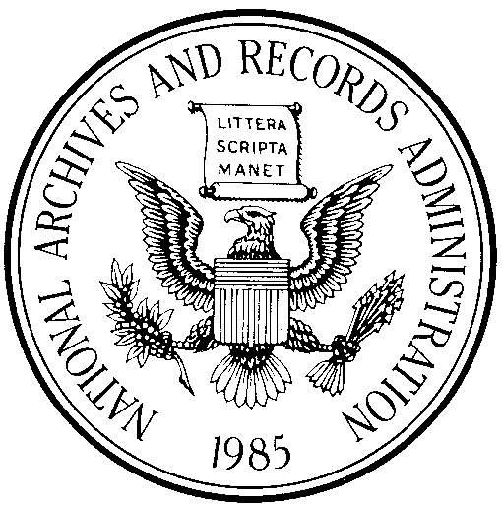
Federal Managers’
Financial Integrity Act
INTEGRITY
ACT
STATEMENT

It is my informed judgment that there
is reasonable assurance that NARA's internal controls are achieving
their intended objectives.

Allen Weinstein
Archivist of the United States
November 2005
The Federal Managers’ Financial Integrity Act mandates that agencies establish controls that reasonably ensure that (i) obligations and costs comply with applicable law; (ii) assets are safeguarded against waste, loss, unauthorized use, or misappropriation; and (iii) revenues and expenditures are properly recorded and accounted for. This act encompasses operational, program, and administrative areas, as well as accounting and financial management. It requires the Archivist to provide an assurance statement to the President on the adequacy of internal controls and conformance of financial systems with Government-wide standards.
Internal Controls Program
NARA’s internal controls worked to ensure the attainment of our mission and FY 2005 goals, maintain efficient operations, and reduce fraud and the misuse of taxpayer-provided resources. NARA managers submitted an annual assurance statement, along with a management control plan, to the Archivist of the United States at the end of the fiscal year. These statements were based on various sources and included
- Management knowledge gained from daily operation of programs
- Management reviews
- Program evaluations
- Audits of financial statements
- Reviews of financial systems
- Annual performance plans and periodic performance reporting to the Archivist
- Senior Staff reviews and briefings
- Internal oversight groups for agency programs
- Monthly reporting in NARA’s Performance Measurement Reporting System and monthly Strategic Schedule reporting
- Reports and other information provided by the congressional committees of jurisdiction
In addition, audits and reviews performed by the Office of Inspector General (OIG) and the Government Accountability Office reviewed the agency’s internal controls and led to improvements in them. Annually, the OIG reviews the state of NARA’s internal controls. The Archivist’s assurance letter reports on the results of this assessment.
FY 2005 Integrity Act Results
NARA evaluated its internal control systems for the fiscal year ending September 30, 2005. This evaluation provided reasonable assurance that the agency’s internal controls achieved their intended objectives. Pursuant to Section 2 of the Integrity Act, we identified three material weaknesses in fiscal years 2000, 2001, and 2005. Corrective action plans were developed for material weaknesses in computer security, collections security, and in textual preservation. Much progress has been made, and substantial corrective actions for computer security were completed in FY 2005. Pursuant to Section 4 of the Integrity Act, the financial subsystems of NARA generally conformed with the objectives detailed in OMB Circular A-127, revised. Although three systems (Order Fulfillment Accounting System; Trust Fund-Gift Fund Financial Review, Analysis, and Reporting System; and Records Center Revolving Fund financial management systems) were not in complete conformance because they failed to meet the financial management system requirements, the nonconformances were not deemed material.
Federal Information Security Management Act
The Federal Information Security Management Act (FISMA) requires Federal agencies to conduct an annual self-assessment review of their information technology security program, to develop and implement remediation efforts for identified security weaknesses and vulnerabilities, and to report to OMB on the agency’s compliance.
Following established FISMA requirements, our review indicated no new significant deficiencies in NARA’s FY 2005 FISMA, submitted October 7, 2005, to OMB.
Federal Financial Management Improvement Act
GSA is the financial services provider of NARA financial systems via PEGASYS. At the end of FY 2005, GSA had a material weakness concerning the PEGASYS system, because it was not compliant with the Joint Financial Management Improvement Program (JFMIP), required by FFMIA. NARA changed its financial services provider, effective October 1, 2005, and anticipates this will correct any related deficiencies.
Prompt Payment Act
During FY 2005, GSA was the financial services provider of NARA financial statistics and acted as our agent for implementing the Prompt Payment Act. As a result, NARA statistics were not specifically identifiable.
Inspector General Act
NARA satisfied nearly 70 percent of all open audit recommendations, maintaining its steady progress in resolving and implementing open audit recommendations presented in OIG reports. Section 5(b) of the Inspector General Act requires agencies to report on final actions taken on OIG audit recommendations. This information can be found in the Performance Section of this report.

Facilities

National Archives Building
700 Pennsylvania Avenue, NW
Washington, DC 20408
202-501-5400

National Archives at
College Park
8601 Adelphi Road
College Park, MD 20740
301-837-2000

Washington National
Records Center
4205 Suitland Road
Suitland, MD 20746
301-778-1600

NARA–Northeast Region
Diane LeBlanc,
Regional Administrator

NARA–Northeast Region (Boston)
380 Trapelo Road
Waltham, MA 02452
866-406-2379

NARA–Northeast Region (Pittsfield)
10 Conte Drive
Pittsfield, MA 01201
413-236-3600

NARA–Northeast Region
(New York City)
201 Varick Street, 12th Floor
New York, NY 10014
212-401-1620

NARA–Mid Atlantic Region
V. Chapman-Smith,
Regional Administrator

NARA–Mid Atlantic Region (Center City Philadelphia)
900 Market Street
Philadelphia, PA 19107
215-606-0100

NARA–Mid Atlantic Region (Northeast Philadelphia)
14700 Townsend Road
Philadelphia, PA 19154
215-305-2000

NARA–Southeast Region
James McSweeney,
Regional Administrator

NARA–Southeast Region (Atlanta)
5780 Jonesboro Road
Morrow, GA 30260
770-968-2100

NARA-Southeast Region (Atlanta)
4712 Southpark Boulevard
Ellenwood, GA 30294
404-736-2820

NARA–Great Lakes Region
David Kuehl,
Regional Administrator

NARA–Great Lakes Region (Chicago)
7358 South Pulaski Road
Chicago, IL 60629
773-948-9001

NARA–Great Lakes Region (Dayton)
3150 Springboro Road
Dayton, OH 45439
937-425-0600

NARA–Central Plains Region
R. Reed Whitaker,
Regional Administrator

NARA–Central Plains
Region (Kansas City)
2312 East Bannister Road
Kansas City, MO 64131
816-268-8000

NARA–Central Plains Region (Lee's Summit)
200 Space Center Drive
Lee's Summit, MO 64064
816-288-8100

NARA–Central Plains Region (Lenexa)
17501 West 98th Street, #31-50
Lenexa, KS 66219
913-825-7800

NARA–Southwest Region
Kent Carter,
Regional Administrator

501 West Felix St, Bldg 1
P.O. Box 6216
Fort Worth, TX 76115
817-831-5900

NARA–Rocky Mountain Region
Barbara Voss,
Regional Administrator

Denver Federal Center, Building 48
P.O. Box 25307
Denver, CO 80225
303-407-5700

NARA–Pacific Region
Shirley J. Burton,
Regional Administrator

NARA–Pacific Region
(Laguna Niguel)
24000 Avila Road
P.O. Box 6719
Laguna Niguel, CA 92607
949-360-2641

NARA-Pacific Region
(Riverside)
23123 Cajalco Road
Perris, CA 92570
951-956-2000

NARA–Pacific Region
(San Francisco)
1000 Commodore Drive
San Bruno, CA 94066
650-238-3500

NARA–Pacific Alaska Region
Steven Edwards,
Regional Administrator

NARA–Pacific Alaska Region (Seattle)
6125 Sand Point Way, NE
Seattle, WA 98115
206-336-5115

NARA–Pacific Alaska Region (Anchorage)
654 West Third Avenue
Anchorage, AK 99501
907-261-7800

NARA–National Personnel Records Center
Ronald Hindman, Director

NARA–National Personnel Records Center
(Civilian Personnel Records)
111 Winnebago Street
St. Louis, MO 63132
314-801-9250

NARA–National Personnel Records Center
(Military Personnel Records)
9700 Page Avenue
St. Louis, MO 63132
314-801-0800

Herbert Hoover Library
Timothy G. Walch, Director
210 Parkside Drive
P.O. Box 488
West Branch, IA 52358
319-643-5301

Franklin D. Roosevelt Library
Cynthia Koch, Director
4079 Albany Post Road
Hyde Park, NY 12538
845-486-7770

Harry S. Truman Library
Michael Devine, Director
500 West U.S. Highway 24
Independence, MO 64050
816-268-8200

Dwight D. Eisenhower Library
Daniel D. Holt, Director
200 Southeast Fourth Street
Abilene, KS 67410
785-263-6700
John Fitzgerald Kennedy Library
Deborah Leff, Director
Columbia Point
Boston, MA 02125
617-514-1600

Lyndon Baines Johnson Library
Betty Sue Flowers, Director
2313 Red River Street
Austin, TX 78705
512-721-0200

Nixon Presidential
Materials Staff
Michael Woywod, Acting Director
National Archives at College Park
8601 Adelphi Road
College Park, MD 20740
301-837-3290

Gerald R. Ford Library and Museum
Elaine K. Didier, Director

Gerald R. Ford Library
1000 Beal Avenue
Ann Arbor, MI 48109
734-205-0555

Gerald R. Ford Museum
303 Pearl Street, NW
Grand Rapids, MI 49504
616-254-0400
Jimmy Carter Library
Jay E. Hakes, Director
441 Freedom Parkway
Atlanta, GA 30307
404-865-7100

Ronald Reagan Library
Duke Blackwood, Director
40 Presidential Drive
Simi Valley, CA 93065
805-577-4000

George Bush Library
Warren Finch, Director
1000 George Bush Drive West
P.O. Box 10410
College Station, TX 77845
979-691-4000

William J. Clinton Library
David E. Alsobrook, Director
1200 President Clinton Avenue
Little Rock, AR 72201
501-374-4242

Copies of This Report
This report is available on our web site at—
www.archives.gov/about/plans-reports/performance-accountability/
Links are provided to both the full report (Management’s Discussion and Analysis [MD&A], Performance and Financial sections, and Appendixes) as well as the summary report (MD&A). Also located on that page are links to our Strategic Plan, annual performance plans, and past performance reports.
Copies of this report also may be obtained by electronic request via the form at—
www.archives.gov/contact/inquire-form.html
or by writing to National Archives and Records Administration, Policy and Planning Staff, 8601 Adelphi Road, Room 4100, College Park, MD 20740-6001. Please specify whether you are interested in the summary report or the full report. Also, we welcome your comments on how we can improve this report for FY 2006. Please e-mail any comments to Vision@nara.gov.

Other Web Pages of Interest

Reports, Strategic Documents, Messages from the Archivist: Find the latest information regarding our mission, vision, and strategic initiatives. | www.archives.gov/about/
The National Archives Experience: Participate in an interactive, educational experience about the power of records in a democracy. | www.archives.gov/national-archives-experience/
Archival Holdings: Find records of interest in Washington, DC, the regional archives, and Presidential libraries. | www.archives.gov/research/arc/
Public Documents: The U.S. Government Printing Office and the Office of the Federal Register at NARA work closely to disseminate the official text of Federal laws, Presidential documents, administrative regulations and notices, and descriptions of Federal organizations, programs and activities. | www.gpoaccess.gov/nara/
Public Regulations: Find, review, and submit comments on Federal documents that are open for comment and published in the Federal Register, the Government’s legal newspaper. | www.regulations.gov
Careers at NARA: Review current job openings and learn how to apply. | www.archives.gov/careers/
Visit NARA: Learn how to prepare for a research visit, about facility hours and locations, and more. | www.archives.gov/research/
Prologue Magazine: Keep up to date on NARA activities through its quarterly journal. View selected articles and subscribe online. | www.archives.gov/publications/prologue/.

